Microsoft Azure Fundamentals (AZ-900) Cert Prep: 1 Cloud Concepts

Course details

The Microsoft Azure Fundamentals certification exam is for anyone looking to begin their professional journey in cloud computing. To pass the AZ-900 exam, you need a high-level knowledge of the cloud, Azure architecture, core security, its basic services, management tools, and governance. This first course in the AZ-900 cert prep series covers the Cloud Concepts part of the exam objectives. Your instructor Kunal D Mehta provides a comprehensive guide toward understanding cloud computing, including the three “as-a-service” models, types of cloud configurations, and the potential benefits that organizations can get by leveraging cloud computing.

Hello, cloud!

[Narrator] The entire world is undergoing a digital transformation. With each day, more IT professionals are realizing the inefficiencies of traditional on-premises environments and discovering how cloud computing can help run their businesses with greater agility than ever before. Cloud enables instant access to computing resources from anywhere at any time, and automatically adjusts the quantity of resources you need. It's also very economical. You can instantly get your business up and running without having to empty your pockets purchasing expensive hardware. Cloud computing also takes modern, cutting edge technologies like artificial intelligence, machine learning, augmented reality, and makes them accessible to the general public like us, so that everyone can be empowered to achieve their vision of the future. With the cloud, the only limitation is our imagination. This is probably why you keep hearing about the cloud so much. I presume that's why you're here, to get a piece of the action. If that's the case, you have picked the perfect course to watch because I'm here to accompany you through your expedition in learning about the cloud and Microsoft Azure. Say the magic words "Hello Cloud!" to begin.

Overview of AZ-900

[Instructor] I'm sure you know this, but for the record, let me just put it out there. AZ-900 is the code for the Microsoft Azure Fundamentals exam. Before you give the exam or even start preparing for it, there are crucial things you need to know. Let me explain what they are. It's a human tendency to resist change. The unpredictability of the change makes us a little uncomfortable, and that's natural. The same sentiments are triggered when you go tell a person, "Hey, there's this new thing called the Cloud. You should totally jump on board." Microsoft's intention with this exam is to make you comfortable with this change so you can embrace the Cloud with confidence. The AZ-900 exam is designed to address four of the most basic concerns anyone can have. That is, what exactly is the Cloud? What services does it offer to start with? What about its security? And how easy or difficult it is to manage the Cloud? If you look at the official AZ-900 exam curriculum, you'll see it perfectly aligns with answers to these four questions. The exam curriculum is sectioned into three parts. First is Describe Cloud Concepts, which weighs around 25 to 30% of the exam. This is designed to ensure you understand exactly what the Cloud is. The second part is Describe Azure Architecture and Services. It weighs a good 35 to 40% of the exam. This is designed to ensure you understand what services and security Azure has to offer. And the third part is Azure Management and Governance. Weighs around 30 to 35% of the exam. This is designed to ensure you understand the manageability aspect of Azure. It is very important to keep in mind that AZ-900 is designed to introduce new learners to Microsoft Azure. It is not intended to make you a super pro max Cloud ninja. Nevertheless, it's certainly going to make you comfortable with Azure and be an excellent first step towards a career as a Cloud professional. In this course, which is the first in the learning path for AZ-900 on LinkedIn Learning, we'll cover the Cloud Concepts part of the exam.

Agenda

[Instructor] Here is the agenda for this course. For simplicity, I've taken the first section of the exam objective and renamed it to match the title of this course. Microsoft Azure Fundamentals AZ-900: Cloud Concepts. I've divided this course into five chapters. The one you're watching right now is the Introduction. The next chapter will be Understand Cloud Service Models. Here you learn what the cloud is, its key characteristics, infrastructure, platform and software as a service offerings, along with the shared responsibility model. After that, we have the chapter Understand Types of Cloud Computing. Here you learn about the different configurations of the cloud: public, private, hybrid, and sovereign clouds. Then we'll move onto the chapter Understand the Benefits of Cloud Computing. Here you learn about the core attributes of the cloud. Things like scalability, elasticity, high availability, and fault tolerance. I'll also give you a high-level overview of the security, management, and governance experience associated with cloud computing. The final chapter will be the Conclusion. Here I'll summarize the key learnings of the course and point you to the next step in the AZ-900 learning path. Point to be noted is that this course is going to be theoretical. There will be no demonstrations in this course because my primary goal here is to first give you a strong foundation of the fundamental concepts before we jump into hands-on action with Azure later on.

Prerequisites

[Instructor] Here are the prerequisites to gain the maximum value out of this course. Let's talk about the target audience. This course is intended for beginners in IT who want to pursue a career in cloud computing or help desk staff who want to upgrade their skills and grow in their IT careers for better designation and pay. Then we also have seasoned infrastructure professionals as well as software developers who are experienced in IT but not necessarily in the cloud domain. So if you're looking to transition into the cloud from something else, this course is fit for you. You could also be a business decision maker in charge to analyze the pros and cons of the cloud. You can watch this course and report your findings to the team, or you could be a part of the higher management wanting to know if cloud is the way to go for your organization. This course can serve you with the perfect executive level briefing on cloud computing. In terms of the required knowledge, since this is an entry level course you don't need to know a lot. A conceptual understanding of compute, networking, storage, and applications is helpful but not mandatory. In terms of the required resources you need three things. One is access to the AZ-900 learning path on LinkedIn Learning, which you already have. And second, a Microsoft Learn account. Both these materials complement each other really well. Microsoft Learn is the formal documentation that you can use for reference. And this learning path for interactive instructor led videos. A combination of these two should be sufficient to pass the exam. When it comes to learning, I'm a little old school. I also recommend you keep a pen ready to jot down the important points. When you're just sitting and watching learning content your participation is usually passive but when you start writing the things you are learning your participation becomes active. It helps you understand and remember the concepts a lot better. I have included a workbook one document in the exercise files of this course for you to take notes. Before we go any further let me take a moment to introduce myself. I'm Kunal D Mehta, an IT consultant who specializes in Microsoft Cloud and data center technologies. When I'm not doing geeky stuff I like to swim, scuba dive, travel, or just relax, watch a movie and eat pizza. I'm absolutely thrilled to be your instructor for this AZ-900 learning path on LinkedIn Learning. For best experience, watch this course on full screen. If you feel I'm speaking too fast or too slow you can use the controls in the video player to adjust the speed for your comfort. All right, without any further ado, let's jump right in.

1. Understand Cloud Service Models

What is cloud computing?

[Instructor] Welcome to the chapter, understand cloud service models. Here, I'll explain what the cloud is, its key characteristics, cloud service models, and the shared responsibility model. Have you ever wondered why it's called Cloud computing? Here's my perspective on it. If you have ever flown in an aircraft high up in the sky, I'm sure you must have noticed a couple of things from your window seat. Firstly, clouds have this distinctive property where smaller pieces of clouds can seamlessly blend into larger clouds and larger chunks of clouds can seamlessly fragment into smaller pieces. If I had to oversimplify it, this is sort of what happens to computing resources in Cloud computing. You can combine computing resources together to provision smaller or larger pieces out of it in Cloud computing. Secondly, you may have also noticed that clouds in the sky always seem to extend beyond the horizon almost as if to infinity. That's again similar to the aggregate of computing resources in Cloud computing, for all practical purposes there's an infinite amount of computing resources for you to provision in Cloud computing and therefore I believe this name makes so much sense. Now let's see what it actually is , at the center of every IT enabled business is an application that is absolutely critical for the organization to function. It keeps the business alive and the revenues coming in. For example, think of the banking application that banks use, the healthcare application that hospitals use, or the ticketing application that airlines use. Can you imagine how they would function without them? It would be borderline impossible for those businesses to survive without their application in today's world. To top that, modern businesses have a global reach, they have users all around the world in different time zones expecting the application to be accessible anywhere at any time, every minute matters. So it's clear that keeping that application up and running is a priority for all businesses. This is where things become a little inconvenient. You need a lot of supporting components to run this business application at a level where it can match those high expectations. Things like expensive server hardware, networking devices, and storage appliances, the wires, cables, and the connections between them. Then these hardware components need redundant power supplies, redundant cooling, and redundant internet to be on and connected. They all need to be redundant in case any one of them fails. For the safe keeping of these components, you need a secure physical space and you know how exorbitant real estate prices are. Then on top of the hardware, you need to install an operating system and potentially bear the cost of its licensing. This operating system needs regular maintenance by applying software patches and hotfixes to keep it up to date. Then the application itself has it direct dependency on frameworks and runtime environments that it requires to run. And finally, there's data that is generated as a result of the use of this application, not to mention you have to secure the whole thing from top to bottom, physically and digitally. Handling all of this can be a daunting challenge, this is called the traditional IT stack and when you build the whole stack yourself in your own corporate location we refer to it as an on-premises environment or simply on-premises, remember the priority of most businesses is the application and its data, not the underlying components. Let me explain using an analogy. Imagine it's raining on a cozy evening, you're snuggled up in a blanket and all you want to do is eat some cake, let's accept it, we've all been there. Now imagine someone tells you, if you want to eat cake you should go to the kitchen, switch on the microwave, mix flour, milk, eggs, butter, sugar, bake the cake yourself and apply the frosting to eat it. Wouldn't you be mad? I would be furious and probably even throw a shoe at them, I know you agree with me but luckily we have a solution for that. Our civilization has evolved enough to have confectionary stores where you can order the cake as a service, sitting comfortably at home. Not only that, but you can also order as many slices of as many flavors you like. That's true freedom in my opinion, the confectionary store in this case becomes the cake service provider. Now, my question to you is if you don't like to bake your own cake, why should you unnecessarily build your own IT stack? Sounds counterproductive, right? That's where Cloud computing comes to the rescue. Cloud is like the confectionary store of the IT world, you can get access to any computing resources you need as a service. The entity providing them is called the Cloud Service Provider or CSP. In the context of AZ-900, Microsoft is the Cloud Service Provider and the name of their cloud is Azure, meaning bright blue skies. Here's a simple definition of the Cloud based on what we just witnessed. Cloud computing is the delivery of any computing resources from the IT stack as a service by a Cloud Service Provider.

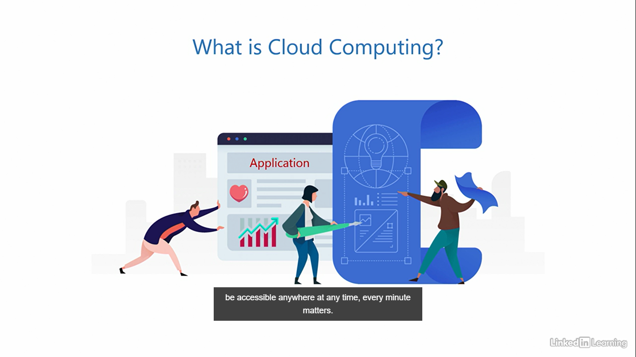

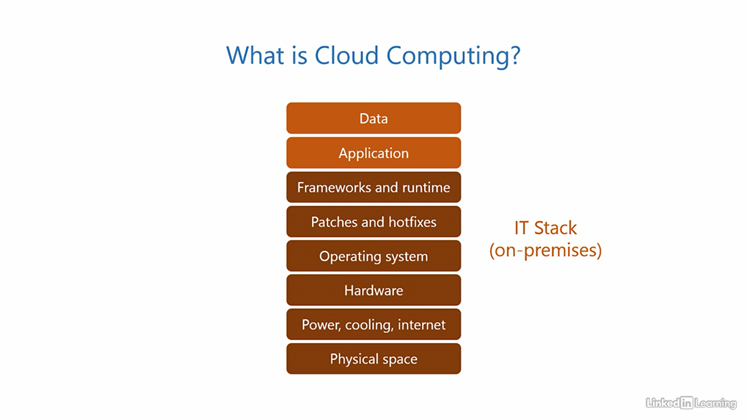

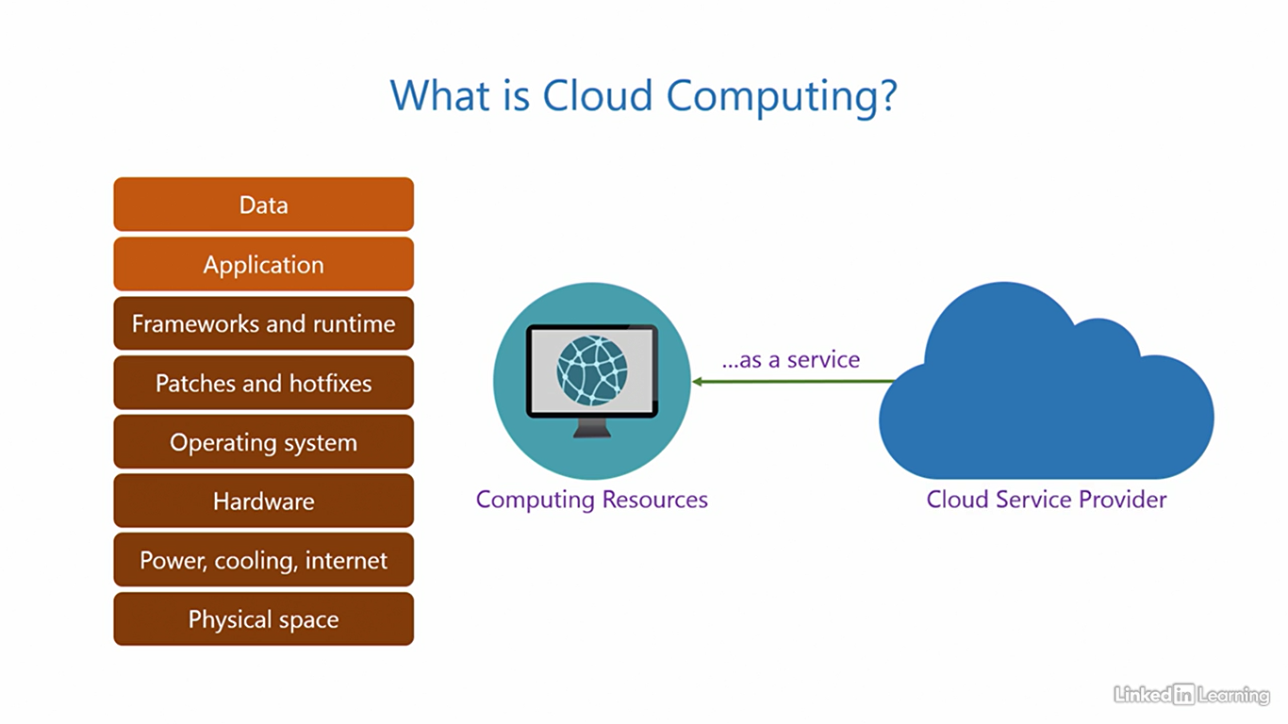

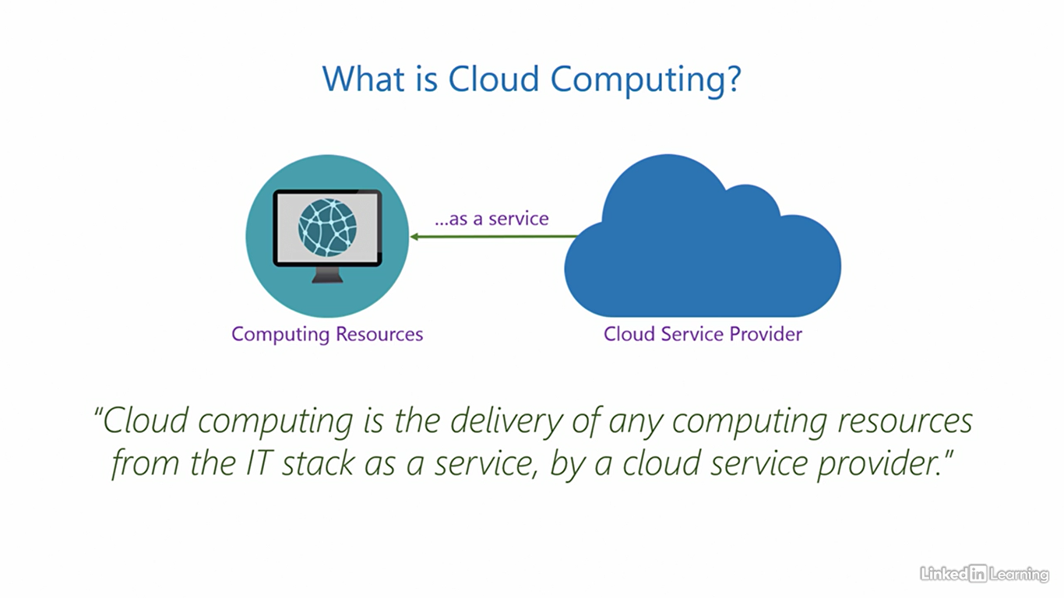

Virtualization is the foundation for cloud

[Instructor] A technology called virtualization is the core foundation for all of cloud computing. Virtualization is what powers the cloud. And without it, the cloud would simply not exist. I'm not going to go too deep into this, but at a high level, here's how. What are the three elementary pieces of a computer system? They are the processor, memory, and the hard disk. All of these are real, physical, tangible objects. So far, so good. Then, the process of virtualization steps in and changes the whole game. It allows you to create software copies of these elementary pieces. So you get a virtual processor, virtual memory, and virtual hard disk. These are not real objects. They're just software copies of the real pieces. But the key being, the virtual pieces function identical to the real pieces. Now, you're probably thinking, "What's the point of doing this?" Fair question. Because these are software pieces, you can provision them over the internet or any network. Remember when I explained cloud computing, I mentioned the delivery of computing resources. This is what makes the delivery possible. You cannot send a real physical processor, memory, or hard disk over a network, but you can provision their virtual counterparts over a network, and they'll behave like the real ones. Virtualization gives mobility to these pieces. This one single capability is what makes the cloud revolutionary. Virtualization also provides isolation between instances of virtualized resources. Any given set of virtualized resources operates independently and confined within its boundaries, completely unaware of other virtualized resources on the system.

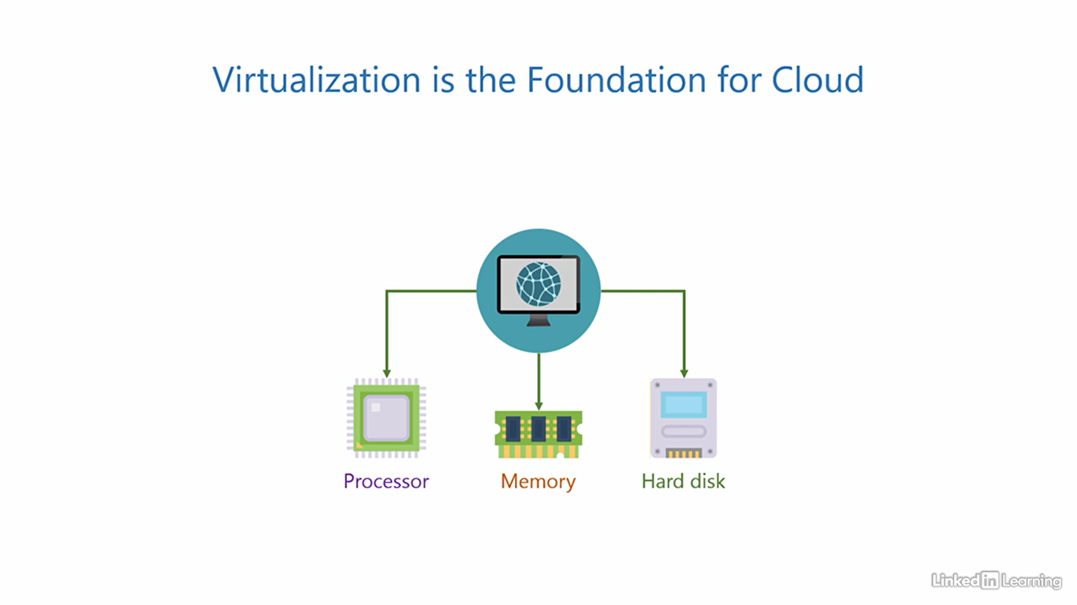

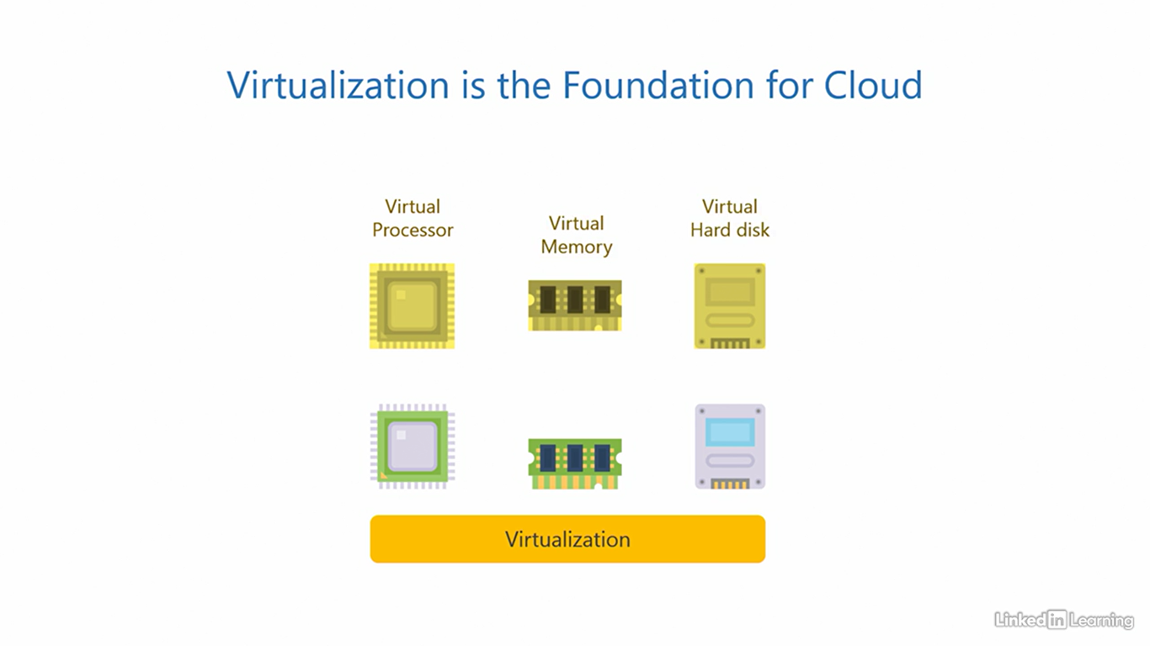

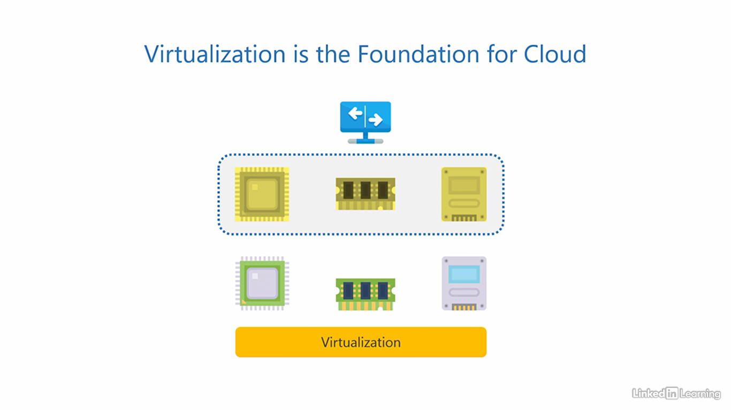

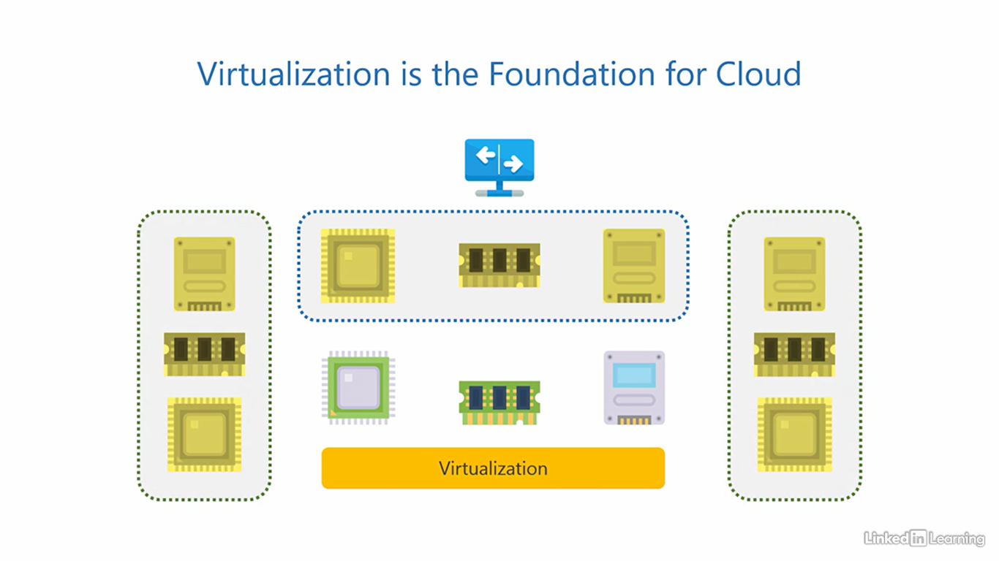

Key characteristics of cloud computing

[Instructor] In the last video, we saw how virtualization is the core foundation for cloud. But just because we have virtualization, does not imply we have a cloud. You need a little more than that. There are four unique key characteristics of cloud computing. Let's see what those are. The first key characteristic is resource pooling. Remember when I mentioned how clouds in the sky blend into larger clouds, or fragment into smaller ones? The technical term we use to describe that in cloud computing is resource pooling. Here, we take a large number of physical computing resources, put them together, and virtualize them. What you get as a result is a large pool of virtualized computing resources. You can now request for these virtualized resources to be provisioned of whatever size you need, a small sized or a large sized resource, depending on your precise requirement. In the diagram on your screen, I'm only illustrating this for the processor, but this actually applies to all three elementary pieces, the processor, memory, and the hard disk. The second key characteristic is elasticity. Remember when I mentioned clouds in the sky look like they extend to infinity? The term we use to describe that is elasticity. Cloud service providers are massive establishments, not small. They usually have hundreds of data centers spread across the world, each with very large capacities. This means the size of the virtualized pool of resources is so huge, that it's practically never ending. You can provision as many extra resources as you need when the workload goes up, and deprovision them when the demand goes down. The third key characteristic is pay per use. In an on-premises environment, you have to bear the huge upfront cost of purchasing expensive computer hardware, irrespective of if you use it or not. But in the cloud, you only pay for the resources you use and the time you use them for. You are not liable to pay for anything else. So if you use two units or one unit, you just pay for that. If you don't use anything, your bill is zero. The fourth key characteristic is automation. All the three characteristics you saw so far, the resource pooling, elasticity, and pay per use billing are all automated. And because everything is automated, it enables you to provision resources on demand and perform self-service on resources, without having to depend on anyone. Neither the cloud service provider, technical support, nor anybody else. Remember, these characteristics apply to all three pieces, the processor, memory, and the hard disk. There you have it, the four key characteristics of cloud computing. It's a real cloud, only if you have, at the very least, resource pooling, elasticity, pay per use, and automation.

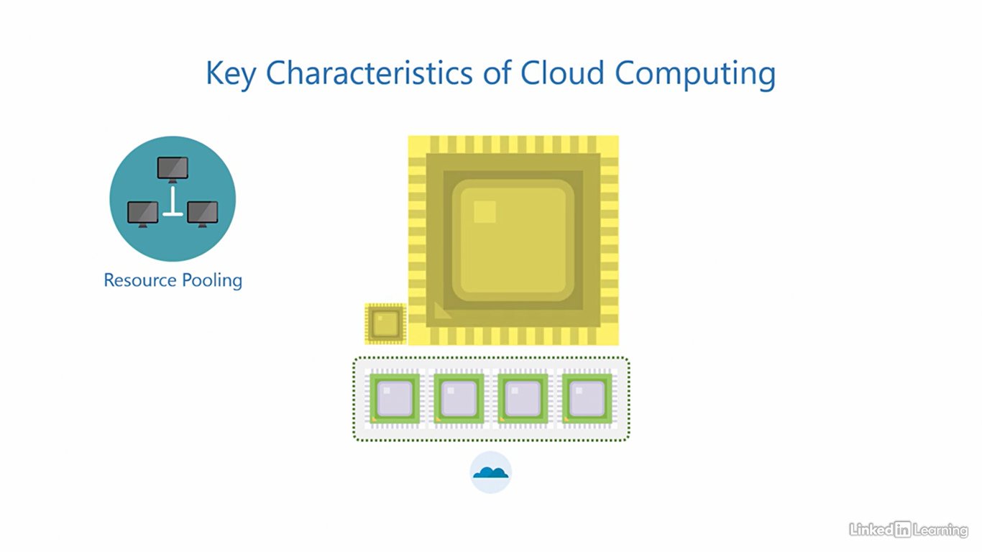 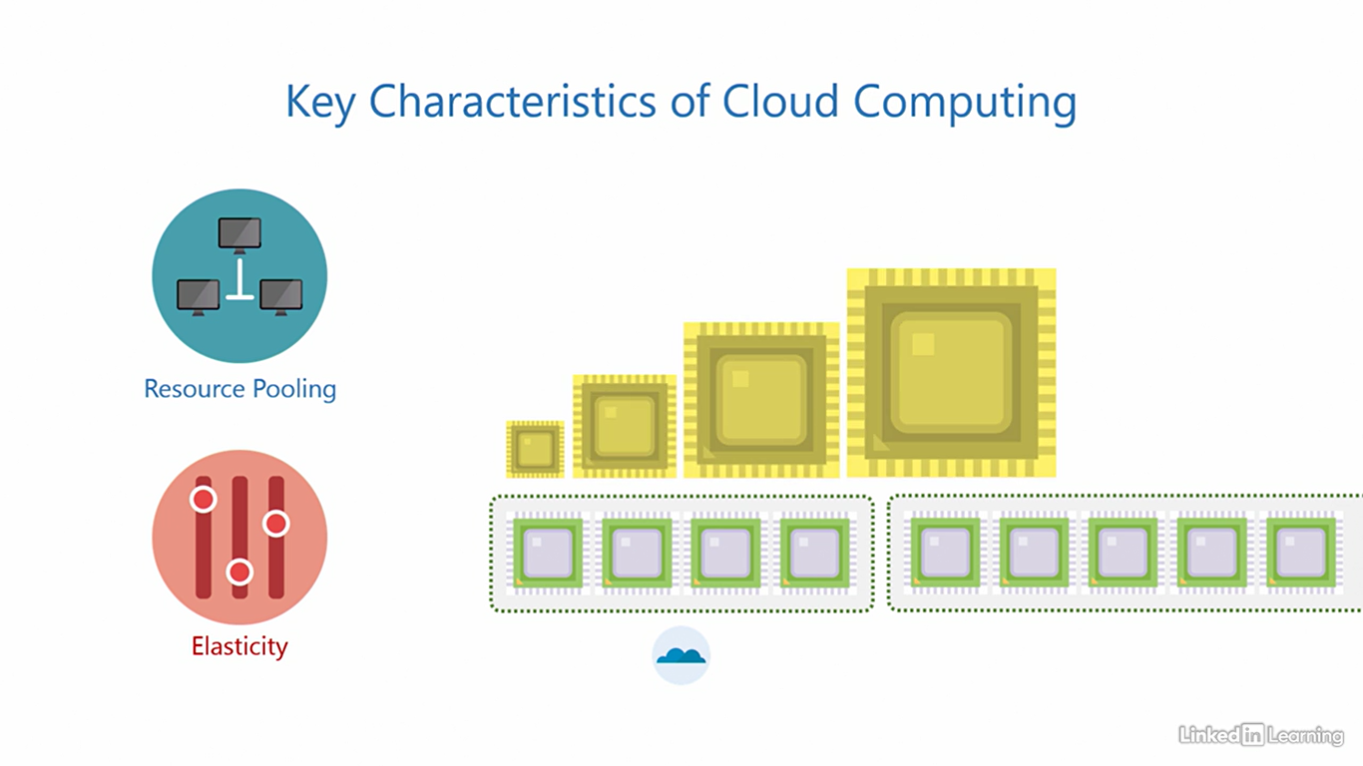

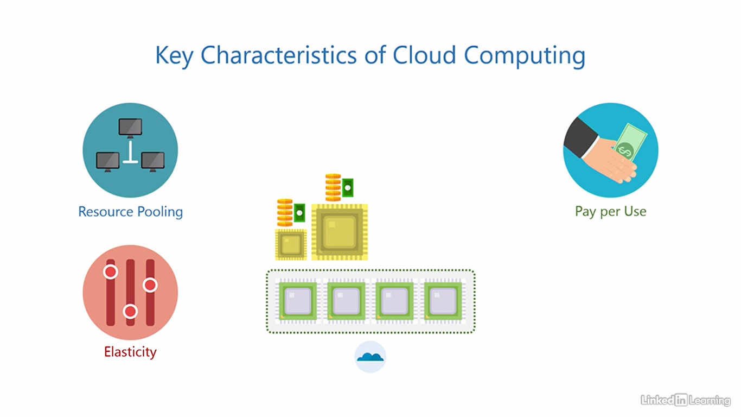

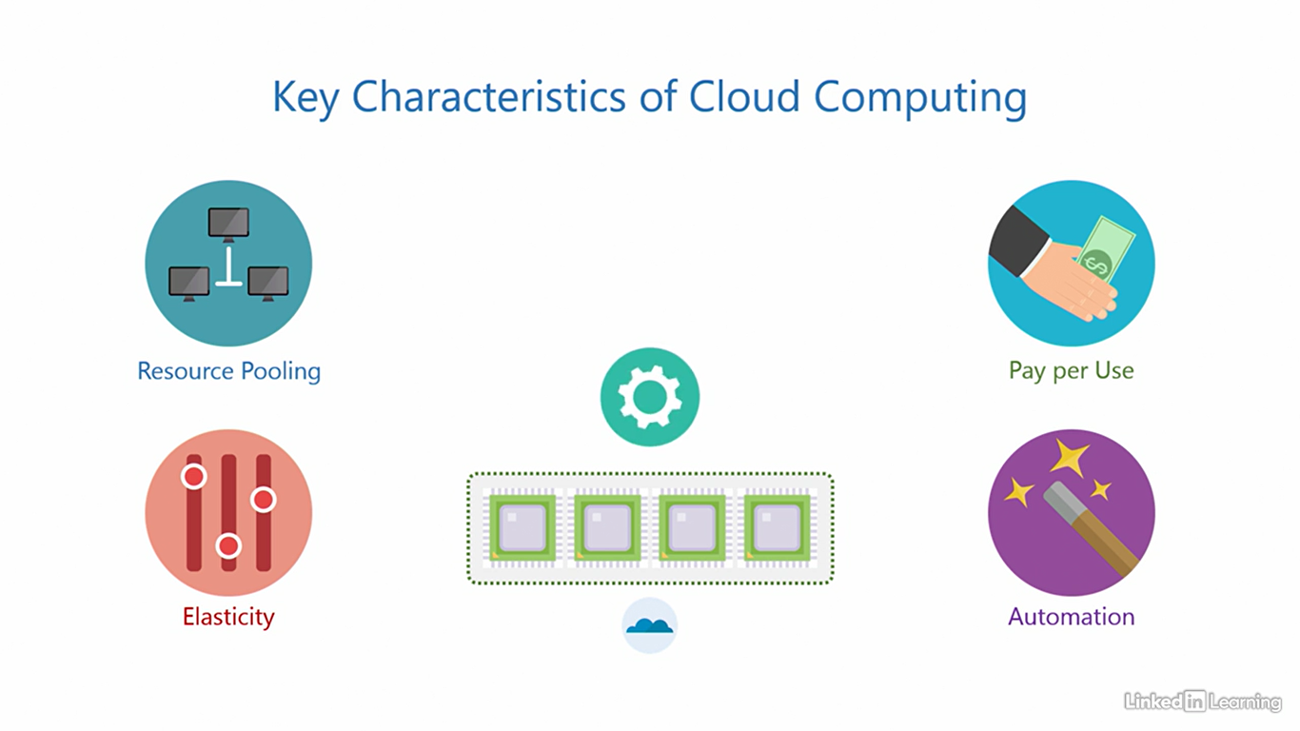

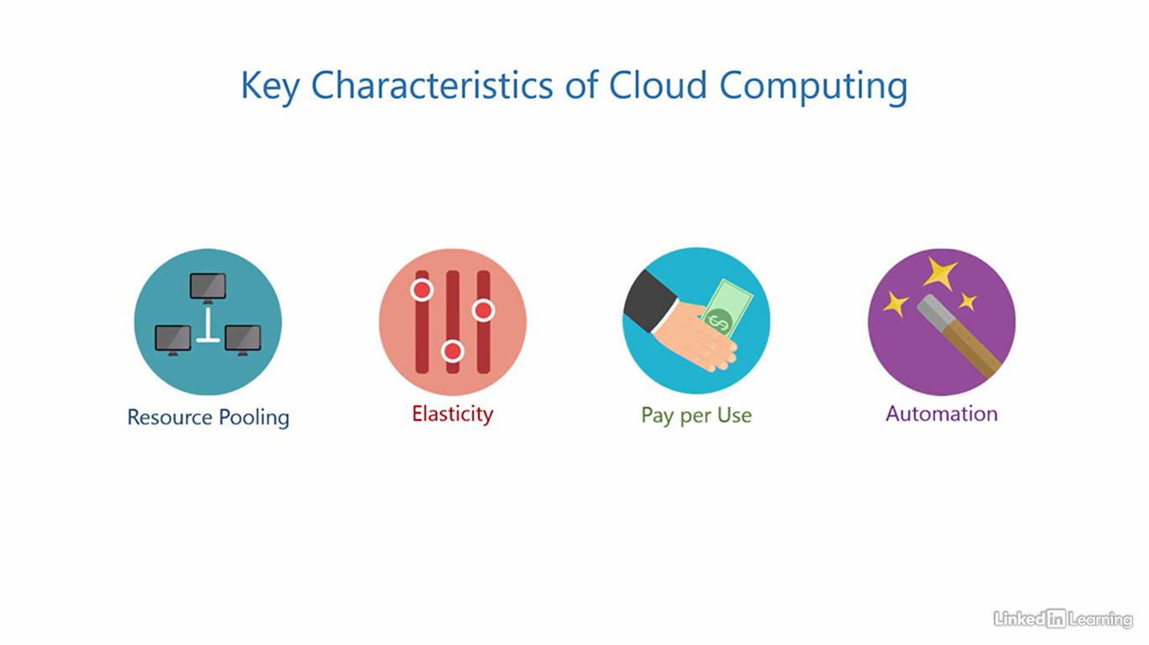

Understand infrastructure as a service (IaaS)

[Instructor] We know that a cloud service provider delivers computing resources from the IT stack as a service. The entity on the other end consuming these resources is a customer organization, or simply a customer. Most enterprise clouds are business to business so the customers are usually startups, small, medium or large companies, and they can choose to consume parts of the IT stack depending on their need. Now you may be wondering, if a customer can get the whole IT stack as a service, why would they choose to avail only parts of it and not the whole stack? I have two words for that, control and customization. Let's go back to the cake example. What if you wanted a cake of a very specific flavor or maybe a very specific brand of whipped cream on top of the icing, and the confectionary store didn't have them. What would you do? You'd take control, source the ingredients and customize the cake yourself. The same theory applies to the cloud. You can choose different pieces of the IT stack when you want more control and customization. There are three cloud service models of how computing resources can be offered to customers. The first one is infrastructure-as-a-service. In this offering, the cloud provides its customers access to virtualized hardware resources. What that means is the cloud service provider procures physical hardware, sets it all up, virtualizes it using virtualization, and then offers these virtualized hardware resources to customers as a service. The cloud service provider also handles the redundant power, cooling, internet connections and the physical space needed to house them. The remaining components above the hardware in the stack are controlled and maintained by the customer. That is the operating system, patches and hotfixes, frameworks and runtime, application and the data. So if there's an application that needs a specific operating system or a feature within the operating system, this offering can be useful. And it's possible because the customer has full control of the operating system and all the competence on top of it. I want you to understand one important point very clearly here. The cloud service provider does not deliver physical hardware. They purchase physical hardware and virtualize it. That's how they're able to serve virtualized computing resources to customers. And the key is, as I mentioned, virtualized computing resources behave identically to their physical counterparts. These three are typically called the infrastructure components. And since the cloud service provider offers them as a service, this model is called infrastructure-as-a-service. Also abbreviated as IAAS, IAAS. The advantage of this offering is that the customer gets maximum control of the application environment, right from the operating system level to the data, the whole upper part of the stack. The disadvantages, there's more work to do because the customer is handling a bigger part of the stack. If you want to determine if IAAS is right for you, think about how much control you need of the environment to run the application and how much work you want to put in.

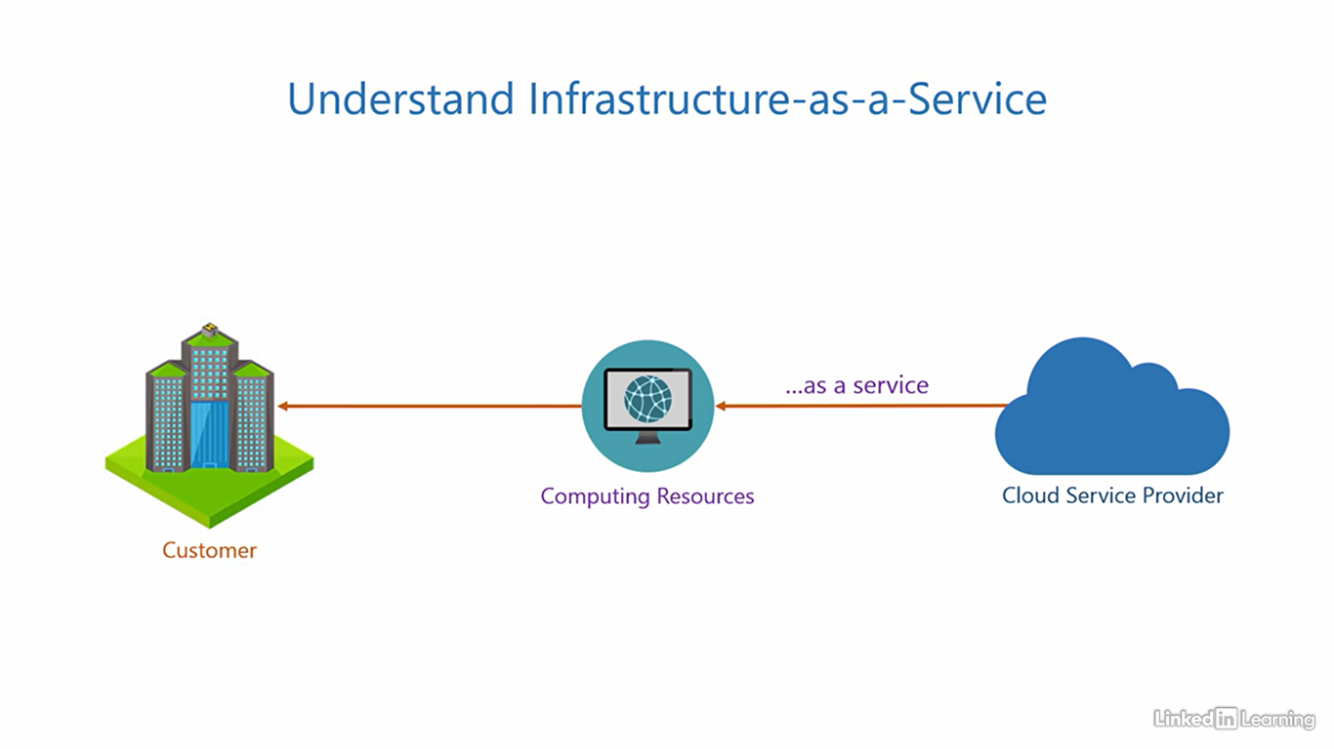

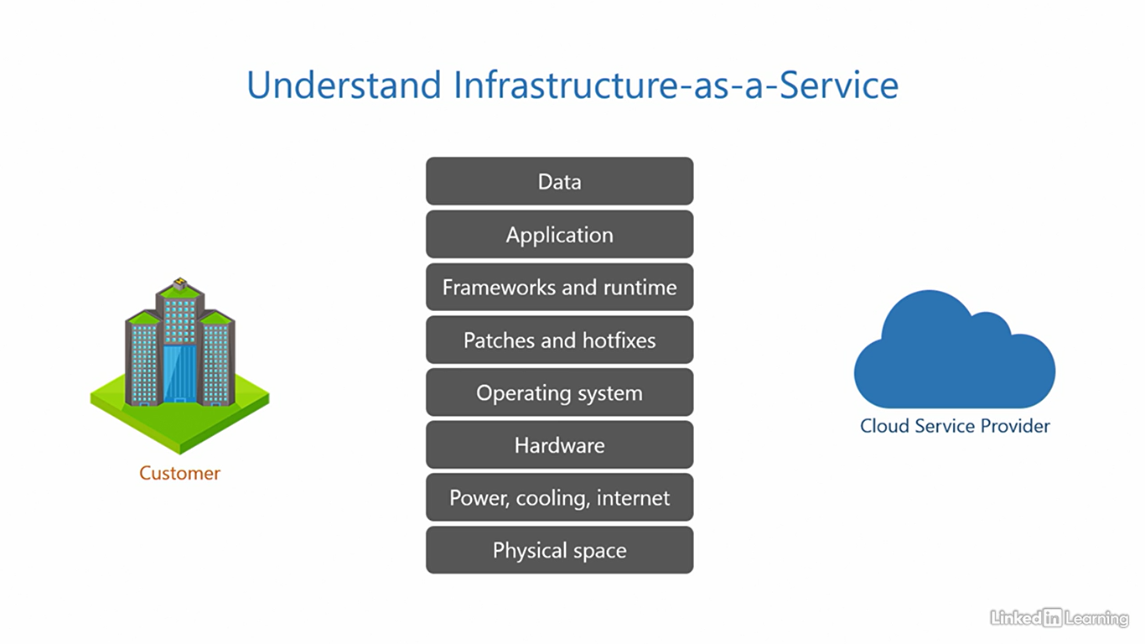

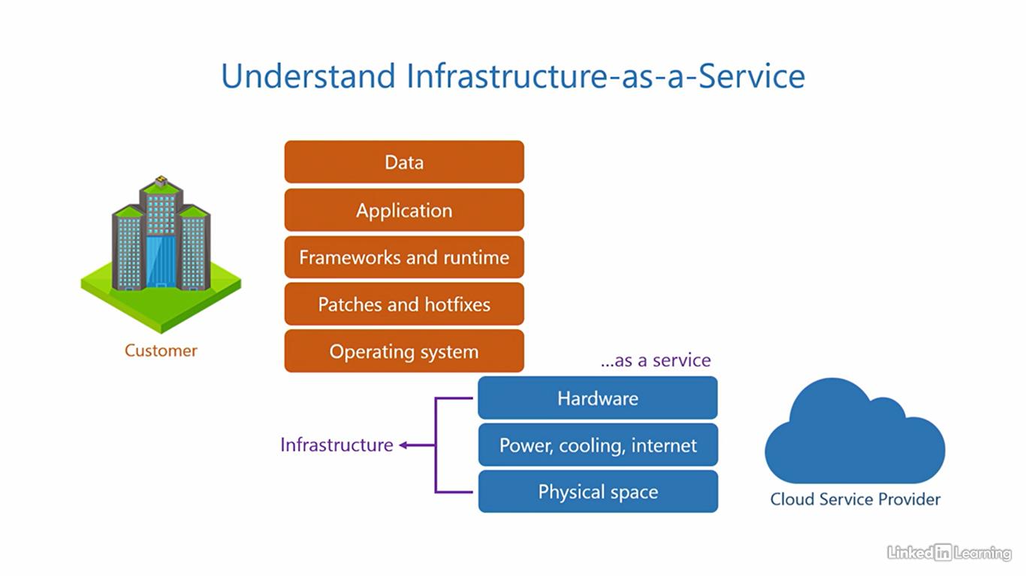

Understand platform as a service (PaaS)

[Narrator] The second service model is platform-as-a-service. In this offering, the cloud provides its customers access to application dependencies. Most significantly, the frameworks and runtime. The cloud service provider sets up the operating system, applies patches and hot fixes to keep it up to date, installs the framework and runtime, and then offers these dependencies to the customers as a service. The application and data are controlled and maintained by the customer. If there's an application developed in-house or purchased from a software vendor that needs to be run, this offering can be useful. The customer will be able to install and run almost any industry standard application using this model without having to configure the underlying dependencies. These three typically contribute to the platform components. And since the cloud service provider offers them as a service, this model is called platform-as-a-service, also abbreviated as PaaS. The advantage of this offering is that the customer can get up and running with their application quickly without having to deal with unnecessary configuration. The disadvantage is a little less control of the environment. In general, this is usually not a problem because most applications run just fine using PaaS. If you want to determine if PaaS is right for you, ask yourself, does the application support PaaS? If yes, then you should consider it. PaaS is the most popular cloud service offering out there among businesses. But if you want more control, IaaS can be a potential alternative.

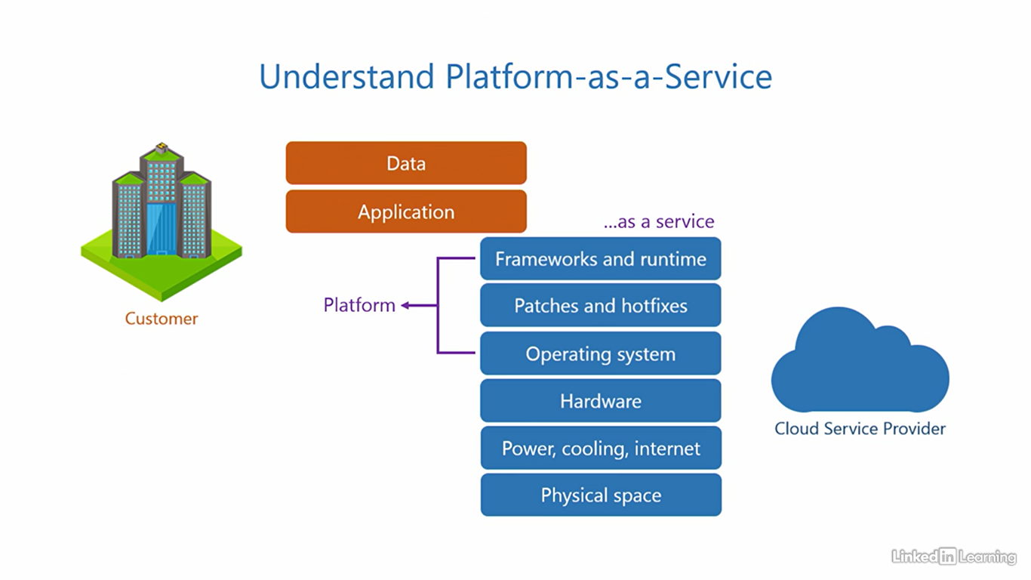

Understand software as a service (SaaS)

[Instructor] The third service model is software-as-a-service. In this offering, the cloud provides its customers with direct access to the application they need. The cloud service provider installs the application in their own environment, configures all the underlying dependencies, and offers instances of the application as a service to its customers, totally ready to use. But, there's a catch here. Cloud service providers only offer popular applications through this service model. Typically those that are high in demand and not just every application that exists out there. If an application you want is available in this model, that's good news. The data generated as a result of using the application is controlled by the customer. Simple and straightforward. Since the cloud service provider directly offers the software you need as a service, this model is called software-as-a-service, also abbreviated as S-a-a-S or SaaS. The advantage of this offering is that the configuration a customer has to make for the application is minimal to none. The application is ready to use. The customer just needs to provide its users access to it, and that is all. The disadvantage is the application a customer needs may not always be available in this offering. If you think about it, kind of makes sense. Cloud service providers want to help you but also want to make money. So they're going to spend their time and effort on popular applications that can bring in greater revenues rather than applications rarely requested by customers. If you want to determine if SaaS is right for you, ask yourself, is the application you need available as a SaaS offering? If yes, then go for it. Or else, you may want to consider PaaS or IaaS alternatives. Microsoft Azure supports all the three cloud service models we discussed, infrastructure-as-a-service, platform-as-a-service, and software-as-a-service.

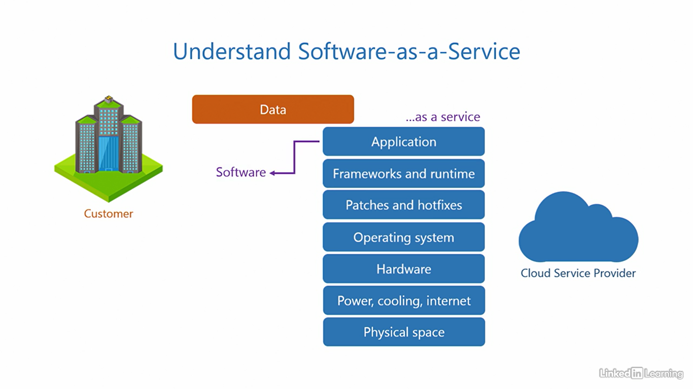

Understand the shared responsibility model

[Instructor] A cycle has two wheels and they work in tandem to give you a smooth ride. Both wheels are responsible for keeping balance and sustaining a comfortable ride. Similarly, both the customer and the cloud service provider are responsible for keeping the application running and secure. In fact, this not just applies to cloud computing but to any place where there are multiple parties and multiple things to do. All parties must have their roles and responsibilities clearly defined for efficiency and to avoid confusion. The cloud is no different. There are two parties here, the customer and the cloud service provider. And they both have a shared responsibility towards application uptime and security. The share of responsibility each of them bears varies depending on the type of service model that is if it is Infrastructure As A Service, Platform As A Service or Software As A Service, let's look at this in a little more detail. Here's the traditional IT stack and for reference and on-premises environment. We use this as a baseline to show the distribution of responsibilities in Infrastructure As A Service Platform As A Service, and Software As A Service. We know that in a on-premises environment, the customer sets up the entire stack in their own data center. They are the only party in this equation. So the responsibility of deploying, controlling and maintaining everything belongs to the customer, end to end, right from acquiring physical space to the data. They're also responsible for the security of the entire IT stack. Now let's see how infrastructure as a service differs. Here, you know the cloud offers infrastructure components as a service. This means the responsibility of these components belongs to the cloud service provider. Acquiring the physical space, redundant power, cooling, internet connections, and hardware, it is also pertinent that if any of these fail, the customer should ideally remain unaffected. So if a server burns out, a disc fails, a network cable disconnects, or anything else happens to these components, it should not impact the customer. That's why cloud service providers try to design their cloud from the ground up, keeping business continuity in mind. They are also responsible for the security of these components, the responsibility of the operating system, and above up to the data belong to the customer, applying patches and hot fixes, making sure the system is up to date, and installing the frameworks and run time. If anything goes wrong in these components and the application goes down, the customer must figure out what's wrong and how to fix it. Not the cloud service provider. The customer is also responsible for the security of these components. Moving on to Platform As A Service. As you may have guessed the load, of responsibilities here shifts a little more towards the cloud service provider. So in addition to the infrastructure, they also become responsible for the platform, including the operating system, patches and hot fixes, frameworks and run time. The cloud service providers do their best to make sure any problems with these components have a minimum impact on the application. They're also responsible for the security of these components. The customer on the other hand is responsible for the application and its data. As long as the customer does not misconfigure the application itself, everything should run smoothly. The customer is also responsible for the security of these two components. Finally, let's look at Software As A Service. In this offering, most of the responsibilities are offloaded onto the cloud service provider, including the application. They need to make sure the application is up and running for the customer no matter what. The customer here is only responsible for the data associated with the application. All service models, Software As A Service, Platform As A Service and Infrastructure As A Service involve two parties, the cloud service provider and the customer. So it's essential to understand who is accountable for which part of the stack. The shared responsibility model that is on your screen is simplified for your understanding. As we progress through the courses, you'll get a better understanding of this. If you observe carefully you'll note, the customer is always responsible for the data.

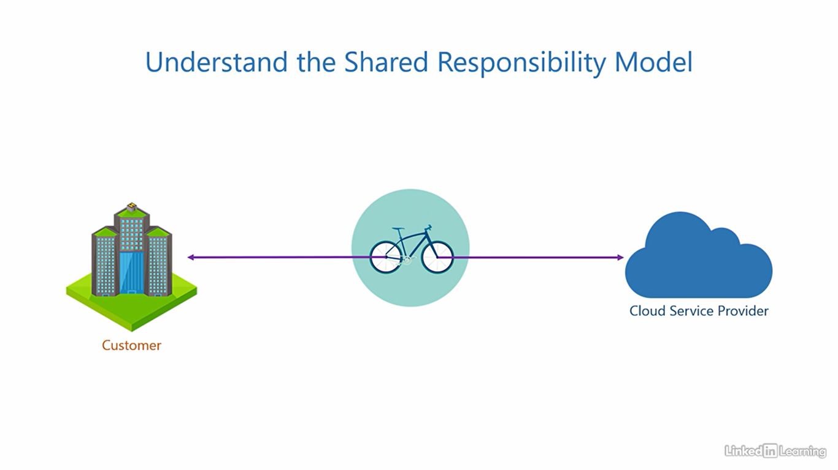 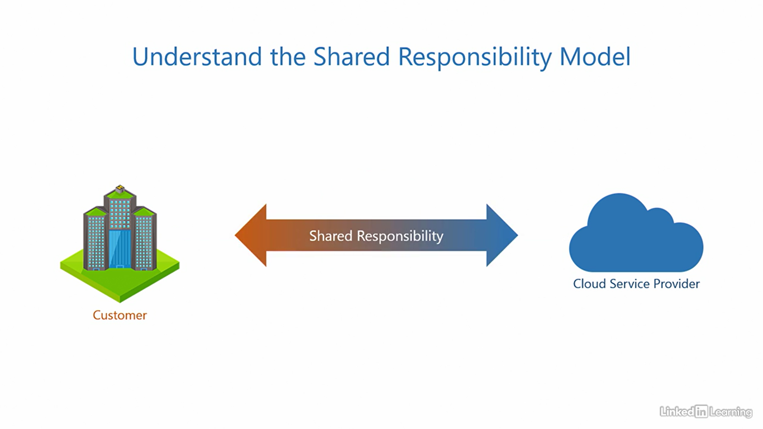

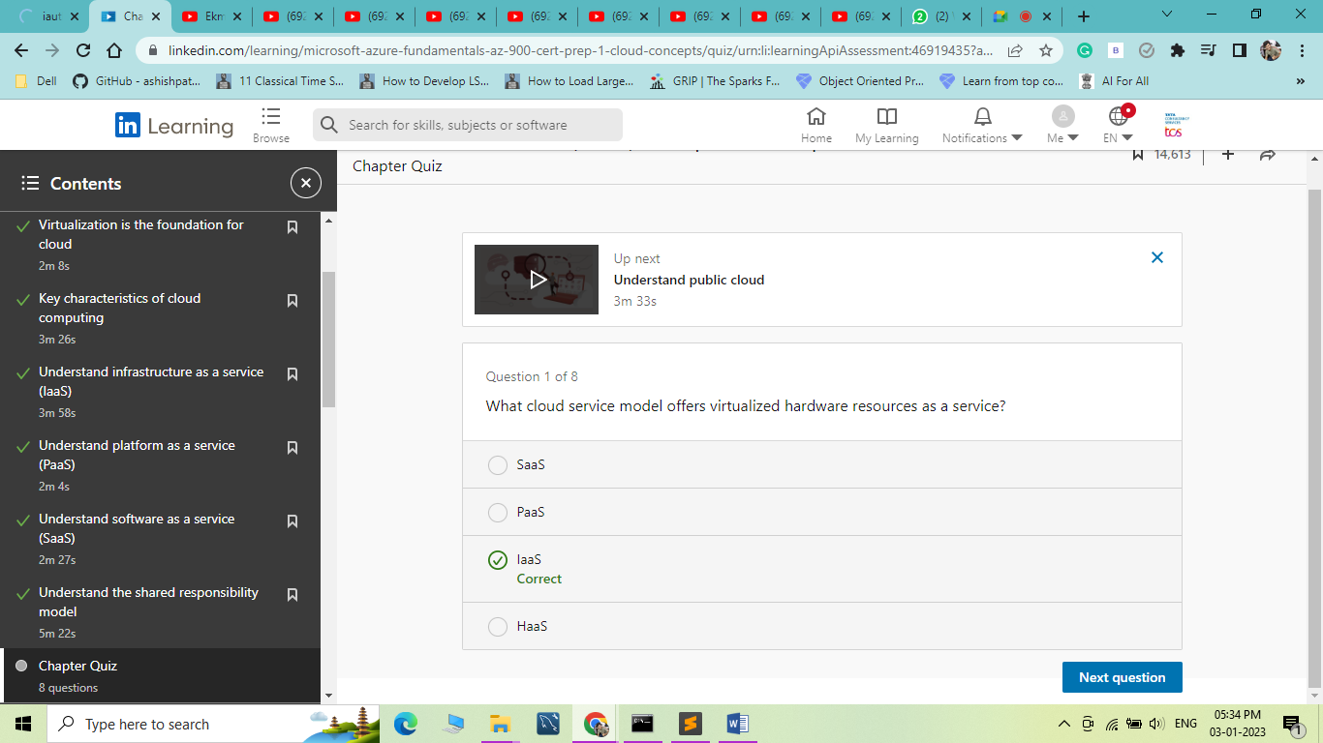

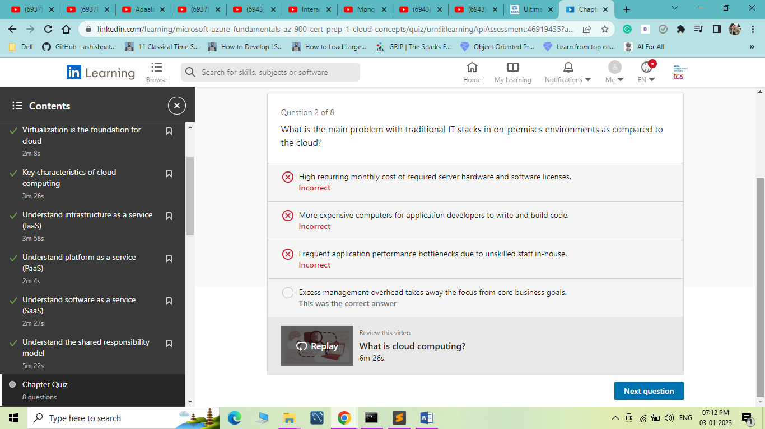

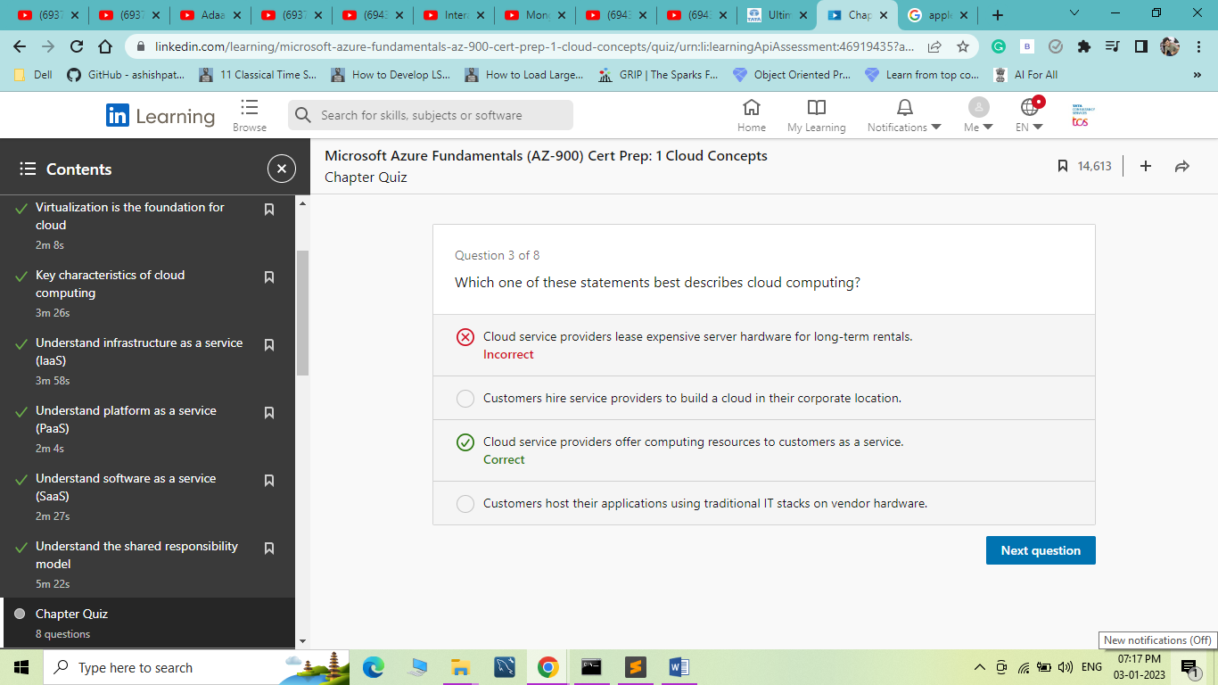

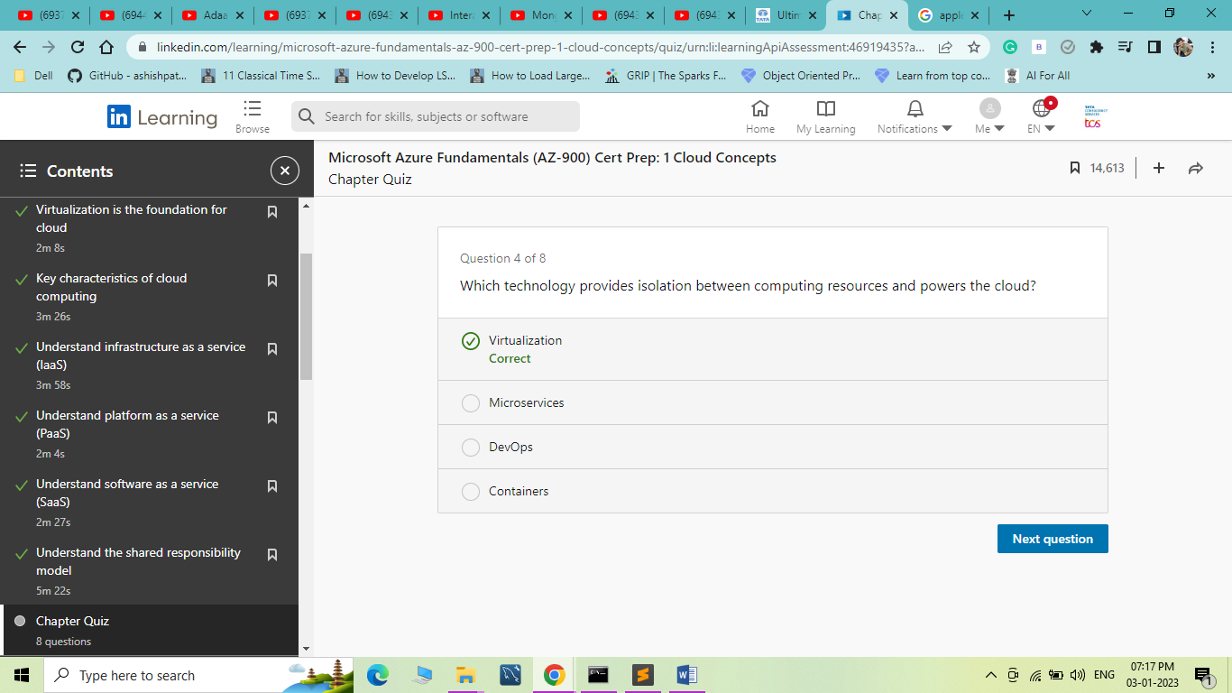

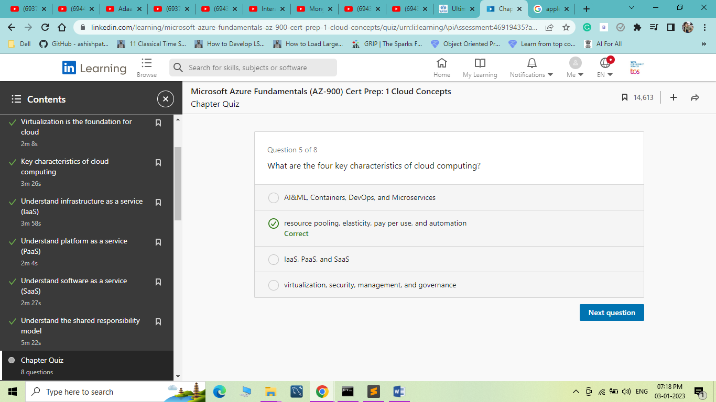

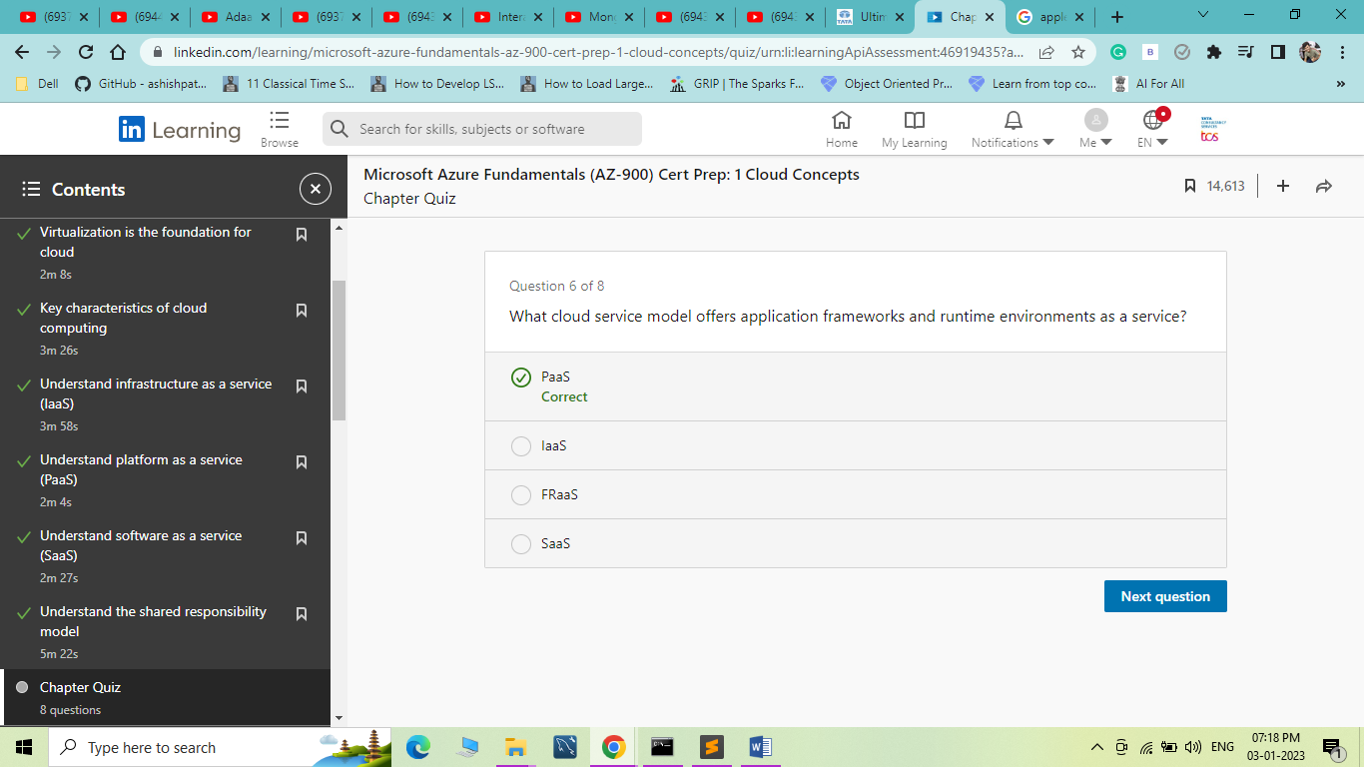

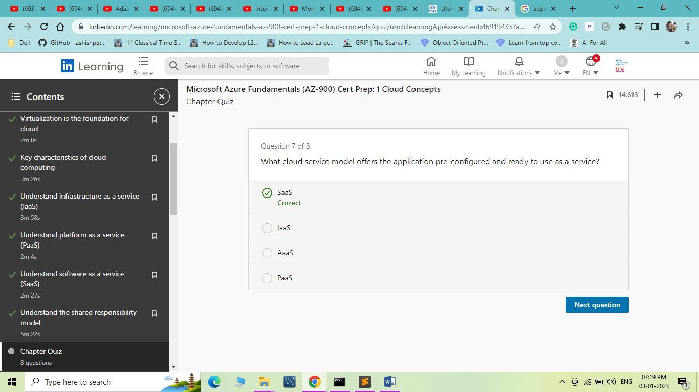

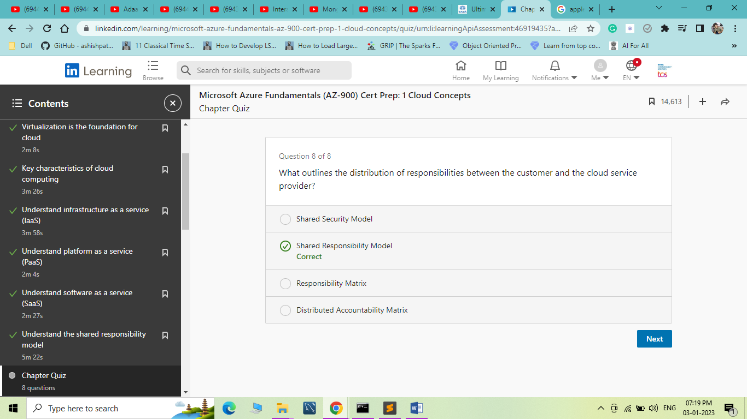

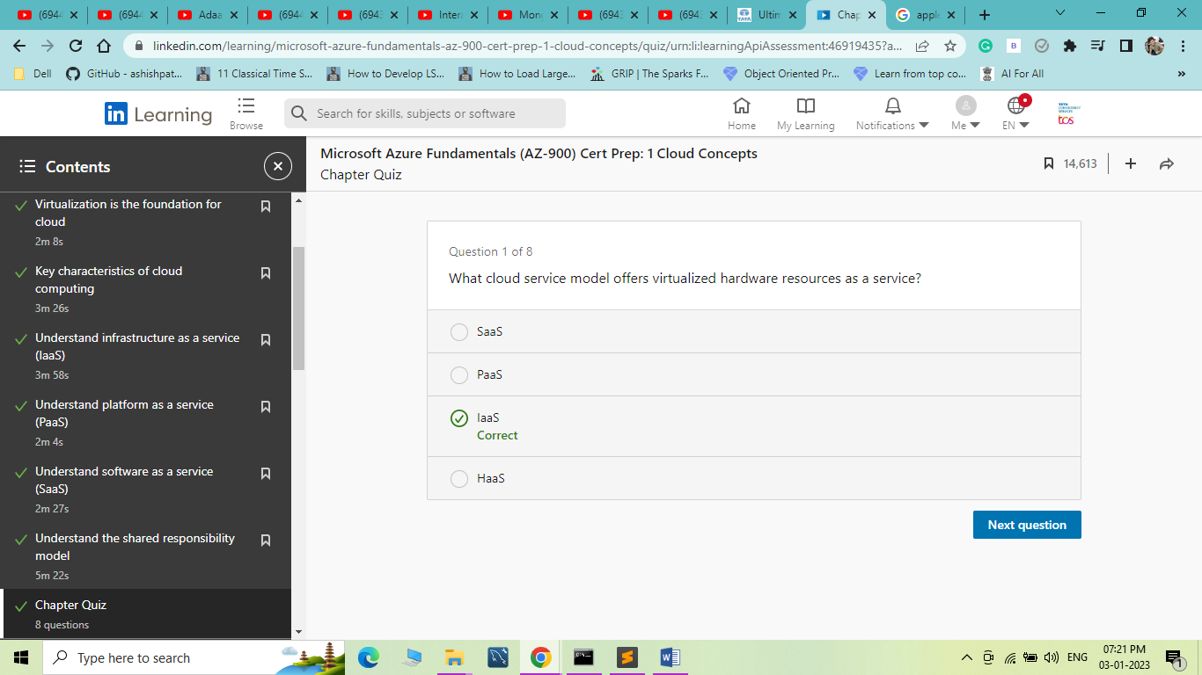

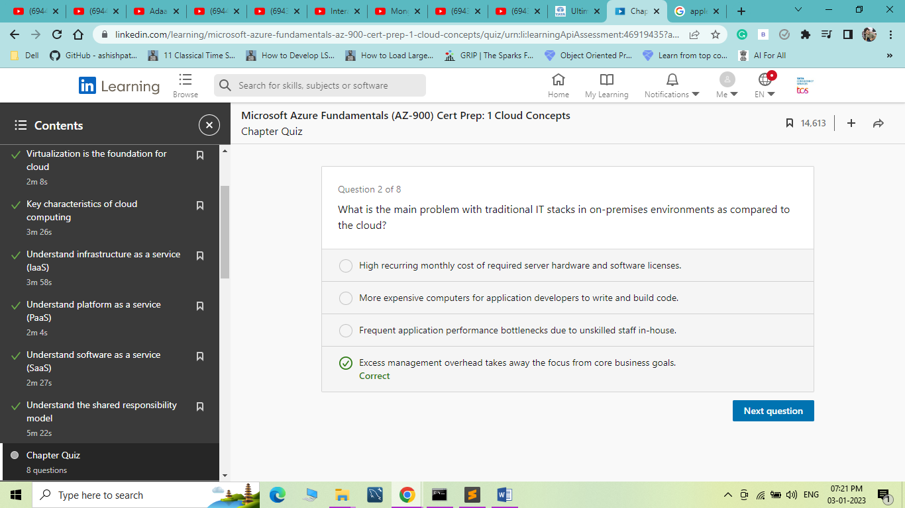

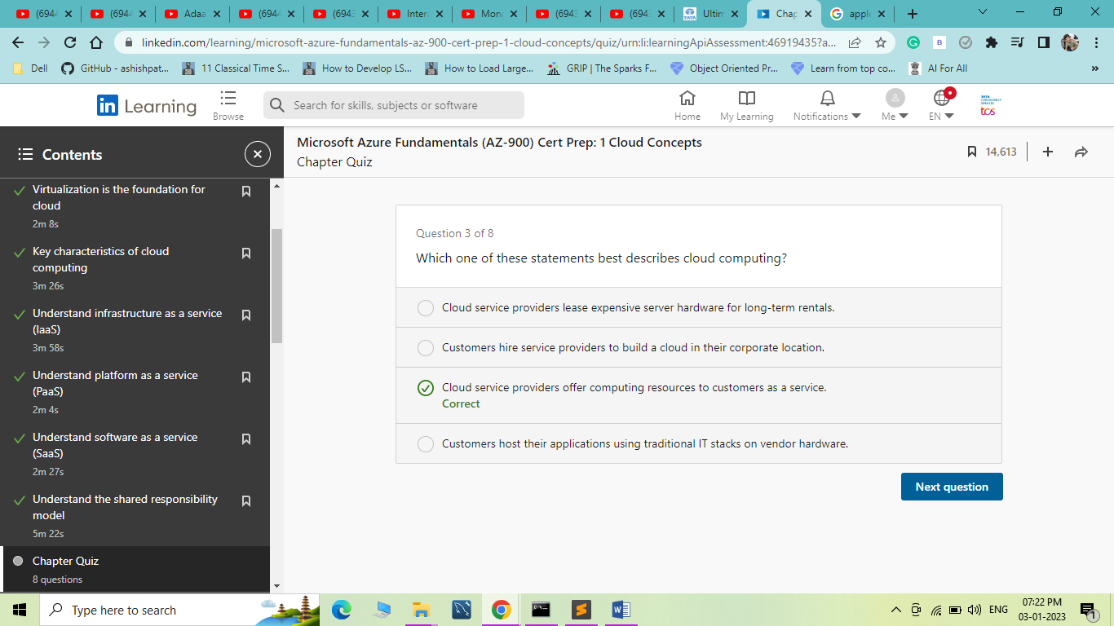

1. Understand Types of Cloud Computing

Understand public cloud

[Instructor] Welcome to the chapter, understand types of cloud computing. Here I'll explain what is a public cloud, a private cloud, a hybrid cloud, and a sovereign cloud along with the differences between them. In the last chapter you learned that a cloud provisions computing resources for a customer. A public cloud is one where it offers its services to not just one but many customer organizations, often over the public internet because it's easily accessible. The services in the cloud are open for anyone to pay for and consume with little or no restriction on who can choose to do so. Hence the term public cloud. The organizations that consume these services are called tenants because they're essentially renting out computing resources from the cloud service provider. The cloud runs instances of all services it has in its portfolio, including services from infrastructure-as-a-service, platform-as-a-service and software-as-a-service models. The tenants can pick and choose what services they want to consume and in what size. Every organization has different needs because their application requirements can widely vary. A public cloud has the power and capability to cater to organizations of all types, let it be startups or small businesses to medium or large enterprises. It's also very economical because public cloud providers run on a low cost but high volume sales strategy. The process of offering shared computing resources to multiple tenants is called multi-tenancy and therefore the public cloud is multi-tenant. I can imagine what you're probably thinking. This is a fair concern for everyone new to the public cloud, the sharing of resources. I know we teach kids that sharing is caring, but when it comes to IT, it's really not. This is where I want to remind you of the role of virtualization. You indeed share physical resources, but your virtualized resources are all dedicated to you and isolated from all other tenants. Your virtual resources and data are never shared with anyone else but you, not even the cloud service provider can read your data. At the ground level, virtualization provides secure isolation between tenant resources. On top of that, there are hundreds of other security controls designed to ensure the security of your data. It's a colossal undertaking, trying to hack into a public cloud. Public cloud providers are experts, not amateurs. They know what they're doing, but again this is subjected to the shared responsibility model. You should take your precautions and they'll take theirs. That's how it works. All the typical key characteristics we discussed in the last chapter apply to a public cloud, resource pooling, elasticity, pay per use and automation. Microsoft Azure is a public cloud.

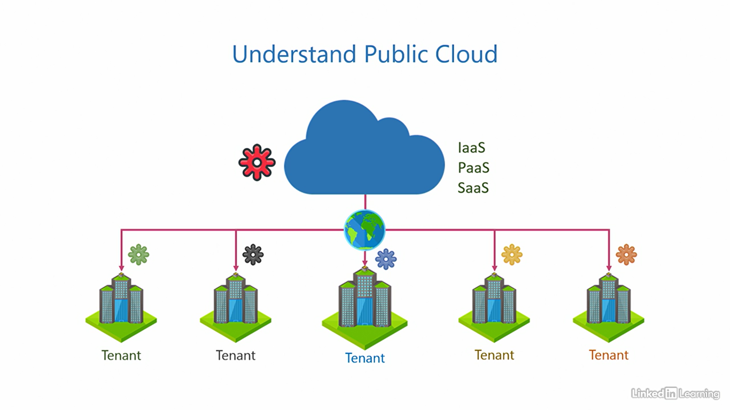

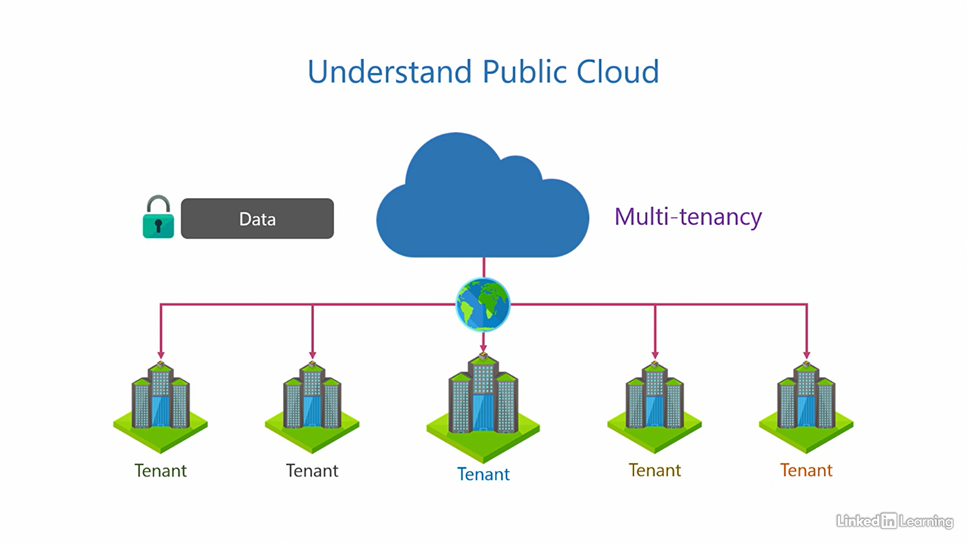

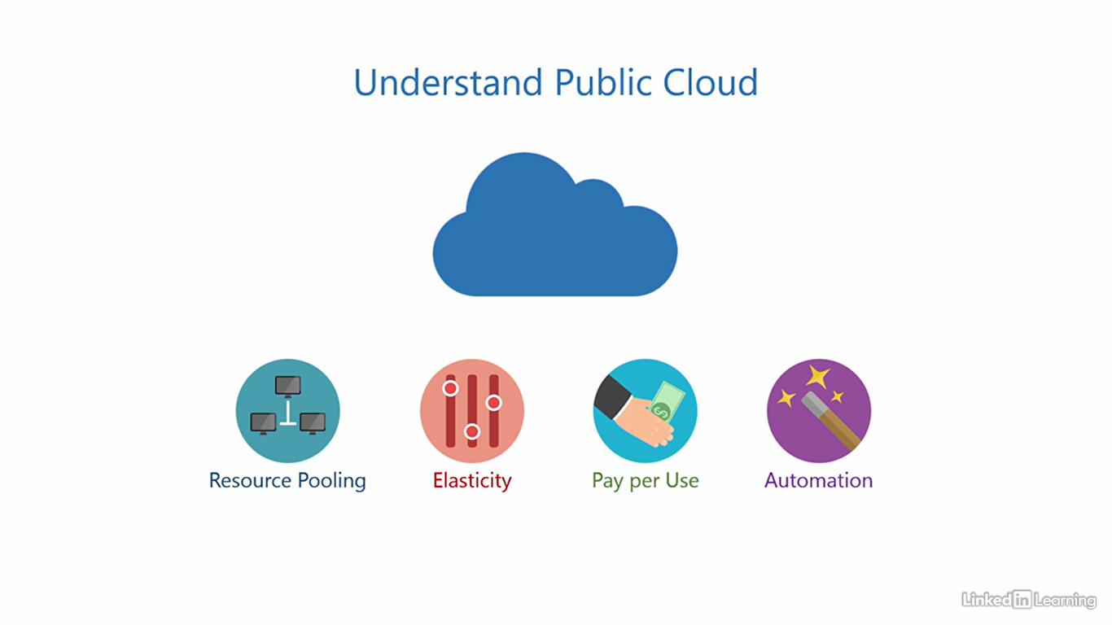

Understand private cloud

[Instructor] A public cloud, that we saw in the last video is great. It has a wide range of services, it's cheap, and available to everyone. But there can be certain situations where you may be restricted from using a public cloud. First is company policy. A company may decide, after due diligence, that the public cloud is not fit for them for various reasons. It's possible that the cloud may not be fully compliant with the requirement the company has, or does not have a service the company needs, or maybe their nearest data center could be in a foreign country the company is not comfortable with. It could also be due to national and regional laws that they're not allowed to use the public cloud. It could be a whole variety of factors. Another reason could be data security. I'm not saying the public cloud is unsafe, but not everyone is entirely comfortable with it just yet. It's also possible that your organization is working on projects where data is extremely sensitive and you want to be in full control. A lot of companies have strict rules governing where the data is stored and how it's transferred. These are the two biggest deterrents to the adoption of the cloud in the industry. So what's the solution here? What organizations can do in such situations, is build a private cloud in their own corporate location, and configure whatever services they need in this private cloud. They can also choose what service models are needed out of infrastructure as a service, platform as a service, and software as a service. Because a private cloud is dedicated to a single organization, and there are no other tenants, it is said to have single-tenancy, and therefore, a private cloud is single tenant. This ensures that organizations can comply with whatever company policy or data security requirements they have. The shared responsibility model does not apply here, because the only party here is the customer organization. They are responsible for the whole environment. I would not blame you if you're a little confused right now. A cloud is supposed to make your job easier, but what's the point if the customer has to set up the entire thing and be responsible for it. It may seem that the very purpose of the cloud is defeated here. And that's a valid question. Here's the thing, the cloud's only purpose is not to handle the part of the IT stack that you want to delegate to it, it's more than that. A cloud is about efficiency, streamlining processes, striving for operational excellence, and implementing best practices. Although a private cloud may not be easy and cheap as a public cloud, it'll sure be a lot more optimized over a traditional on premises IT stack. And how are these optimizations achieved? Back to the basics, through adherence to company policies, data security requirements, resource pooling, and automation. The other two characteristics change in a private cloud as compared to a public cloud. One, there's limited elasticity. I mean, a private cloud is elastic but not to the extent of a public cloud, because no organization can really match the capacity of resources available in the public cloud. The second is cost. A private cloud is not cheap. It's usually more expensive to set up than a traditional on premises IT stack. And there's no pay per use, pay per use instead becomes measure per use. You can use metrics in a private cloud to get insights into how resources are being used internally across departments. It's mostly medium or large enterprises that opt for a private cloud, not startups, or small businesses, because the technical complexity, cost, and effort involved here are significant. If an organization wants a private cloud but does not have the expertise to build it in-house, there are vendors out there who can set it up for them and then hand it over. **Microsoft's private cloud solution is called Azure Stack**, it's not covered in the scope of AZ900.

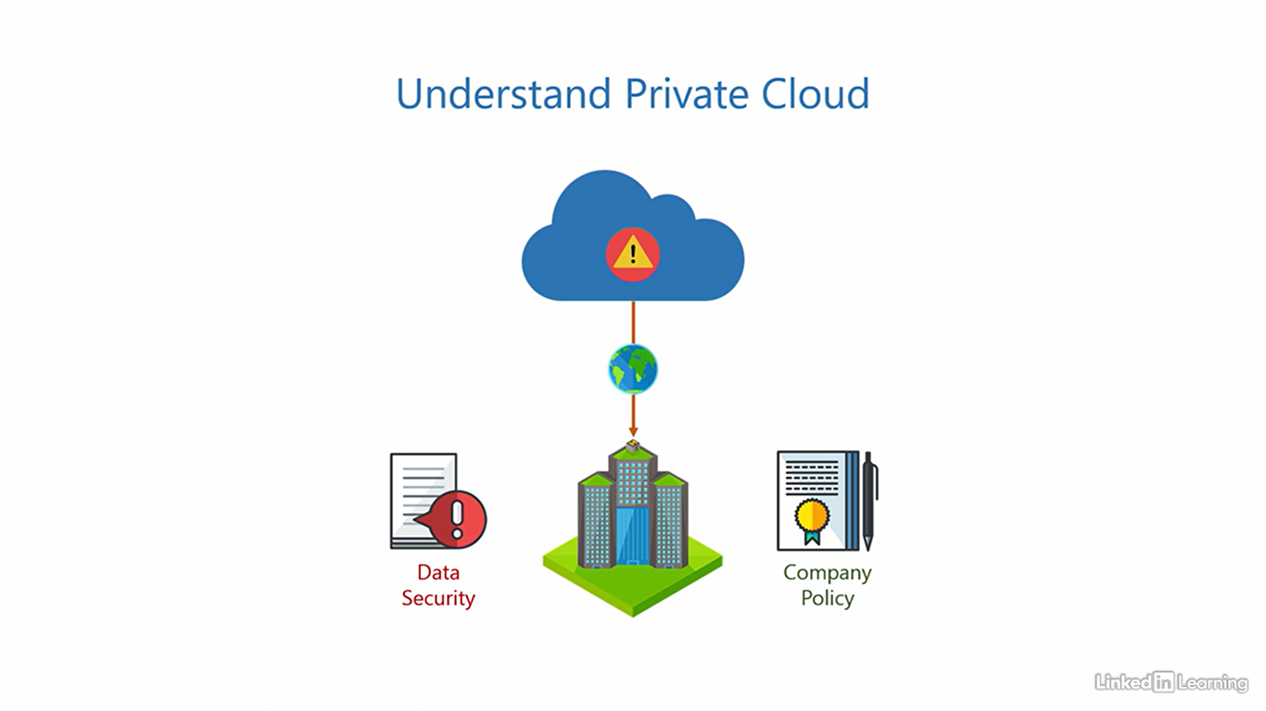

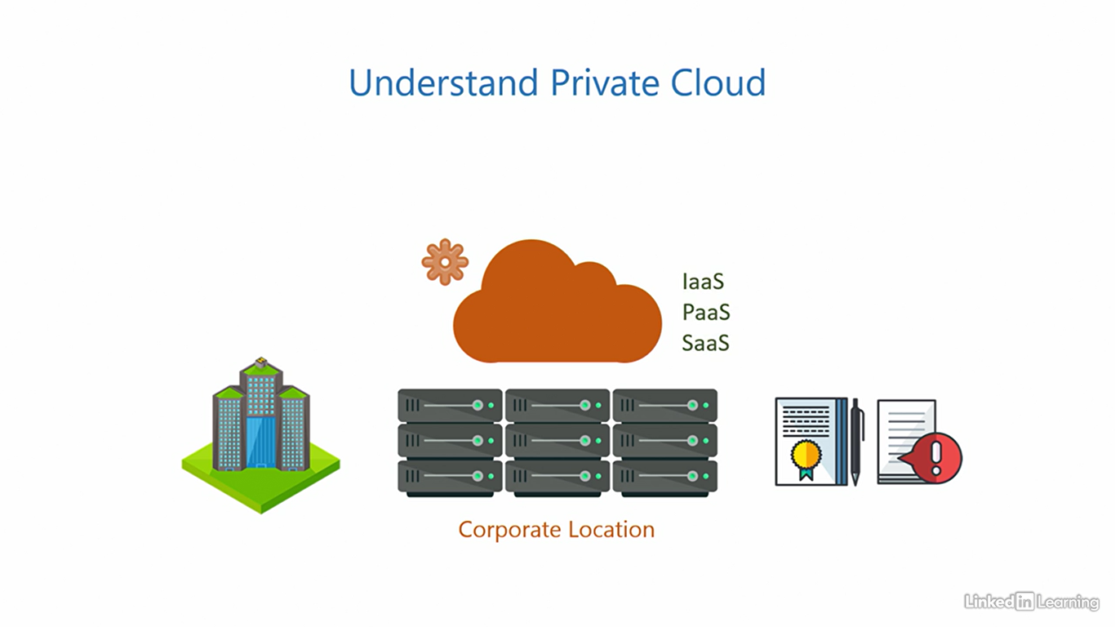

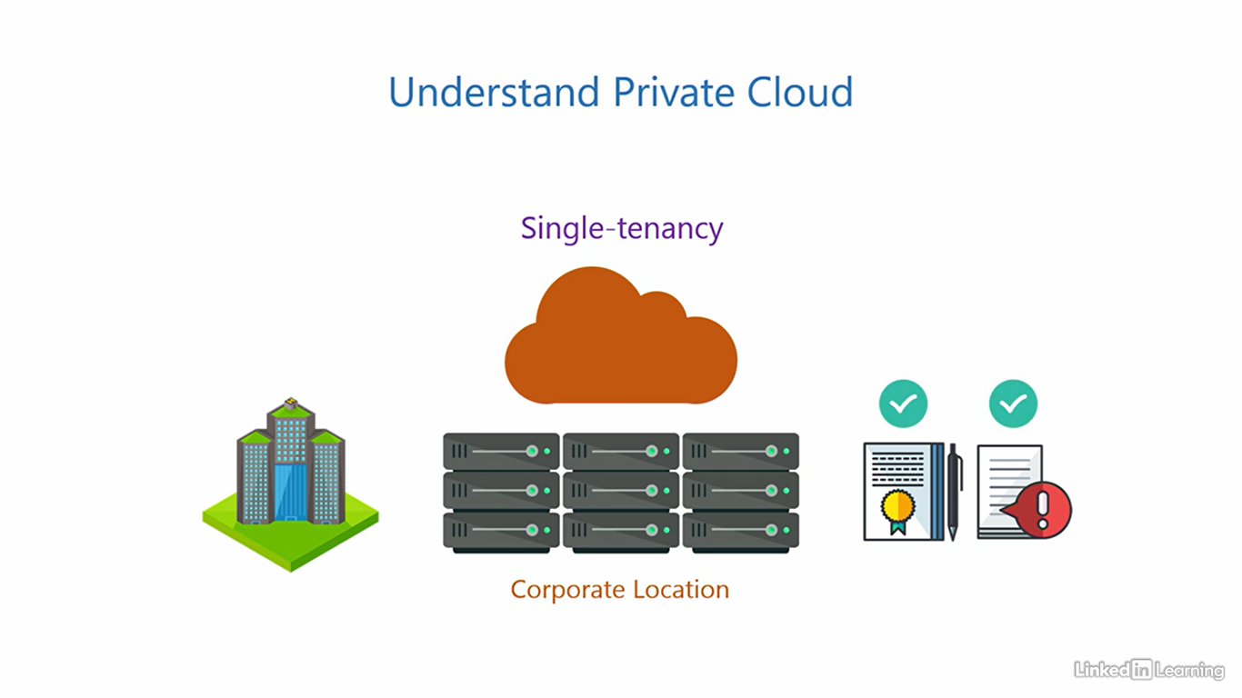

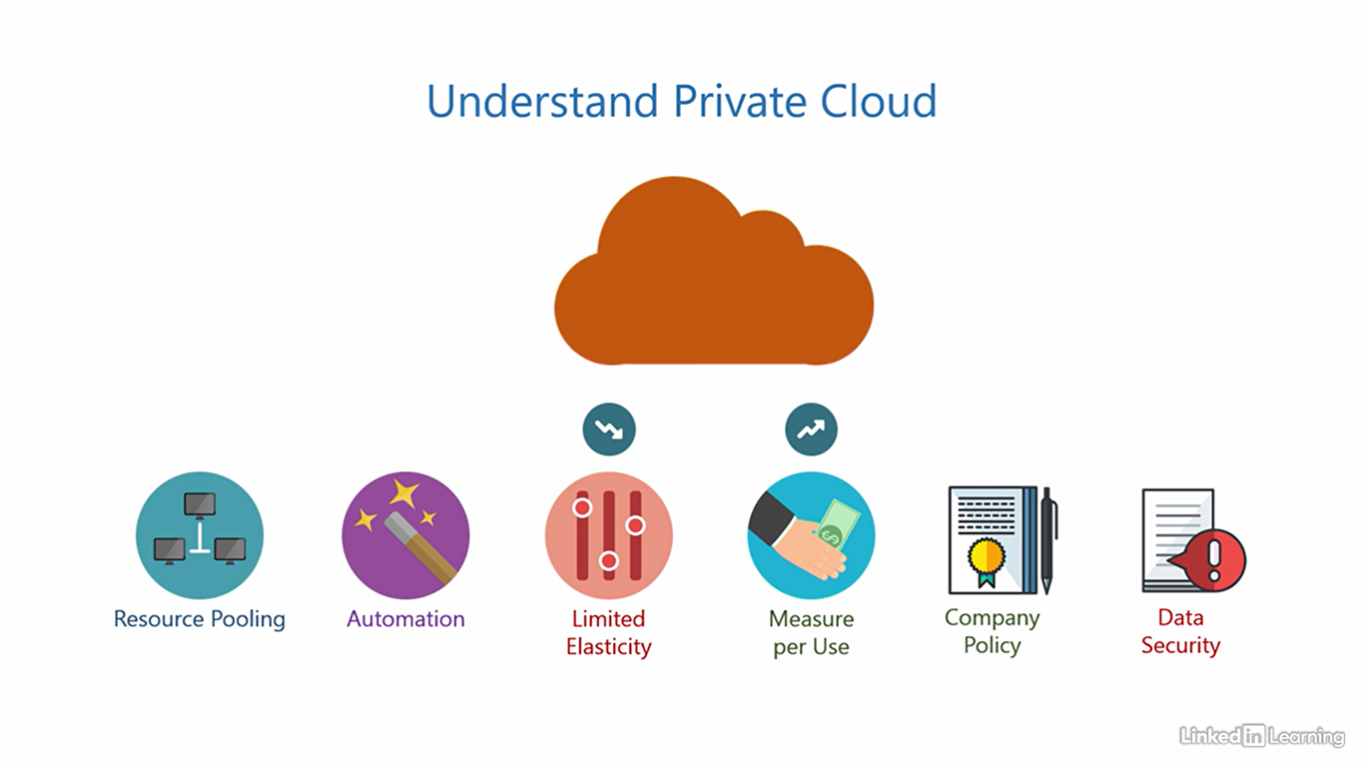

Understand hybrid cloud

[Instructor] You've seen two types of clouds so far. There's a third type of cloud that combines the best of both worlds. And that is a hybrid cloud. Organizations can use a combination of both public and private clouds to distribute workloads across them, often connected through the public internet. The services distributed can be of any type, infrastructure as a service, platform as a service, and software as a service. It is possible for a startup or a small business to run purely off of a public cloud because it's simple and economical. But when it comes to medium or large enterprises, it's rare for them to purely run on just public or private cloud because of their complex needs. It's more common for them to use both in conjunction to realize business goals. Conservative organizations could be more focused on private than public. And modern, ready to embrace the cloud type of organizations can be more public heavy. The exact proportion will depend on how comfortable an organization is with the public cloud. Whatever the proportion may be, it is definite that this unlocks a whole new level of flexibility. The private cloud allows organizations to satisfy company policies and data security for projects that requires stringent control. And other projects within the organization that are not so stringent can leverage the public cloud. That adds up the key characteristics of the public cloud to the equation. So in addition, you also get resource-pulling, elasticity, paper use, and automation. A hybrid cloud also enables a very interesting implementation. Organizations can use their private cloud as a primary environment, and the public cloud as secondary. Let me explain. Let's assume users are requesting resources from the organization. As long as the private cloud has the capacity to support those requests, it serves them and churns out resources. But once the demand for resources in the private cloud comes close to maximum capacity, a cloud burst occurs. All subsequent requests from users are seamlessly redirected to the public cloud for fulfillment. This burst is transparent to end users. They don't have to do anything extra to make this happen. In fact, there's a good chance they won't even realize a burst has occurred. Once resources in the private cloud free up, it can resume serving new requests. The existing resources in the public cloud continue to run there until the users release them. So in essence, in this implementation, the public cloud acts as an extension of your private cloud. Once the private cloud can no longer handle the workload, new requests coming in burst into the public cloud, keeping the business up and running without hiccups. These are the things that will make you fall in love With cloud computing. You can build a hybrid cloud using the public cloud Azure, and the private cloud on Azure stack.

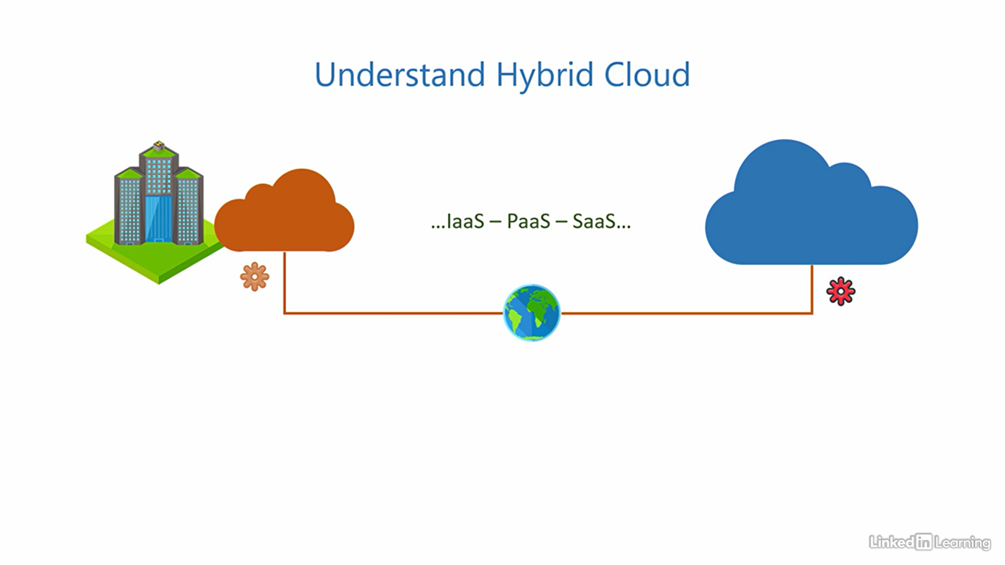

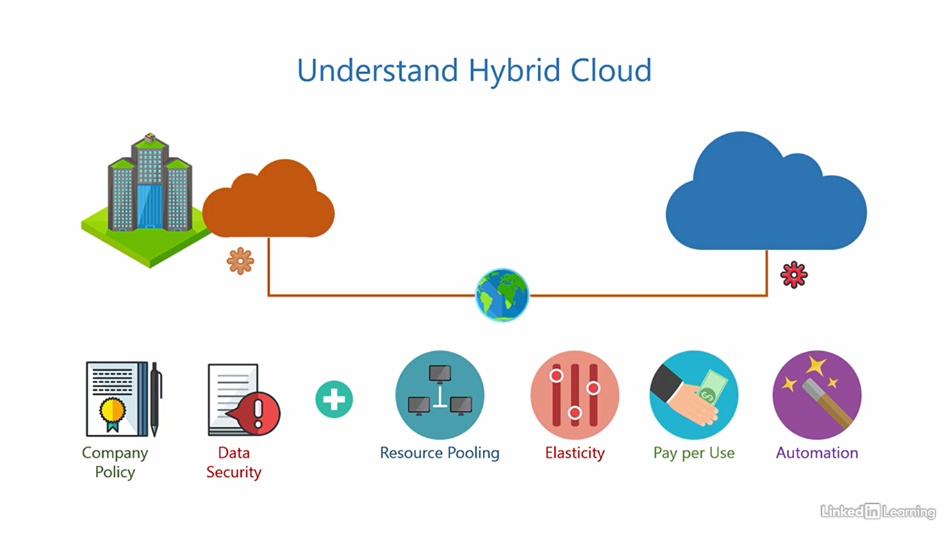

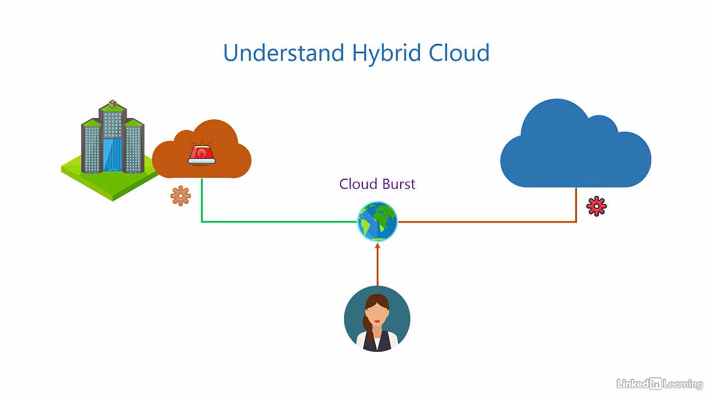

Understand sovereign clouds

[Instructor] There's a fourth special type of cloud called a sovereign cloud. This is reserved for use by national governments to process and store sensitive information pertaining to their country. This includes, but is not limited to, government agencies, armed forces, law enforcement, or any other government organization that processes any information of national interest that needs protection. In an international political conflict, the government is always a primary target of adversaries. Bad foreign actors will either try to steal confidential information, disable functioning of the government, disrupt services, or cause chaos among the citizens. Any of these events can lead to panic, crash the stock market, and cause huge financial losses to a country. The stakes are really, really high, and that's why we have sovereign clouds. These are like isolated, private clouds, but the scale at which they operate, or the capacity they have, compares to that of a public cloud. The government and the cloud service provider outline the terms of such an arrangement. Things like location of the data centers, will it be accessible over the internet or a dedicated network, expected usage, pricing, and any national regulations the cloud needs to comply with. It's all negotiated between the government and the cloud service provider. There are three sovereign clouds active right now. First is Azure US Government Cloud. Microsoft operates this cloud in the US for the US Government as the name suggests. The name has Azure in it, but it is completely isolated from the Azure public cloud. Apart from complying with the data processing and storing regulations, this cloud also requires all personnel involved in the process of running it to be US citizens, and they're only hired after a thorough background check. Only government organizations in the US are allowed to use the Azure US Government Cloud. Second is Azure China. Microsoft has deployed this cloud in China, and the Chinese company, Vianet 21, operates it. Azure China is open to the Chinese Government, as well as organizations that have a business presence in China. Organizations that do not have a presence in the country, are not allowed to use it. Third is Azure Australia Regions. Here, the Australian Government has reserved two regions in Azure for their dedicated use. So two regions are for the government only, and the other regions are open to public. It's all operated by Microsoft. There was a fourth sovereign cloud called Azure Germany, but it is now deprecated in favor of the Azure public cloud in Germany. So yes, sovereign clouds are not something we can get access to unless you are a government employee authorized to do so. But it's good to know what a wide spectrum of demands cloud computing solutions can stand up to.

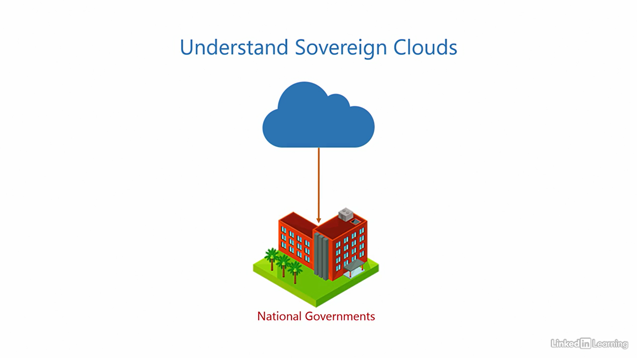

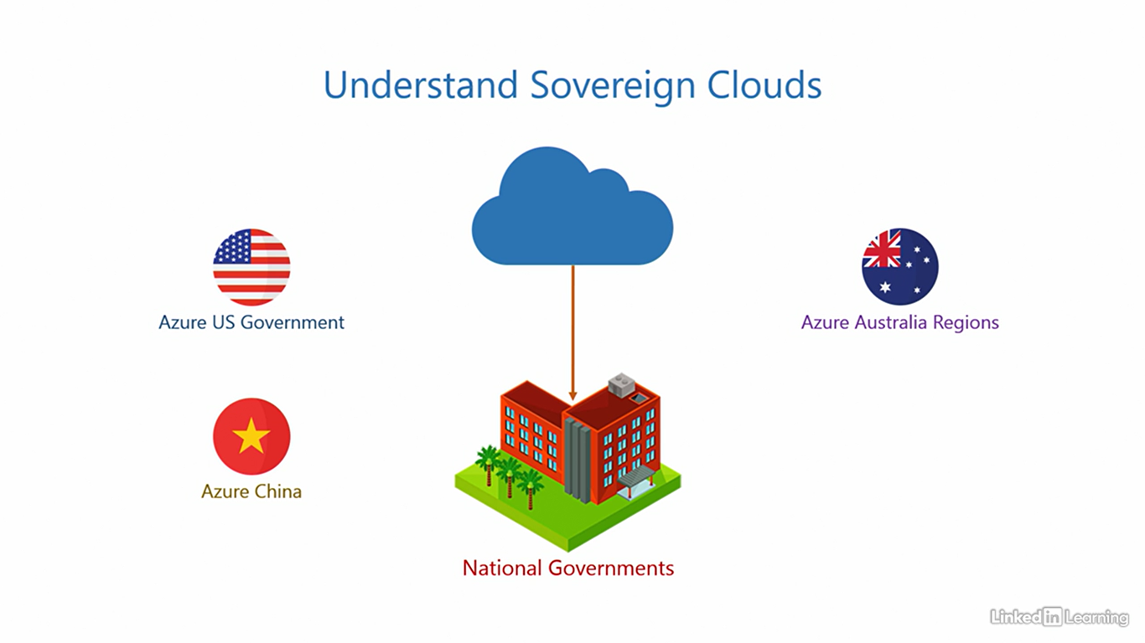

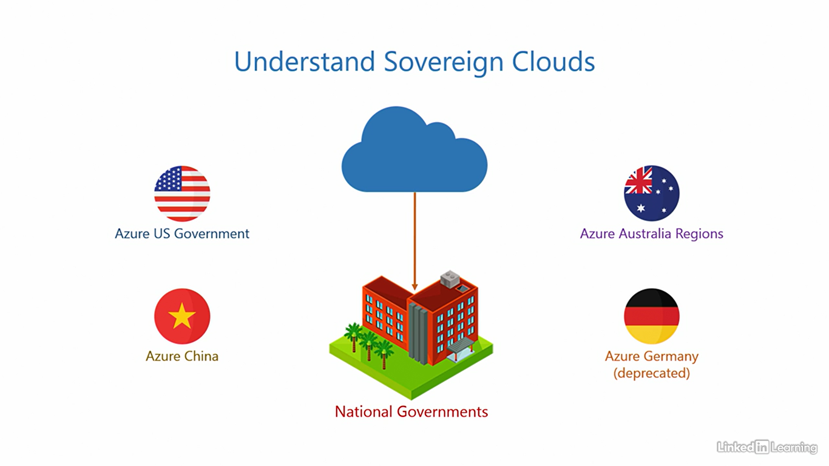

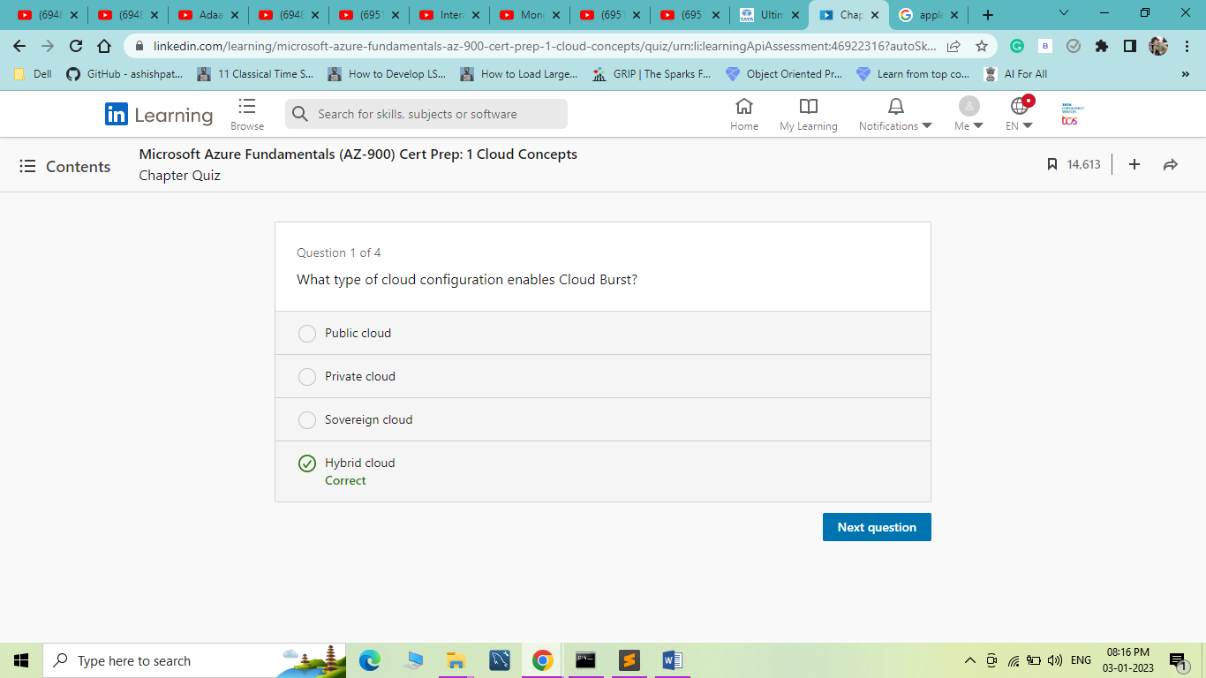

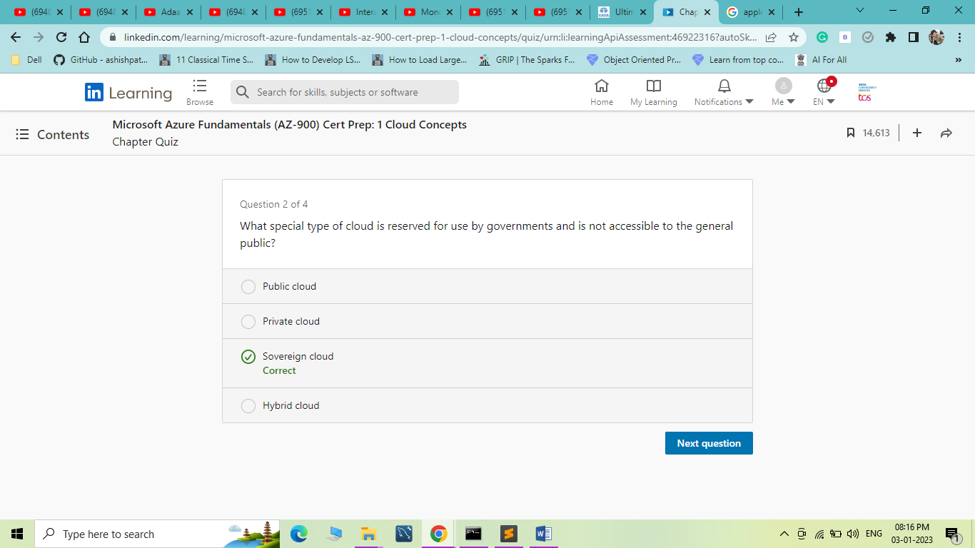

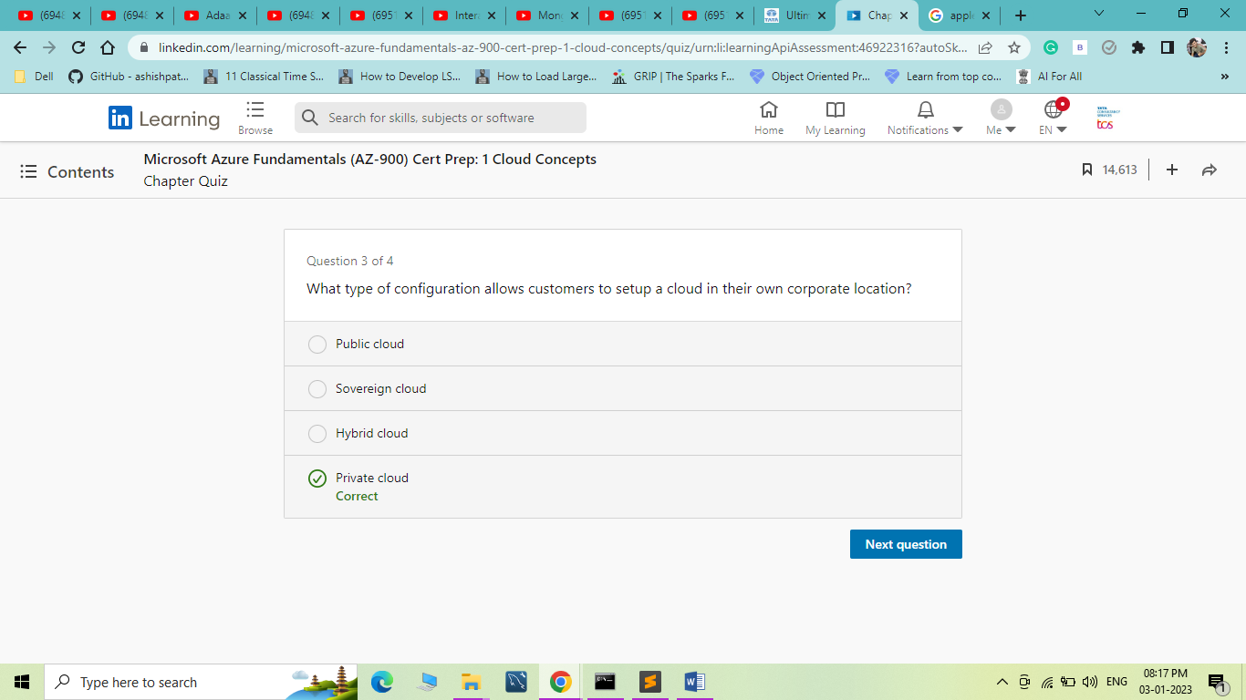

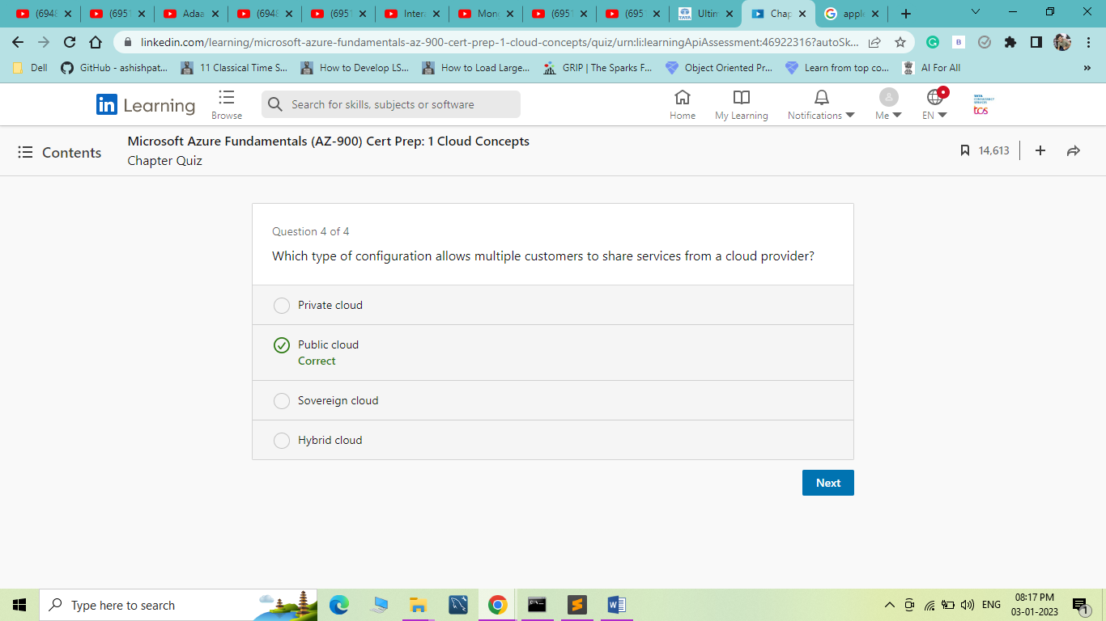

1. Understand the Benefits of Cloud Computing

Understand elasticity

[Instructor] Welcome to the chapter, "Understand the Benefits of Cloud Computing." Here, I'll explain the core benefits of the cloud, like elasticity, scalability, high availability, and fall tolerance. We'll also discuss what we expect from a cloud in terms of security, manageability, and governance. I briefly mentioned the term elasticity in previous videos. Let me put that into context and give you a comprehensive understanding of what it means. Here's our IT stack. To explain elasticity, I'll deconstruct it and only keep the parts of the stack that are relevant. You already know the physical components are called the infrastructure. So for simplicity, I'll represent these three as infrastructure. We'll get rid of things we don't need right now and keep the one we need, the application. So in the simplest of words, we can say, an application needs an underlying infrastructure to run. The infrastructure consists of pools of processor, memory, and storage. When a user provisions this application, a virtualized set of resources is assigned to the application for it to function. If the load on the application increases, it may request more resources from the infrastructure pool to keep up with the demand. The infrastructure pool should be able to do this, that is, provide extra resources when needed. This allows the application to run without disruption despite the excess load. It's like stretching a rubber band to expand it. After some time, if the load on the application decreases and it no longer needs those extra resources, it should be released back into the infrastructure pool, just like a rubber band goes back into its original shape after you let it go. When the application is deprovisioned, the infrastructure pool should reclaim all resources. If the infrastructure pool is able to do these things, that is, assigned resources to an application, provide extra resources when an application requests it, and reclaim it when the application does not need it anymore. If the infrastructure can do this, it is set to be elastic. A cloud should always have an elastic infrastructure. And, therefore, elasticity is a core benefit of the cloud. The cloud service provider is responsible for ensuring elasticity in all three service models, infrastructure as a service, platform as a service, and software as a service. Remember, elasticity is an attribute of the infrastructure. Microsoft Azure also provides elasticity for applications running on it.

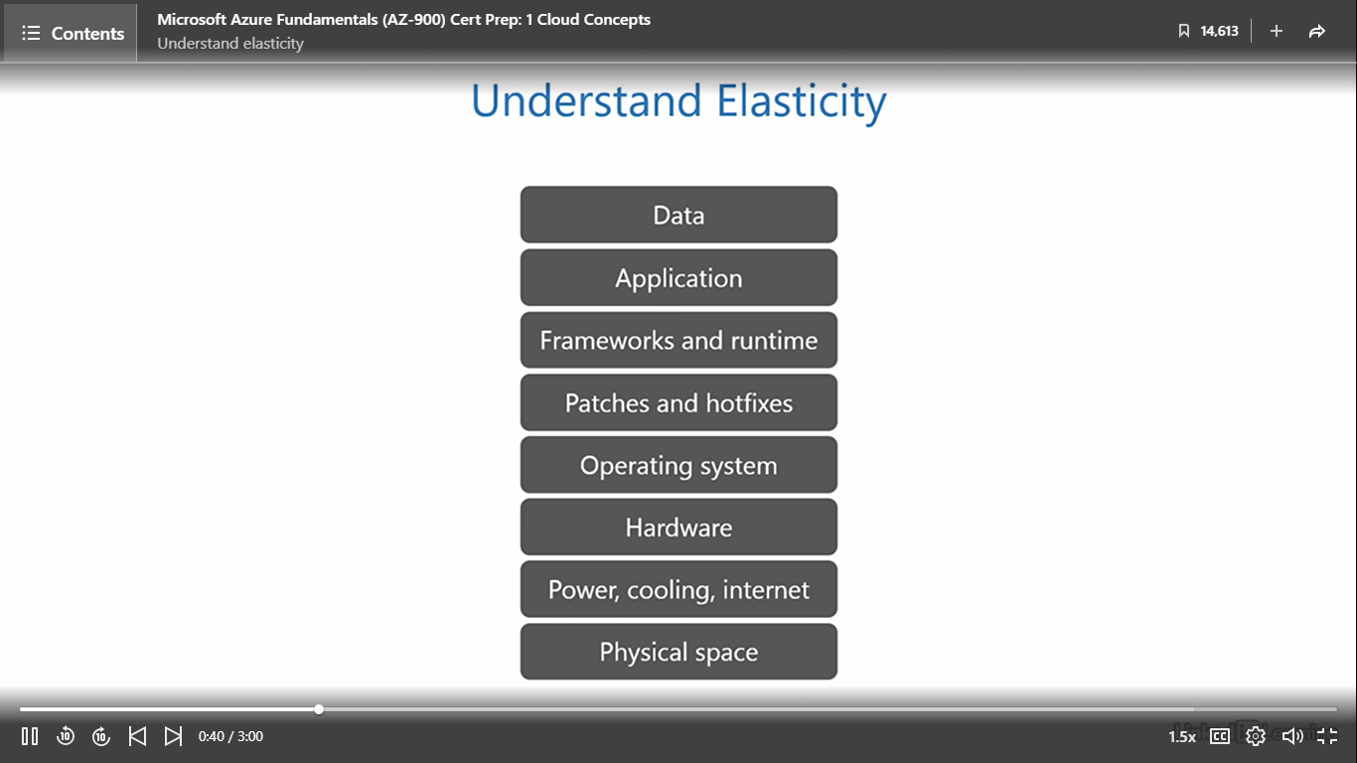

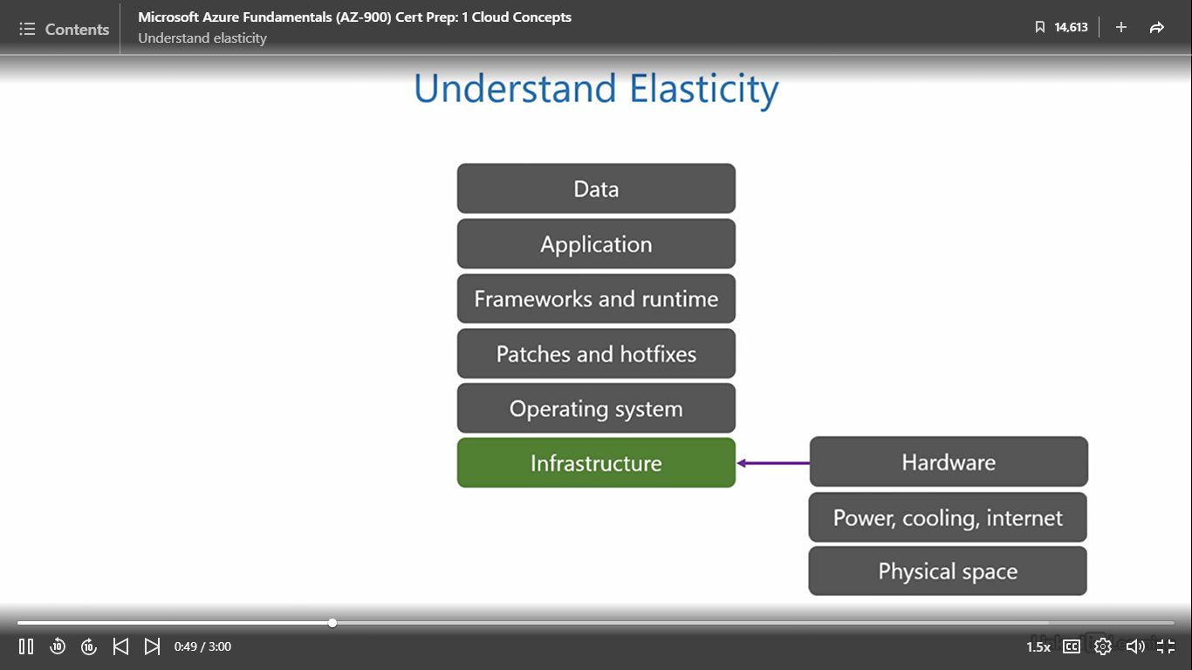

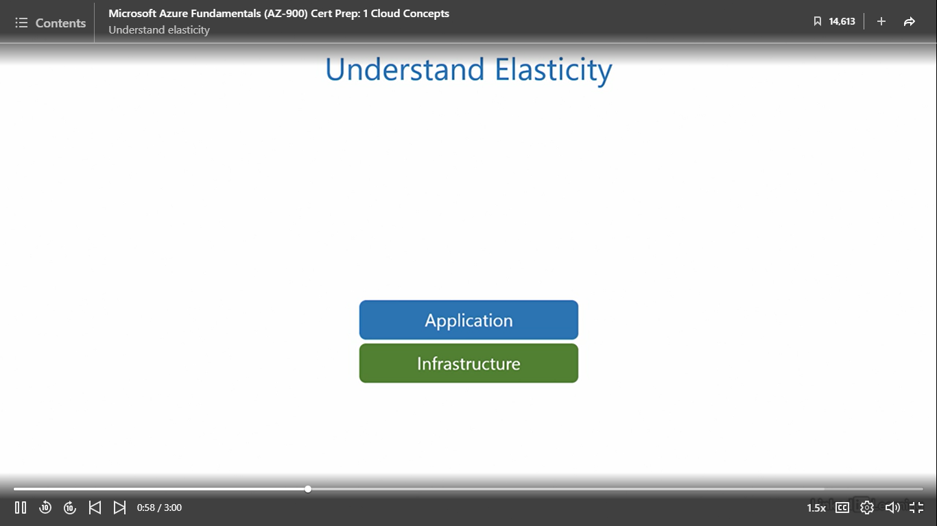

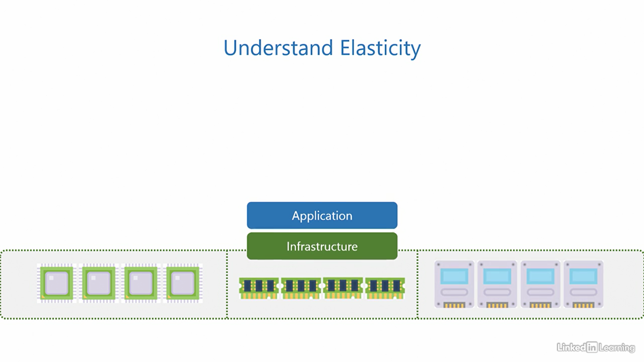 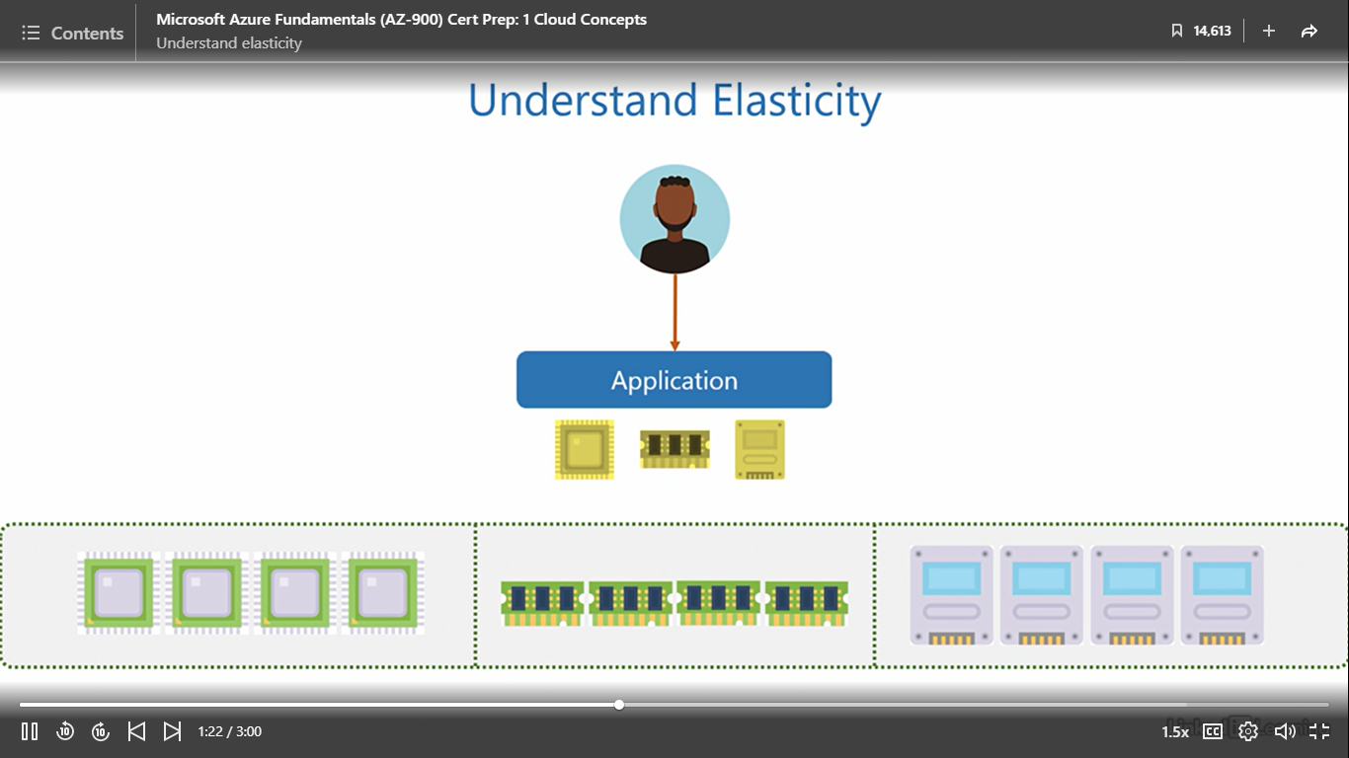

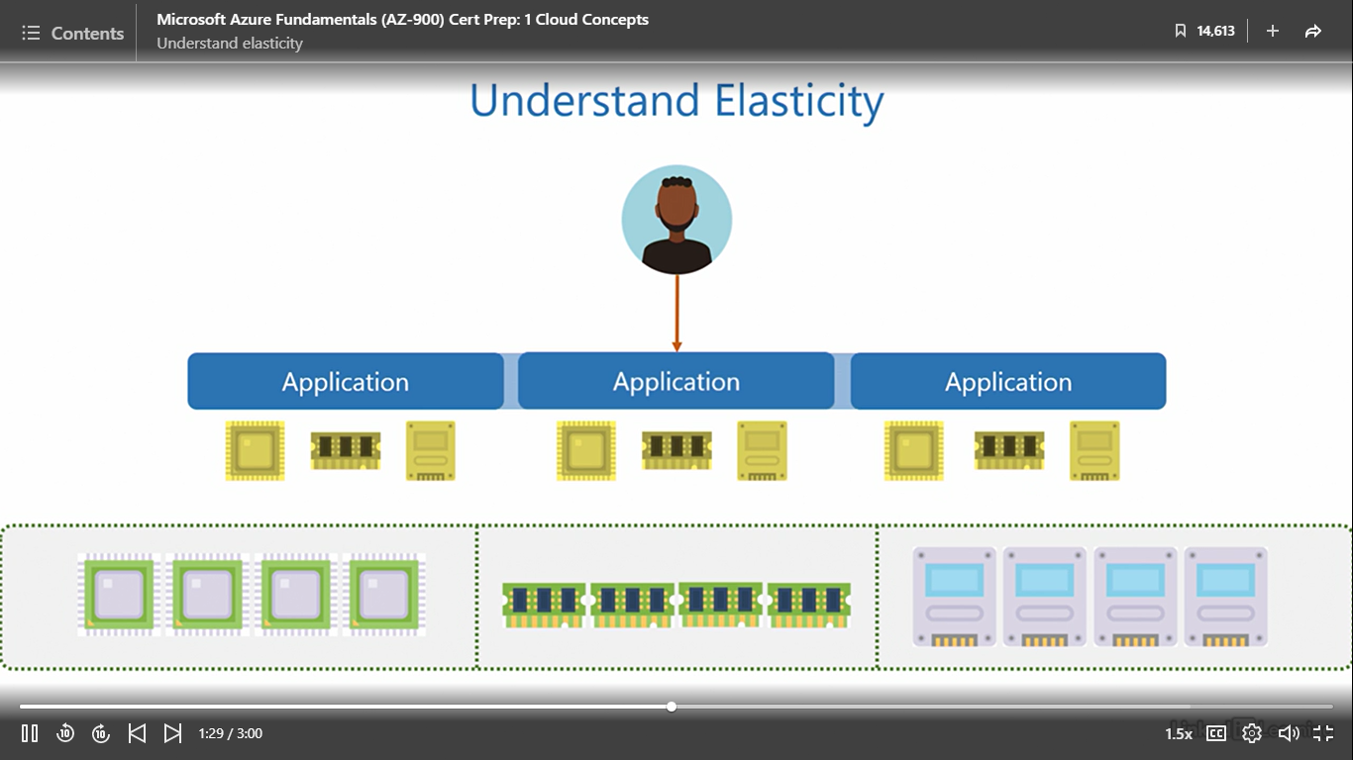

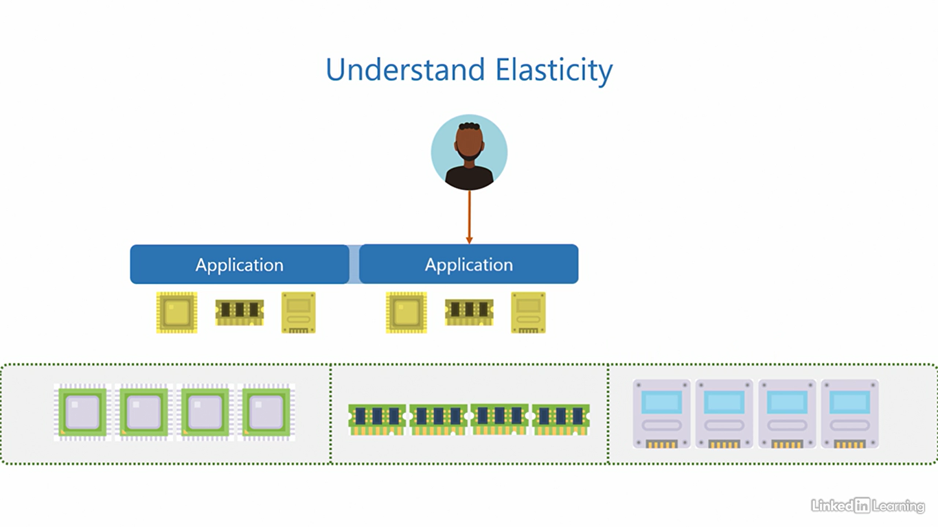

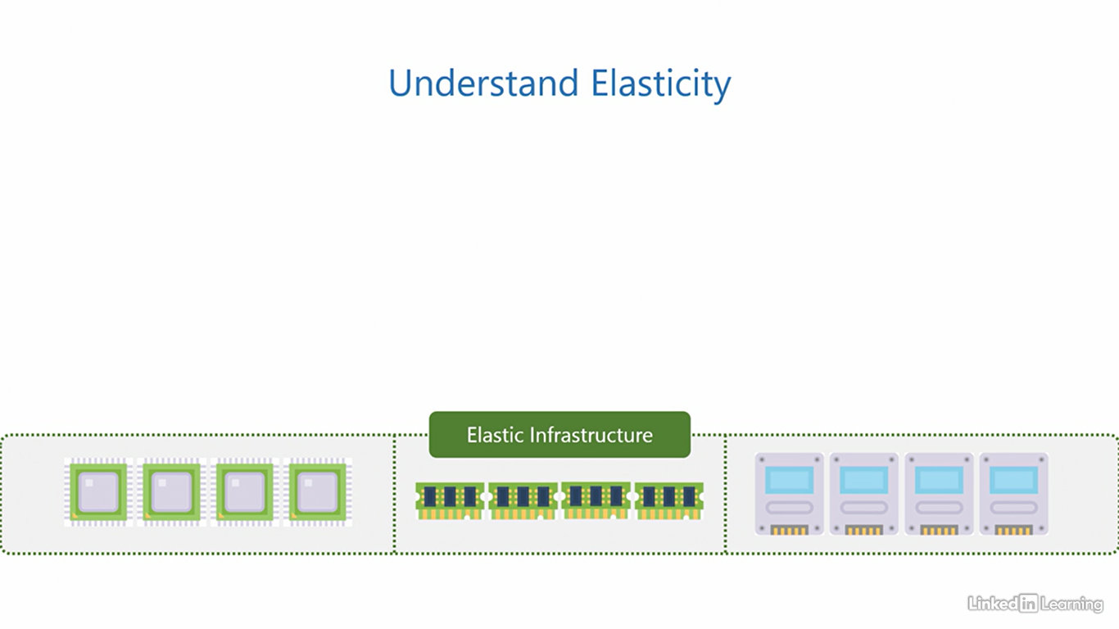

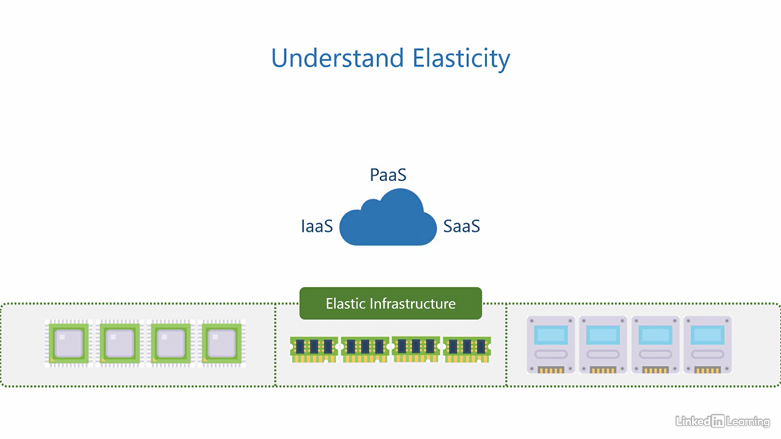

Understand scalability

[Instructor] To understand scalability, let's assume we have an application running on an elastic infrastructure. You already know how an elastic infrastructure responds to an increase in load. Now, let's shift our focus to see how an application behaves during the same circumstances. When a user provisions an application, the elastic infrastructure assigns sufficient resources for it to run. If the load on the application increases, it can react in one of two ways. Let's see what happens in the first case. To keep up with the increase in load, the application can increase the size of its instance and demand a bigger set of resources from the elastic infrastructure, kind of like making itself more powerful to sustain the excess demand. This allows users to continue using the application without disruption despite the excess load. When an application does this, that is, increase the instance size with the help of bigger resources, it is said to scale up. Once the load on the application drops, it should decrease the instance size and adjust the request for resources to match the new load. When an application does this, that is, decrease the instance size and consume a smaller set of resources, it is said to scale down. Here, since the application scales up and down, we collectively call this vertical scaling, going up and down vertically, hence, vertical scaling. This was the first case. Now let's see what happens in the second case. Here, to keep up with the increase in load, the application increases the number of its instances. Each instance is of similar size and consumes a similar amount of resources, kind of like cloning itself to sustain the excess demand. When an application does this, it is said to scale out. Once the load on the application drops, it turns off the extra instances and returns to its original form. When an application does this, it is said to scale in. Since the application scales in and out, we call this horizontal scaling, moving in and out horizontally, hence, horizontal scaling. If an application is able to either scale vertically or horizontally to adjust with an increase or decrease in demand, it is said to be a scalable application. An application can only be scalable if it is supported by an elastic infrastructure. We already know the cloud is elastic, so that means the cloud enables scalability for applications. The customer is responsible for implementing scalability in applications for IaaS and PaaS. But for SaaS, the cloud service provider takes care of the application scalability. Remember, scalability is an attribute of the application. Azure also enables scalability for applications running on it.

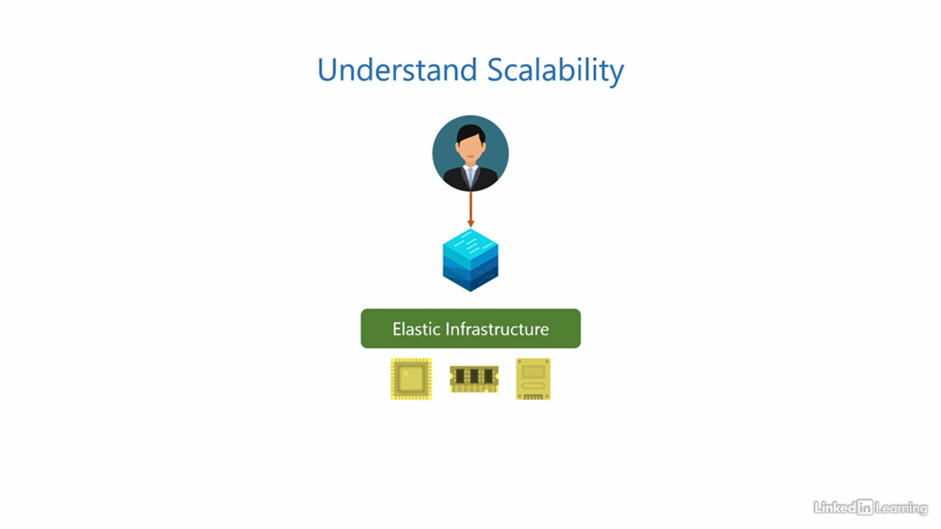

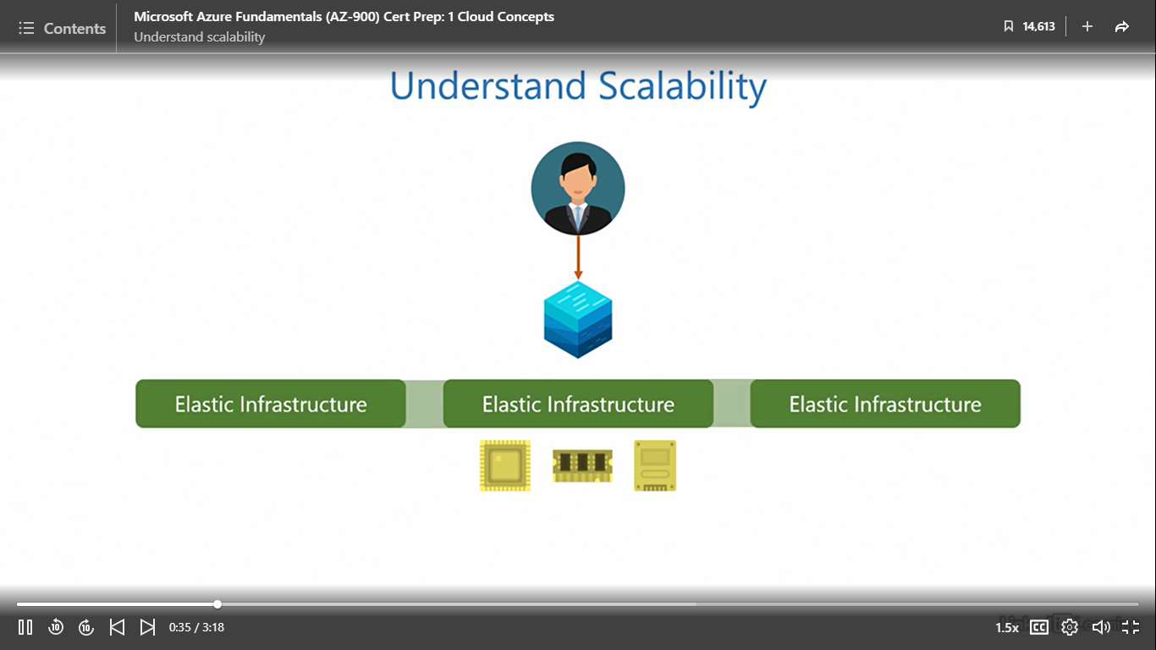

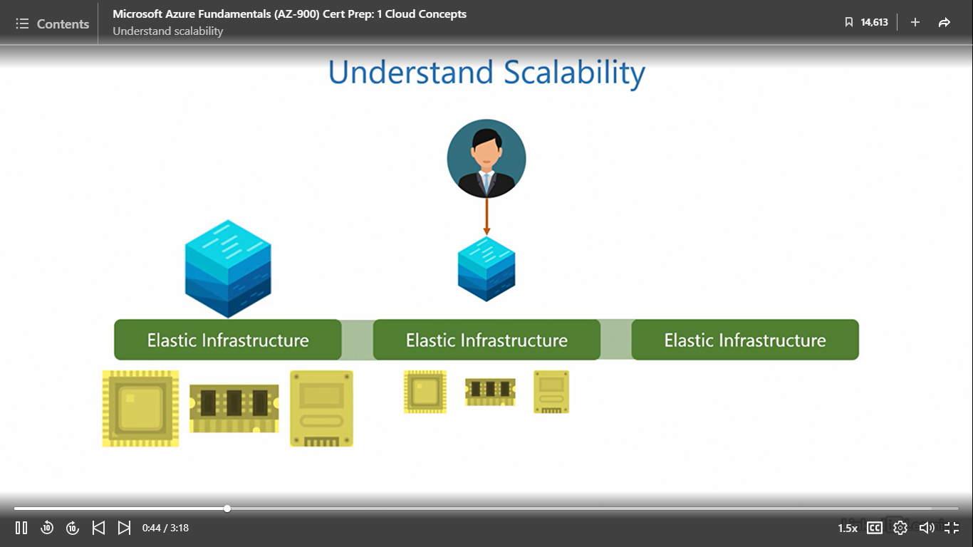

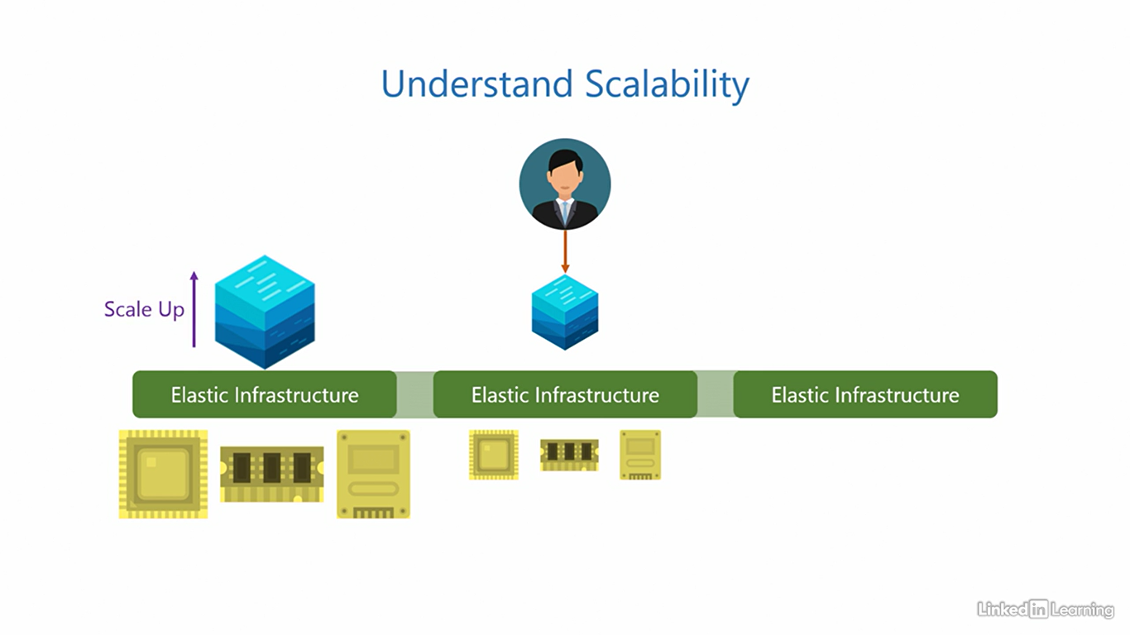

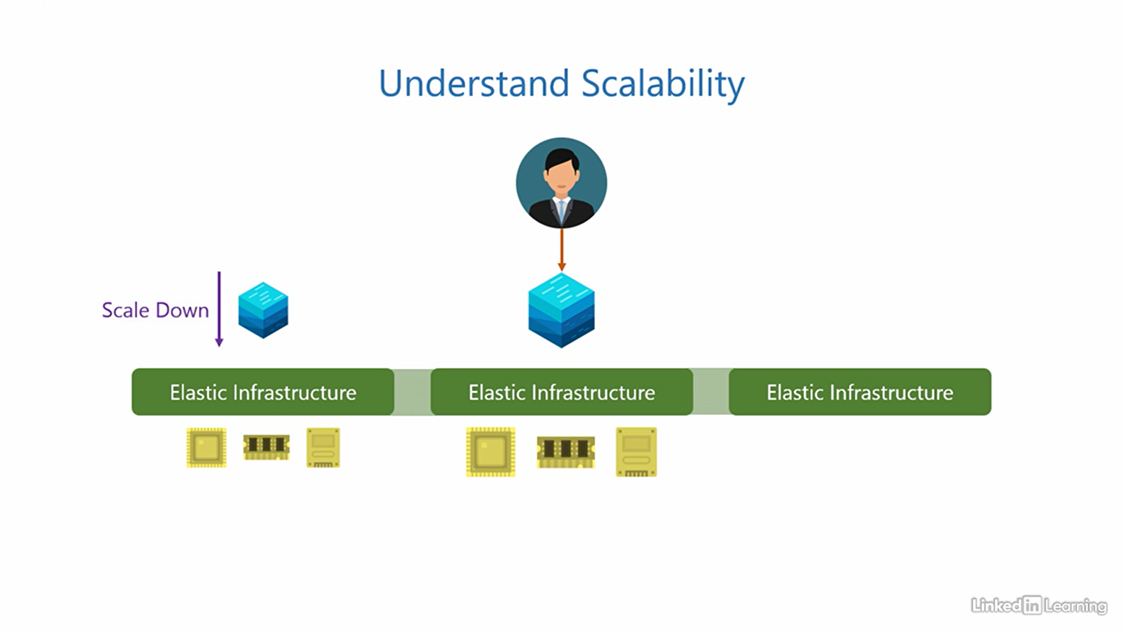

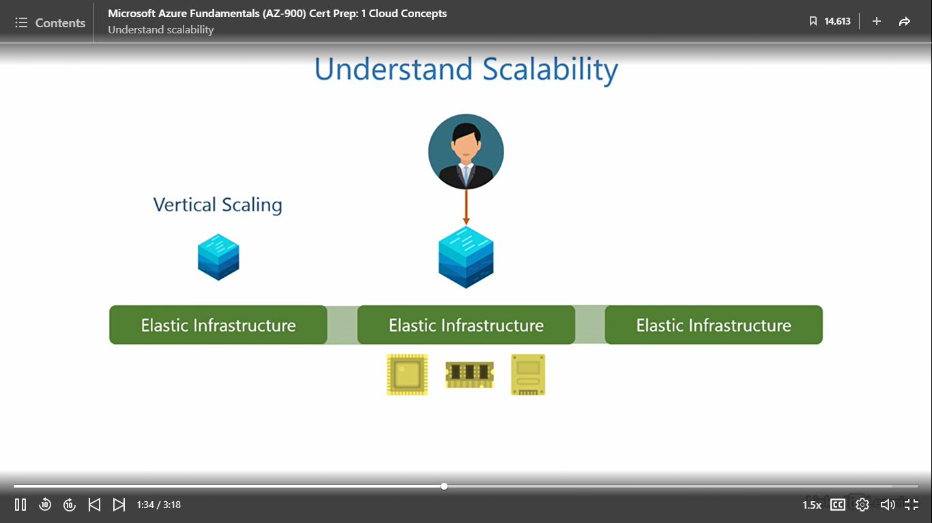

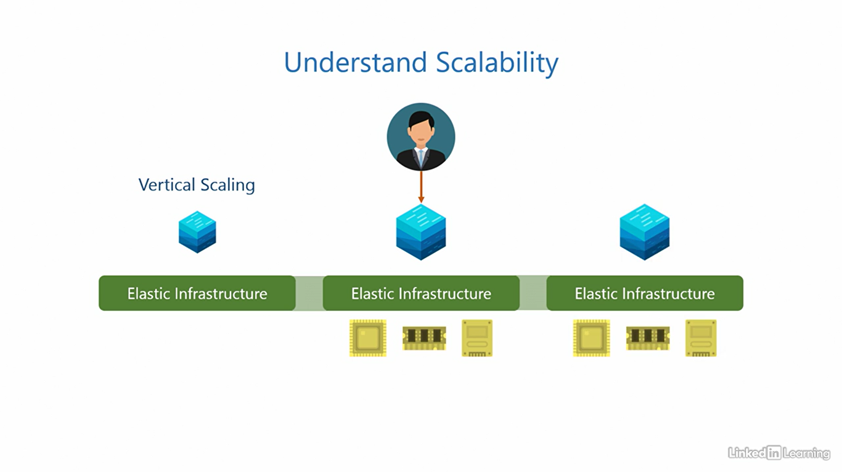

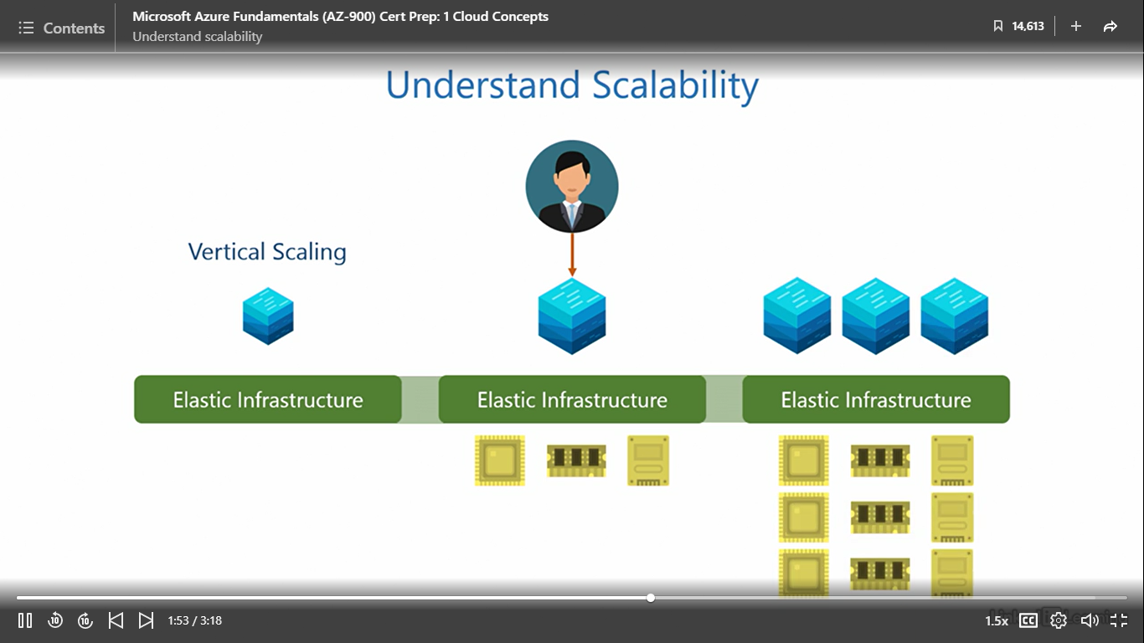

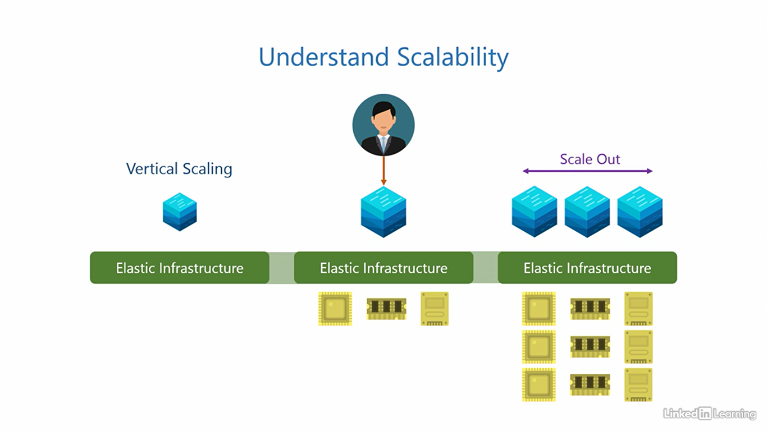

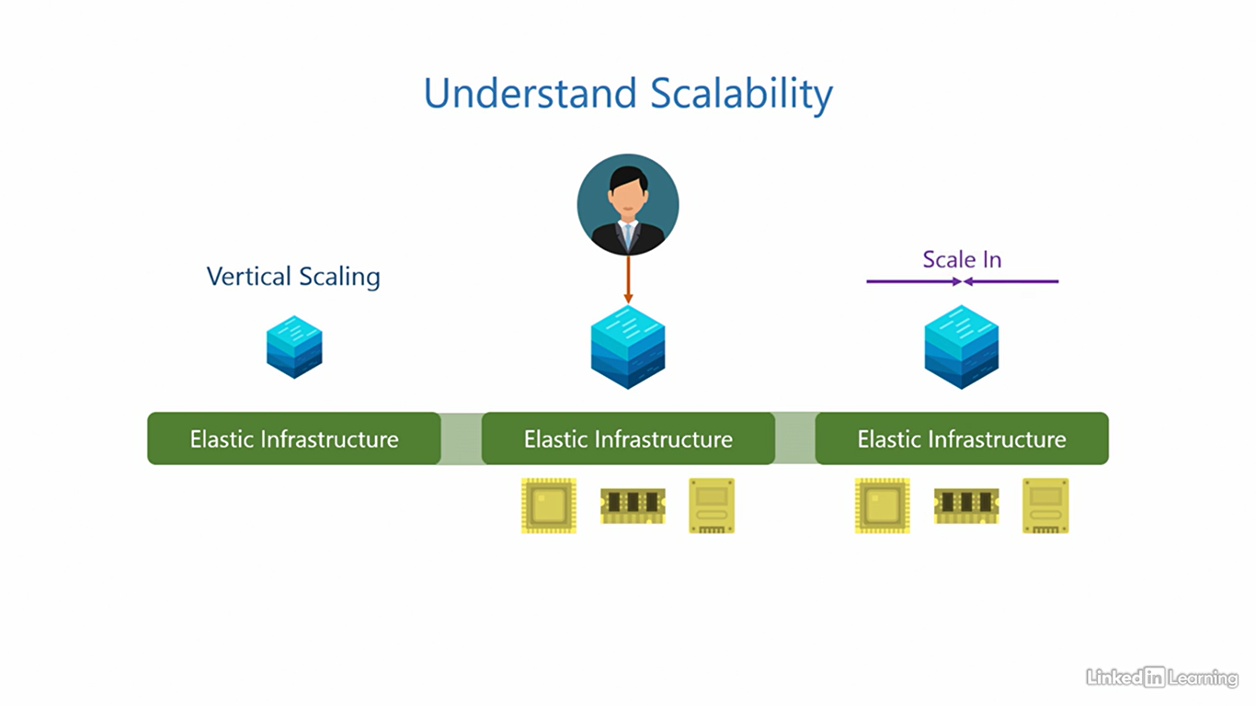

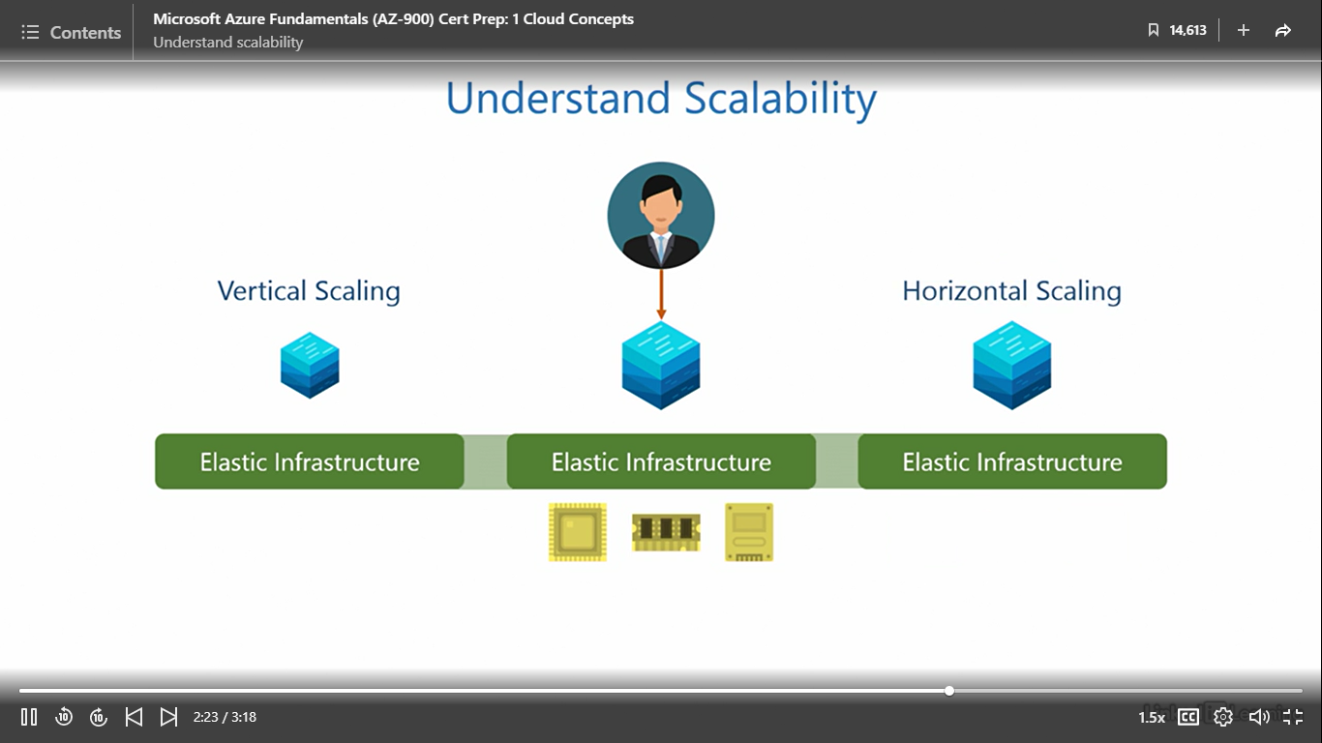

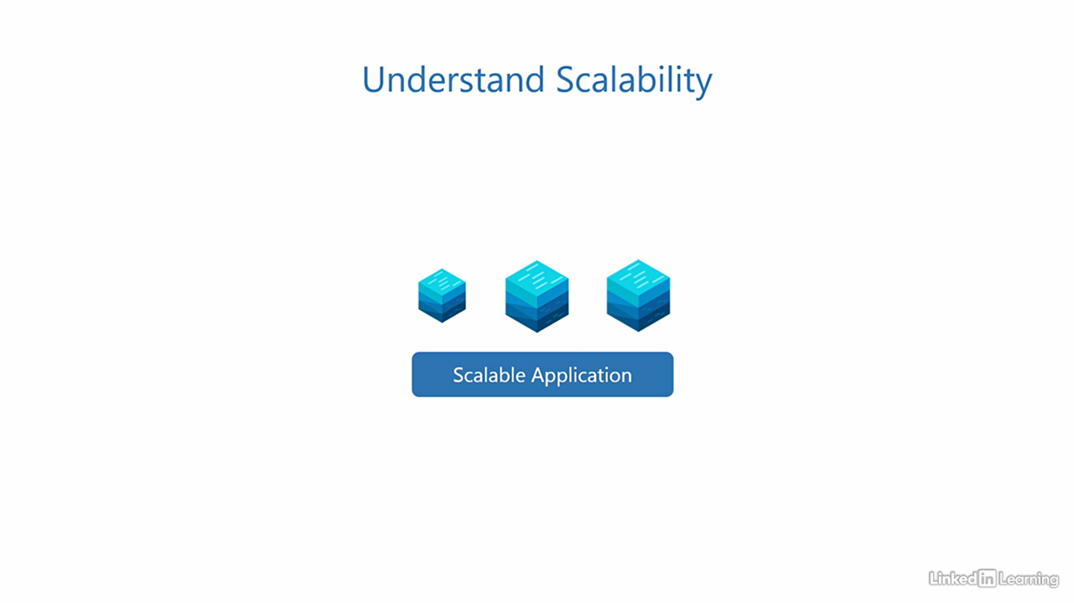

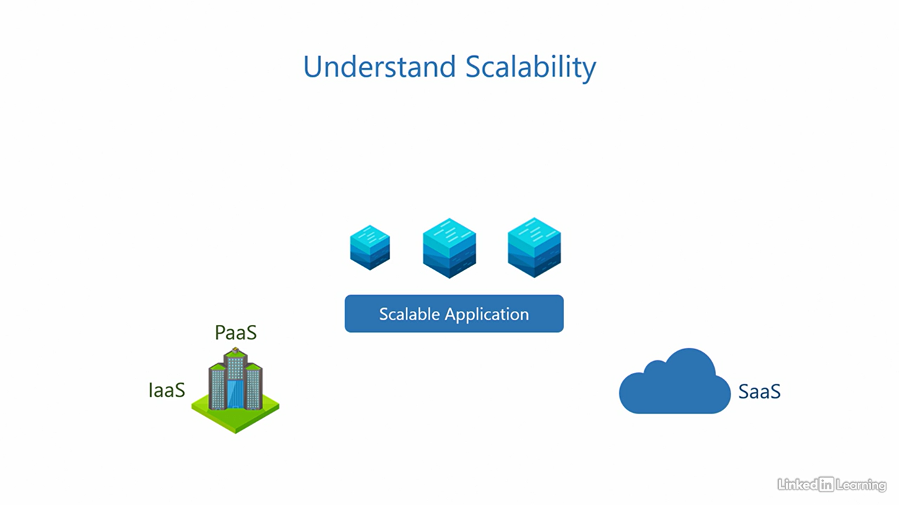

Understand high availability

[Instructor] Both elasticity and scalability ensure business continuity when user demand for an application fluctuates. So an irregular jump in user requests will not overwhelm the application and bring it down, it'll keep running. But what happens when there is a disturbance in the components an application runs on? Let me elaborate. When a user provisions an application it runs with the help of underlying components in the IT stack, a service disruption can occur when any part of the underlying stack needs maintenance, like replacement or upgradation because servers may need to be turned off or restarted in such situations. The users can experience a significant downtime of the application during this time. The purpose of high-availability is to minimize application downtime and maximize uptime, keep the application available for as long as possible, hence the term, high-availability. To achieve that, we configure a planned failover of the application to another node before performing maintenance on the servers. It's called a planned failover because we can prepare for it in advance before doing the replacement or upgradation on the servers. The application can be in a running state and accessible to users during the failover. The user may never even know the application was migrated from one node to another, it's quite seamless. Once the maintenance is done we can configure the application to failback to its original node, again, without any interruption to the users. So there is almost zero downtime in planned failovers, thus ensuring the application is highly available. There's another type of service disruption that we cannot plan for and those are failures of any component in the underlying stack. Failures are sudden and can happen without notice, whatever the failure is or its cause, the application can become inaccessible during this time. To achieve high-availability, its best not to wait until the failure is resolved. Instead, the first thing we do is immediately configure an unplanned failover of the application onto another node and then redirect users to this new instance of the application, it's called an unplanned failover because we can never predict a failure. There's a good chance users will know that somethings amiss for a little time. Once the failure has been rectified, we configure the application to failback to its original node. The downtime here is greater than zero but because we did not wait for the failure to be rectified and immediately spun up an instance of the application on another node, the application can still be highly available with minimal downtime. The uptime for services is defined in a document called the Service Level Agreement and measured in percentage. For example, if a service claims to have a 99.999% uptime in its SLA, we call it five nines because there are five nines, 99.999 and if the uptime is five nines, the downtime is 0.001%. That roughly translates to five and a half minutes of downtime per year. For context, a year has more than half a million minutes, 525,600 minutes to be precise. This means the service may go down for a combined five and a half minutes over a period of one year, applications that use multiple services have a composite SLA, it's calculated keeping into account the SLAs of each service it uses. The customer has to calculate this in IaaS and PaaS because they control the application architecture and the services it uses. But in SaaS, the Cloud Service Provider will define it for you. Remember, high-availability is measured over a period of time. Azure also offers services that are highly available.

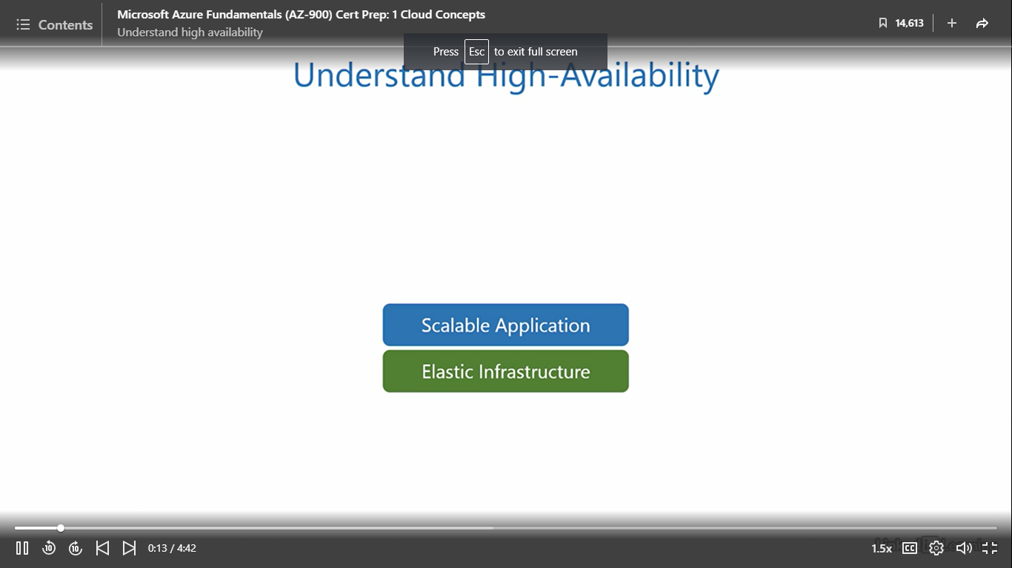

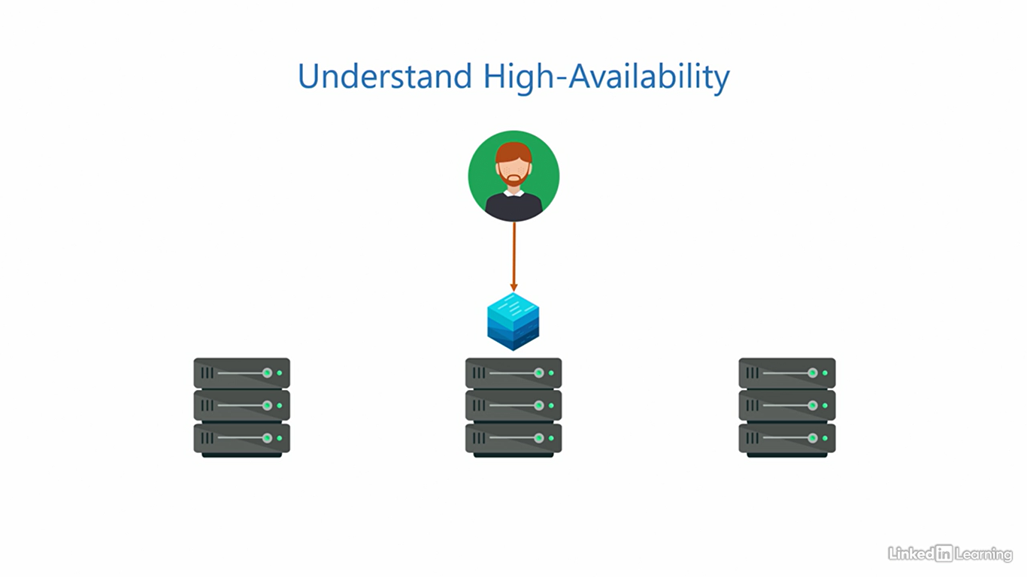

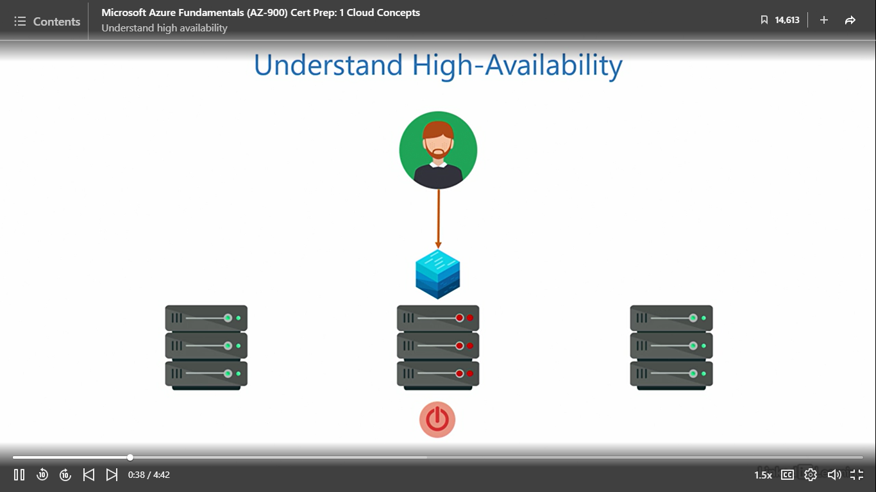

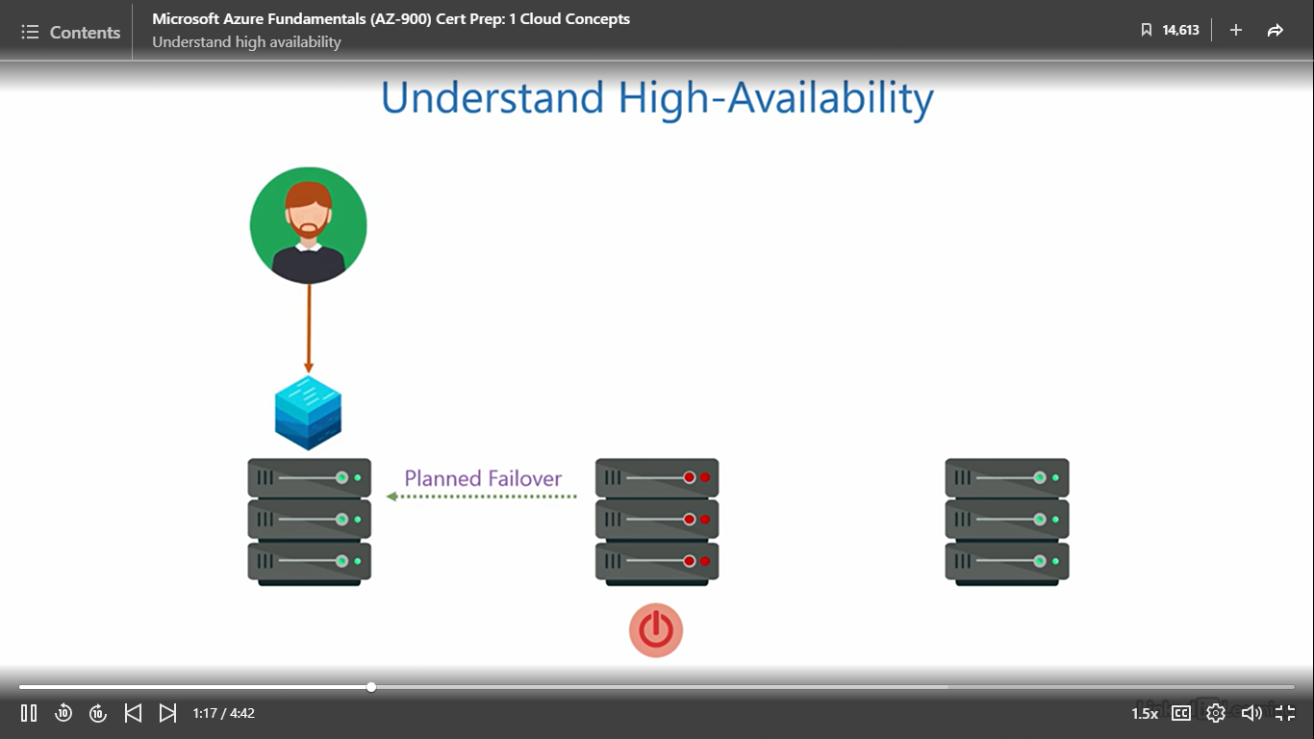

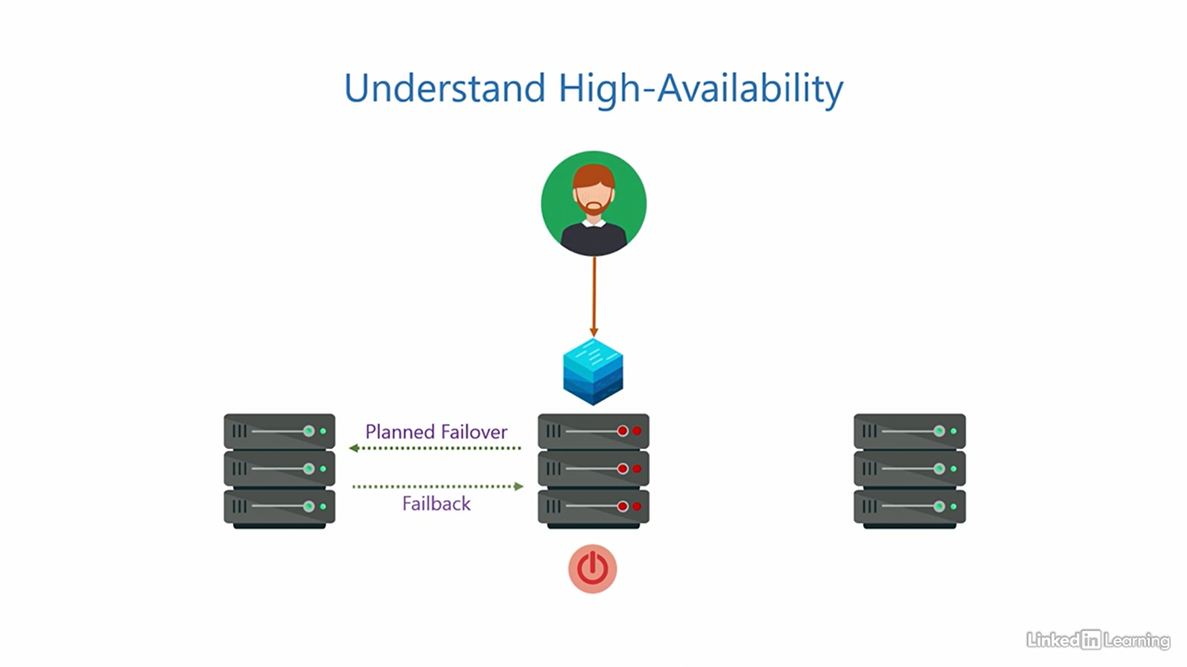

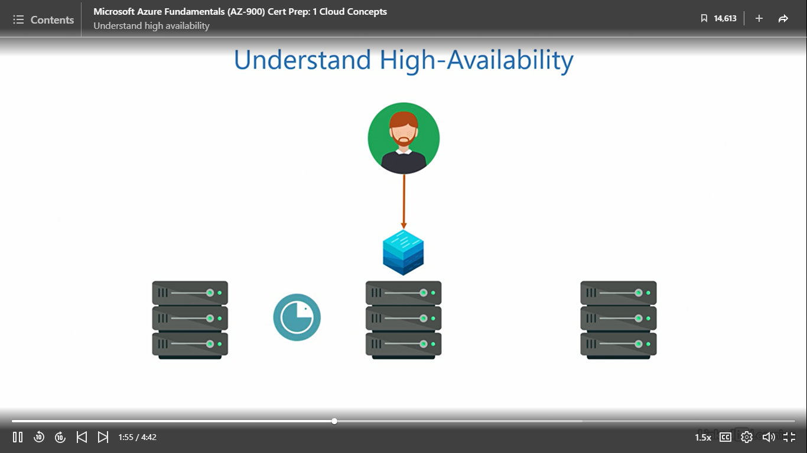

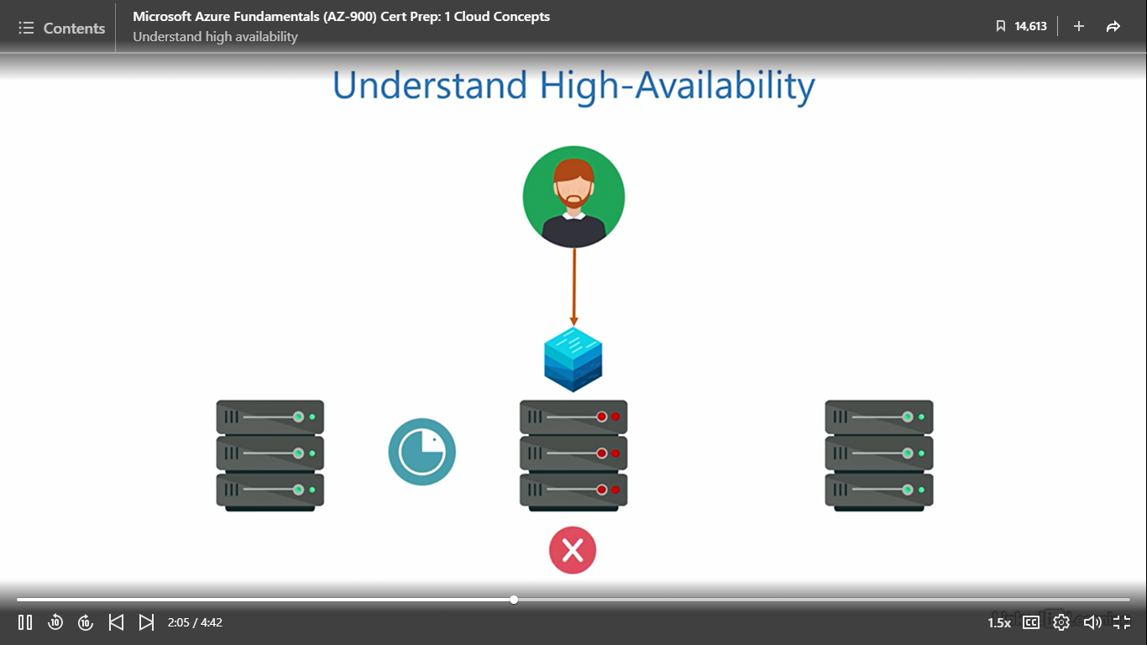

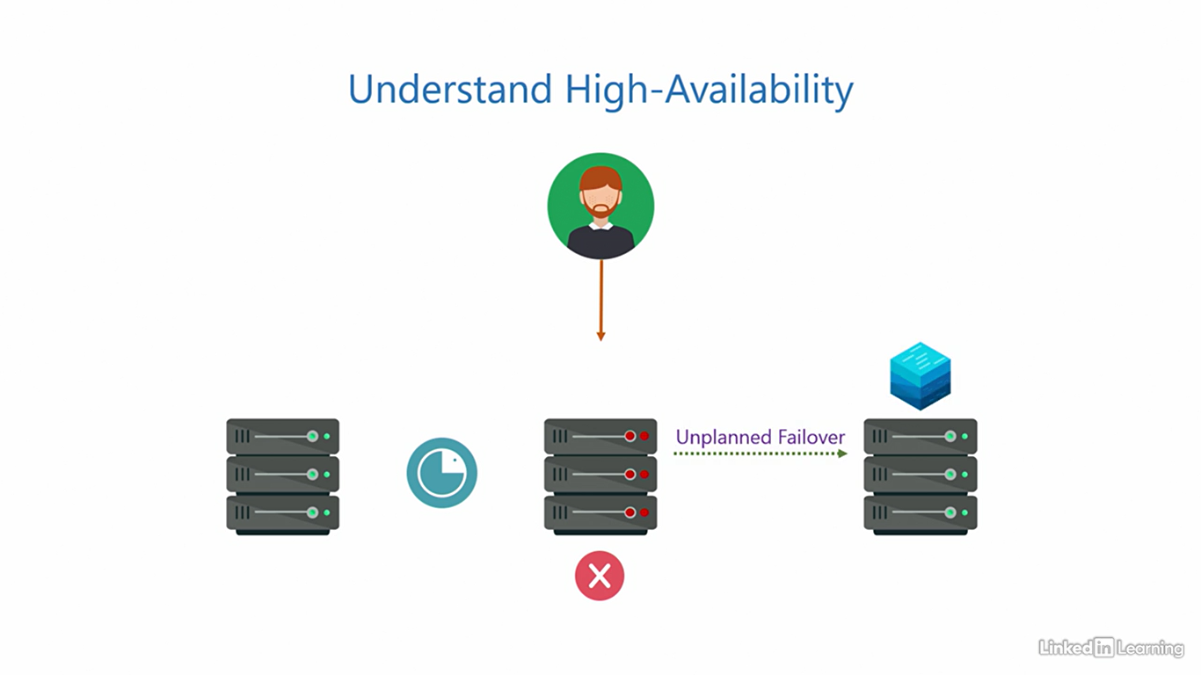

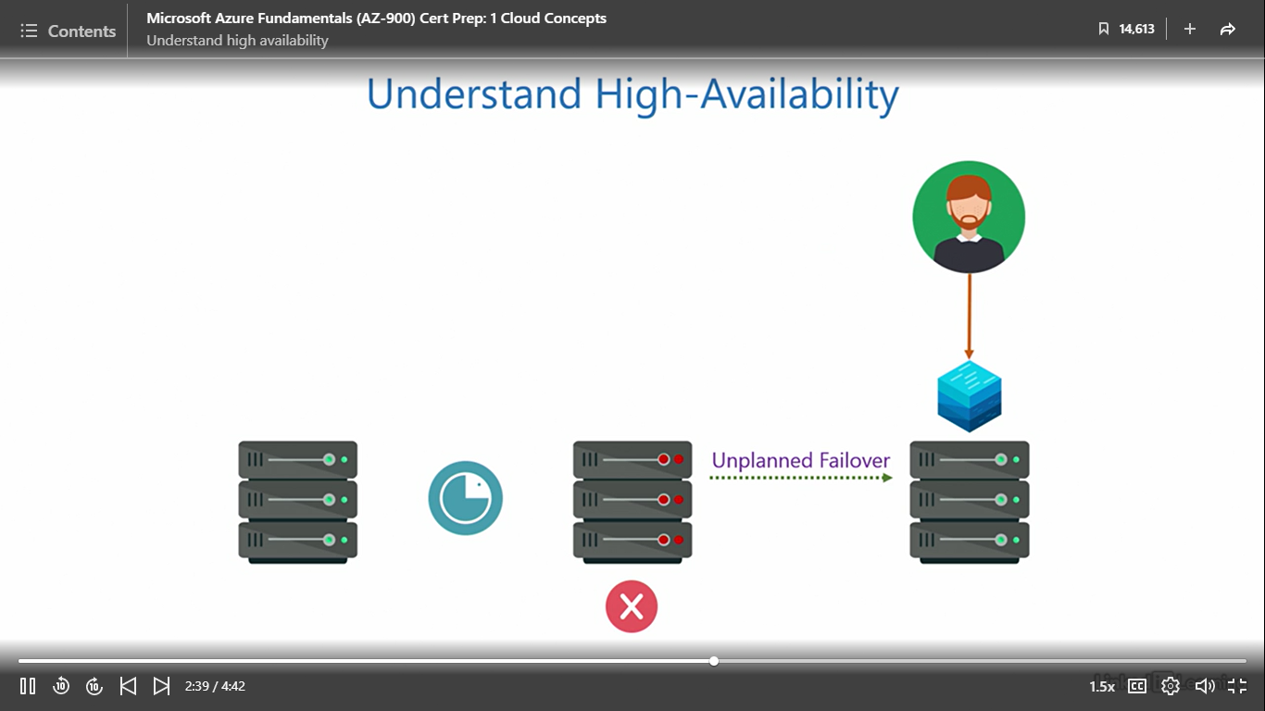

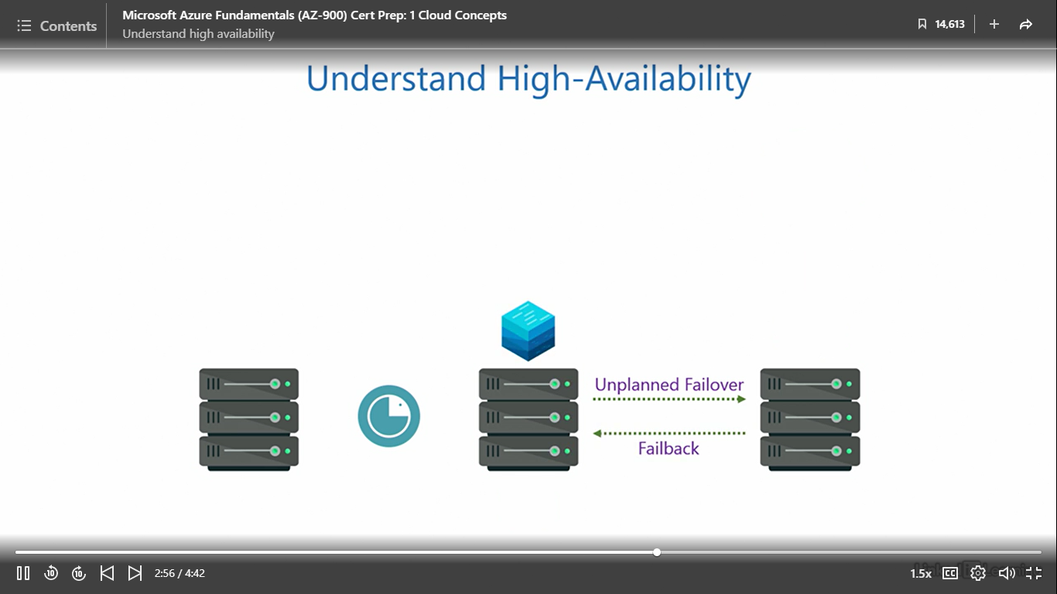

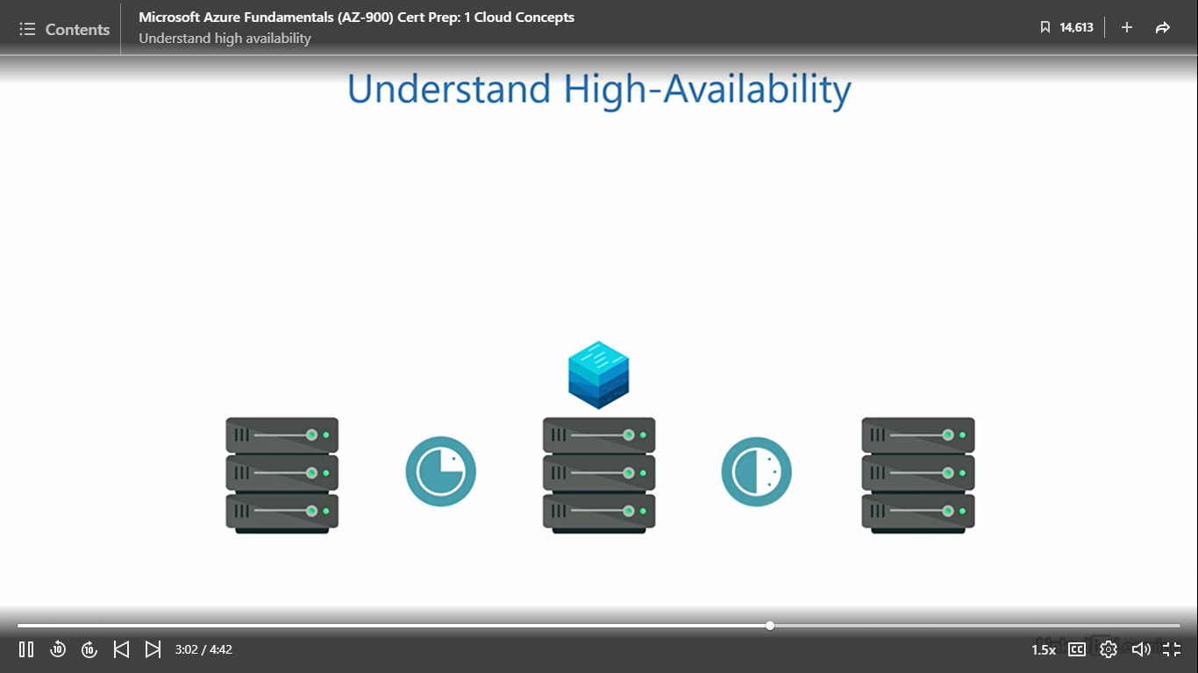

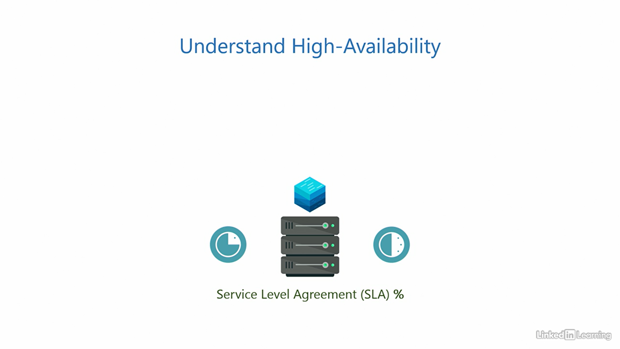

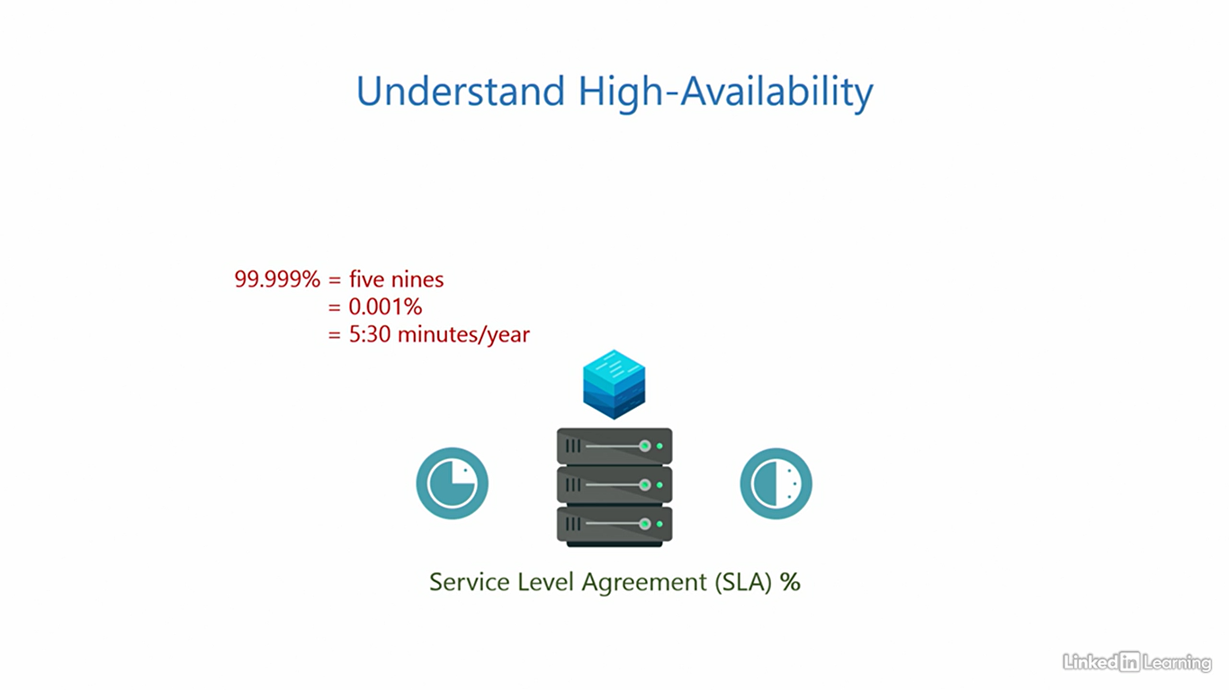

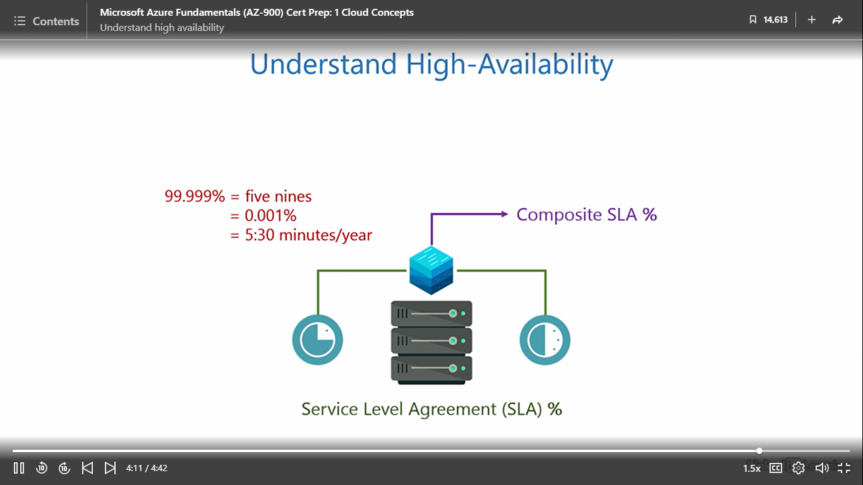

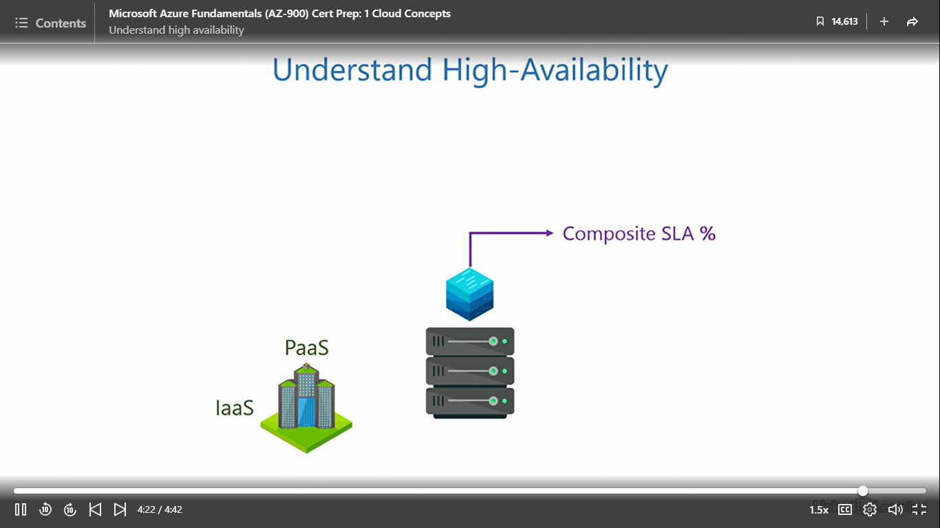

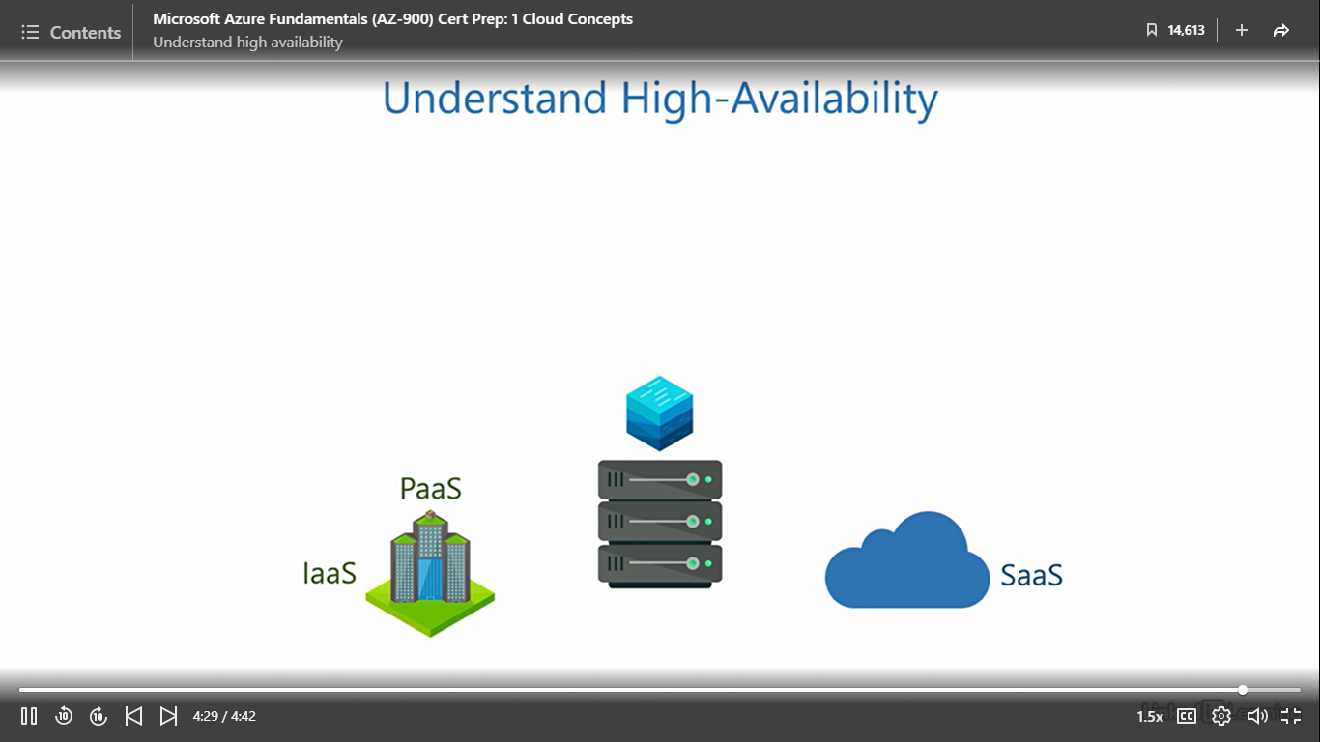

Understand fault tolerance

[Instructor] Here's a variety stack. Fault tolerance is typically an attribute of the operating system. We know when a user provisions an application it runs on a set of computing resources. At any given moment, the system may experience an unexpected event called a fault. This could be due to an exception, error, interrupt, or any other fault in the software or hardware components like the processor, memory, and disc. If you are wondering how a fault is different from a failure, a fault is instantaneous and temporary, but a failure is usually a longer lasting event and needs greater effort to resolve. A car going over a speed bump is like a fault, but an empty fuel tank is like a failure. Anyway, whatever the reason for the fault may be, it has the potential to impact the running of the application, even if it is for a short interval, and that's not good. That's where fault tolerance comes into the picture. A system is said to be fault tolerant if it can preserve the system state when the fault occurs and continue to process the information it was processing without breaking the flow at that given instant. A system that can sustain this successfully is said to have fault tolerance, or else it does not. This feature is usually built into the operating system, and thus is not something we need to manage. The cloud service provider takes care of it in all service models. Azure also has fault tolerance built into its core.

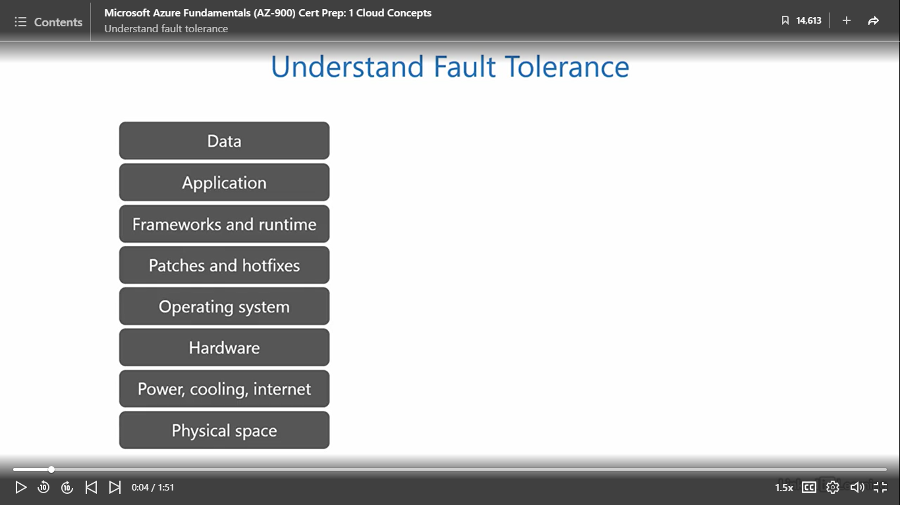

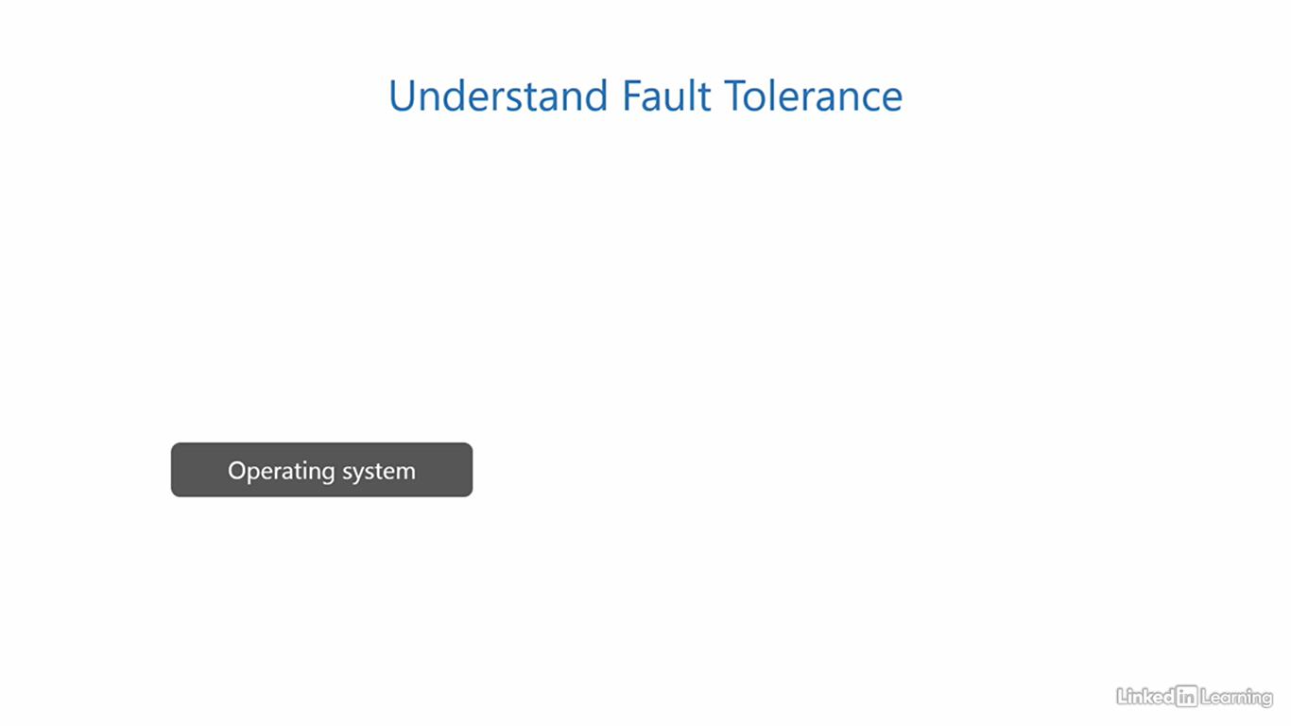

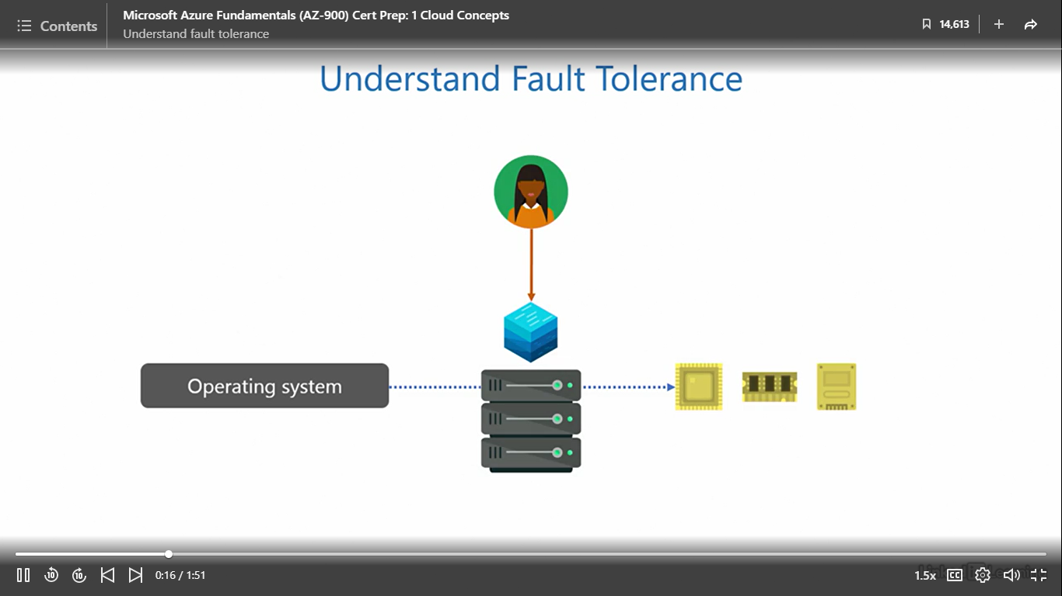 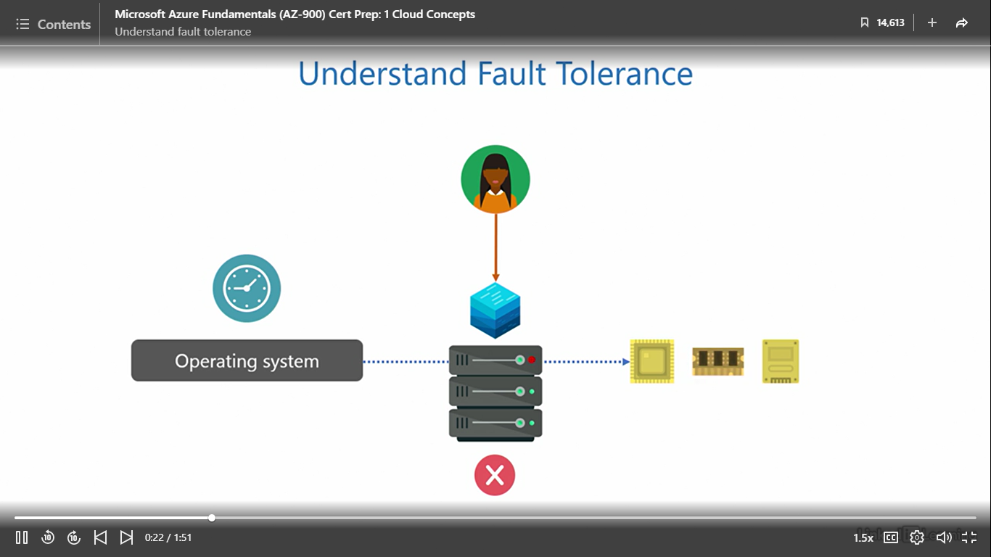

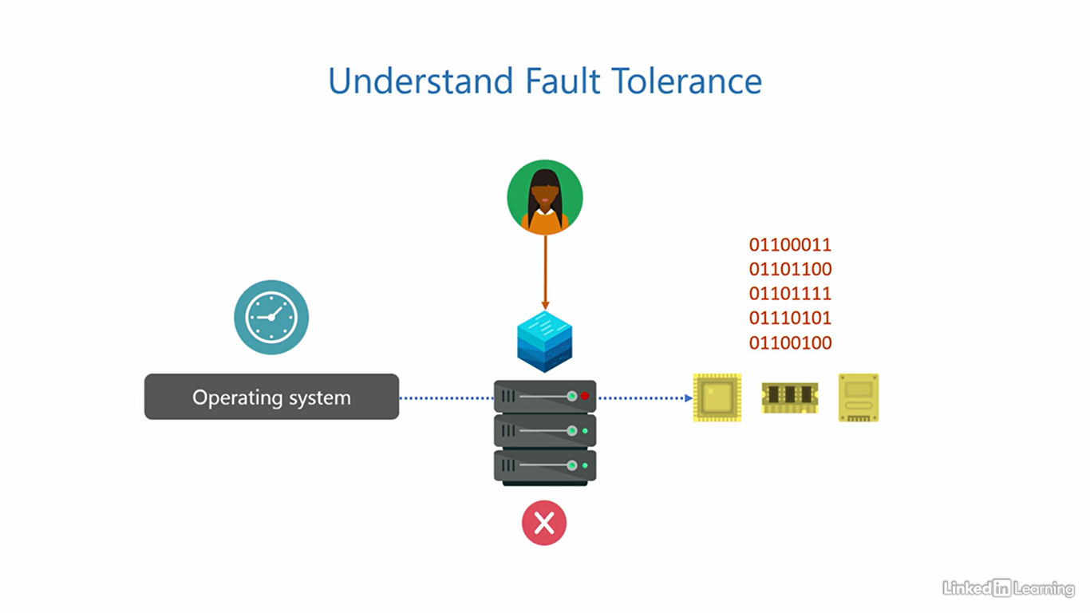

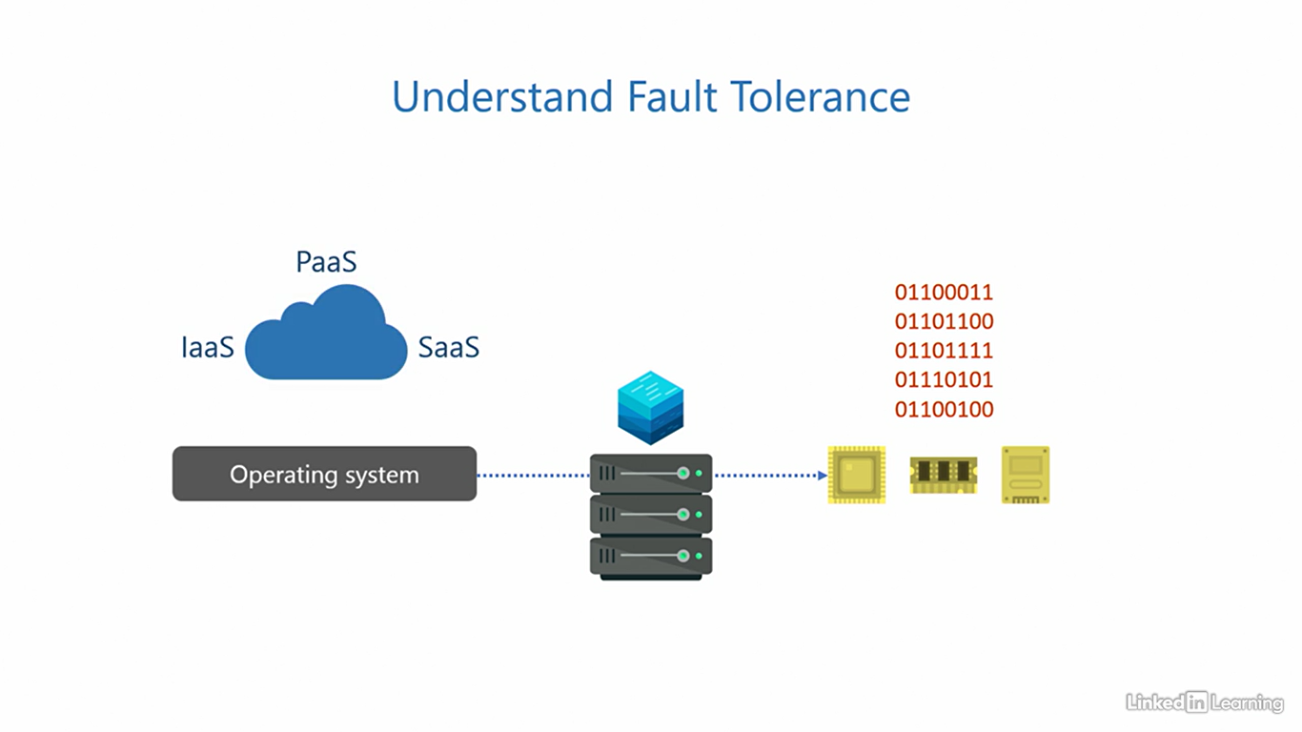

Disaster recovery

[Instructor] The benefits you learned so far are designed to protect customers from smaller impacts, like an overload of requests from users, failures, and faults. But we also need to ensure data is safe from larger impacts, even if the probability of such occurrences is low. A disaster is a large-scale catastrophic event that has the potential to take down an entire region, including one or more data centers. Earthquakes, flooding, hurricanes, forest fires, wars, or any other unforeseen event. From an IT perspective, preserving the integrity of data in such situations is a high priority. Typically, data is stored on servers in the on-premises environment. To avoid losing the data, we take backups. Depending on how critical the data is, the backup schedule can be hourly, daily, weekly, or monthly. If anything goes wrong on the main servers, we can restore data from the last backup. Here's the caveat. Local backups cannot protect data from disasters. That's because both the servers and backups are on the same site, on premises. A disaster will wipe out both. That's why we need disaster recovery. In this strategy, we store backups of the data off site in a physically distant location that's planned in a way that a disaster does not affect them both together. We call this an off-site backup. While this is possible, it can be really expensive to build and maintain an entire site purely for backup. Most small/medium businesses don't quite have such deep pockets to afford it. Here's where things become interesting. You can make the cloud your off-site backup destination at a mere fraction of the cost. The cloud can be the secondary site to your primary site on premises. This means even if your entire primary site goes down, your data is completely safe in the cloud. In fact, cloud service providers use the same disaster recovery strategy to protect your data. Anything you store in the cloud is, in real time, replicated to a secondary site within the cloud service provider's network. So hypothetically, even if the cloud service provider loses an entire site, they can quickly and seamlessly redirect customers to the secondary site. The worst case could be minimal downtime of the application without data loss. And in the best case, you wouldn't even realize anything went wrong.

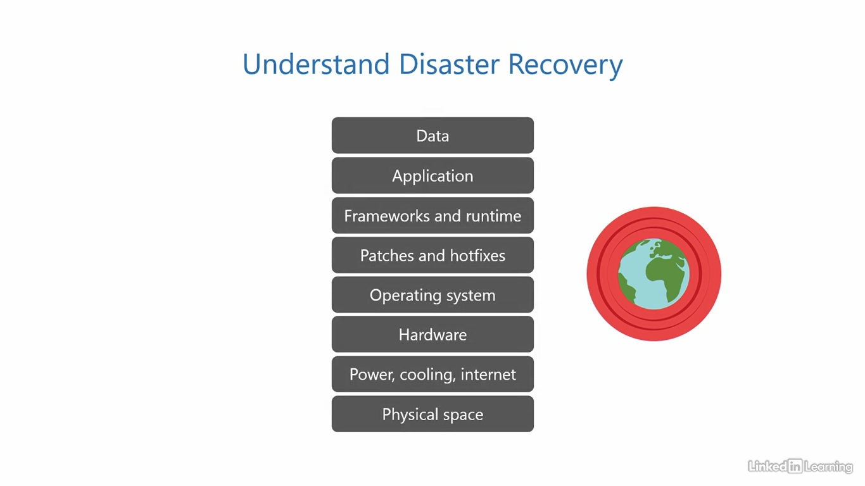

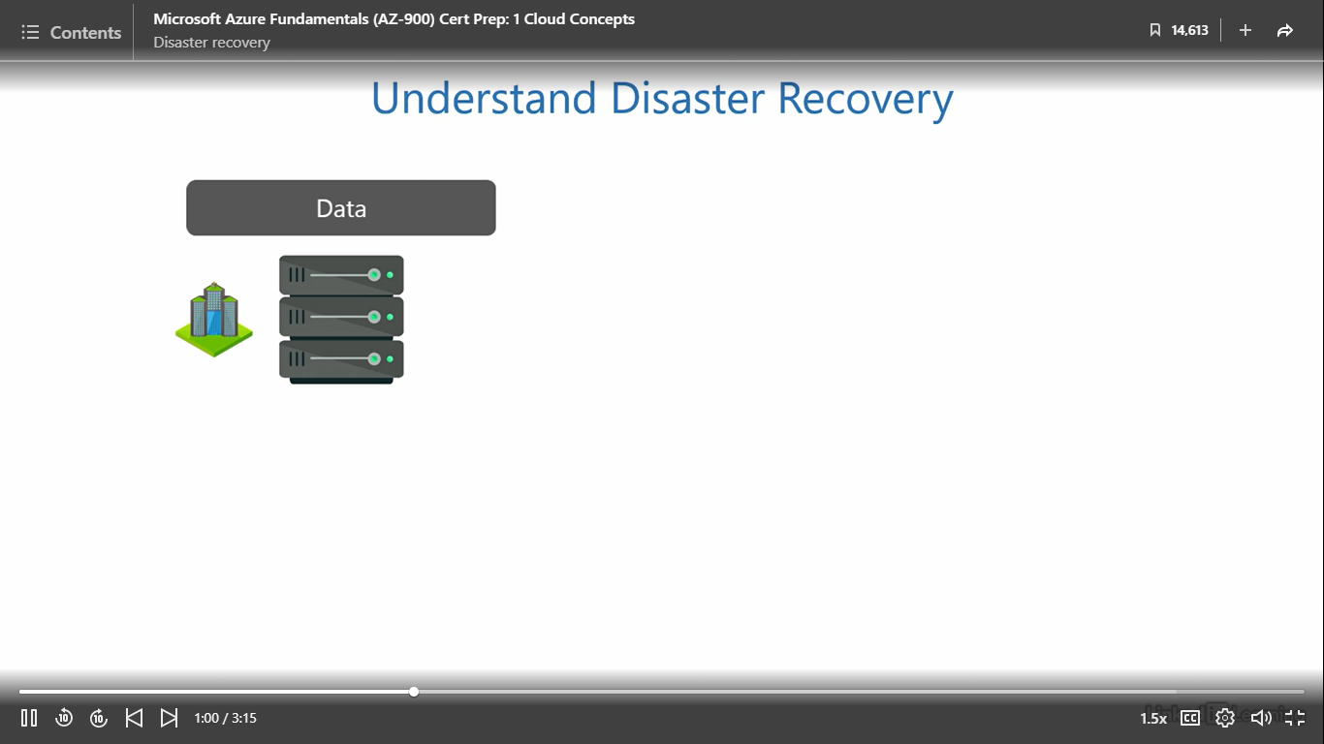

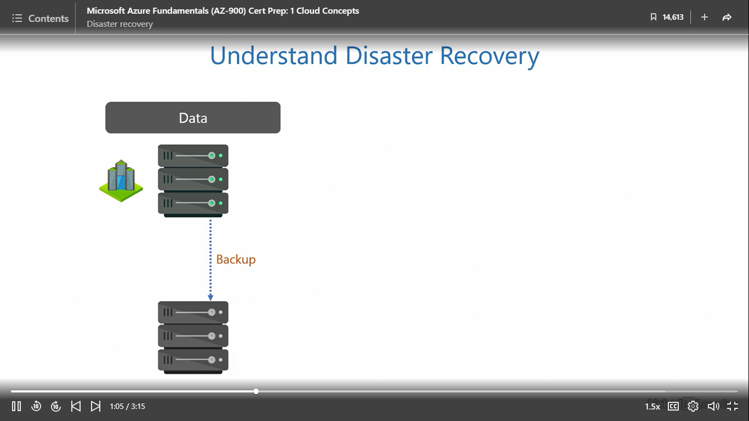

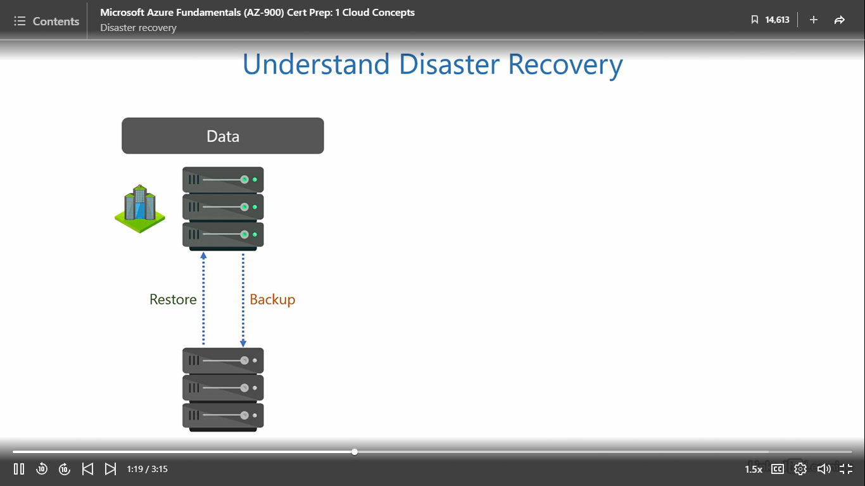

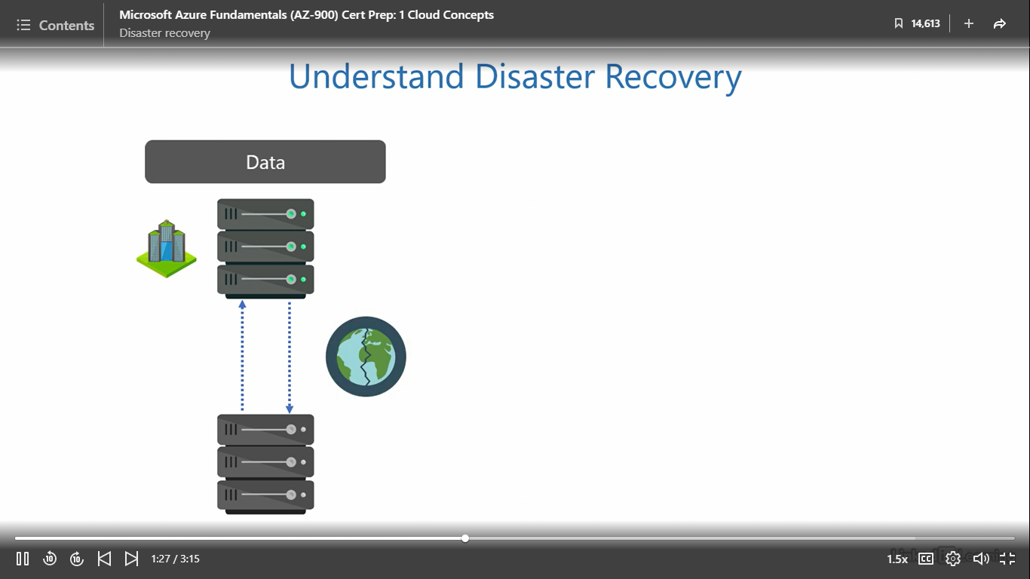

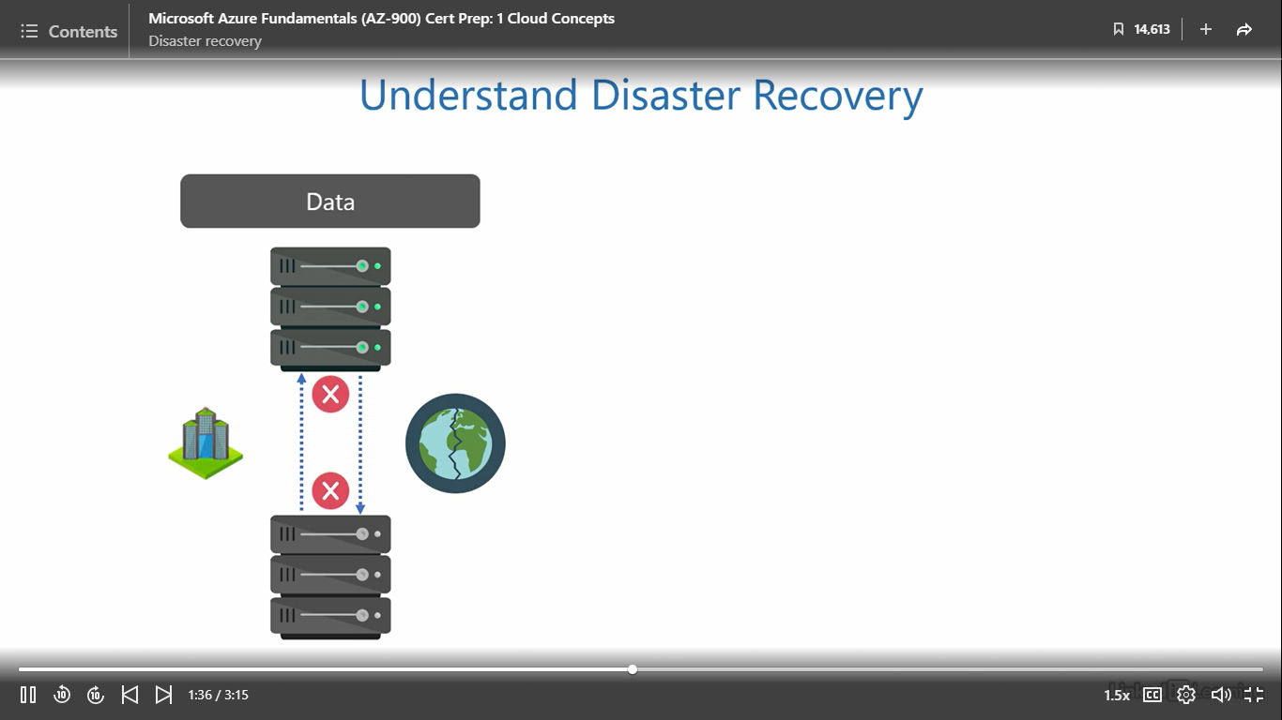

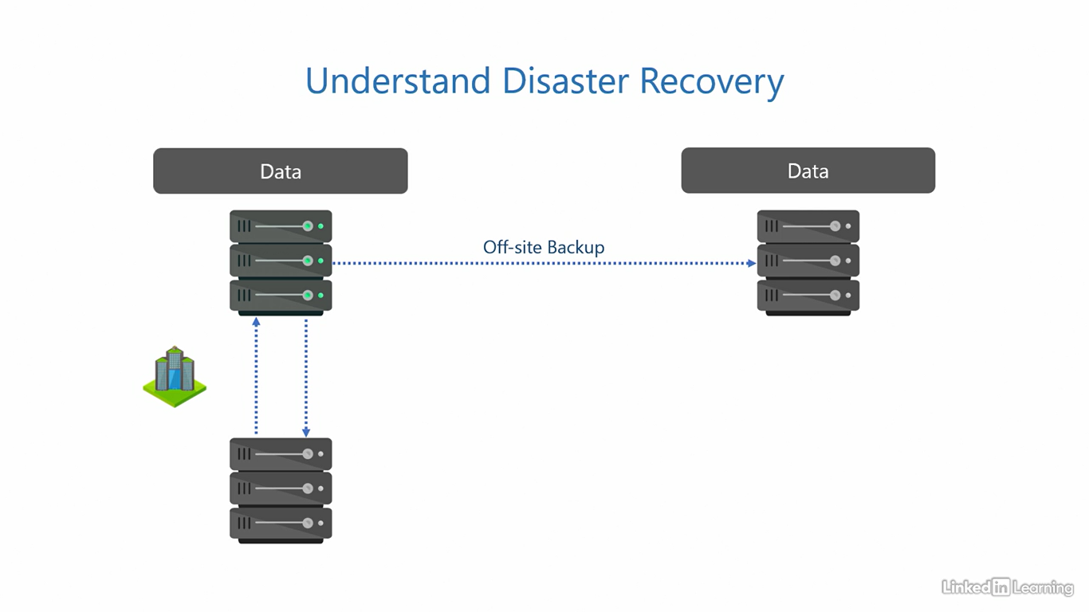

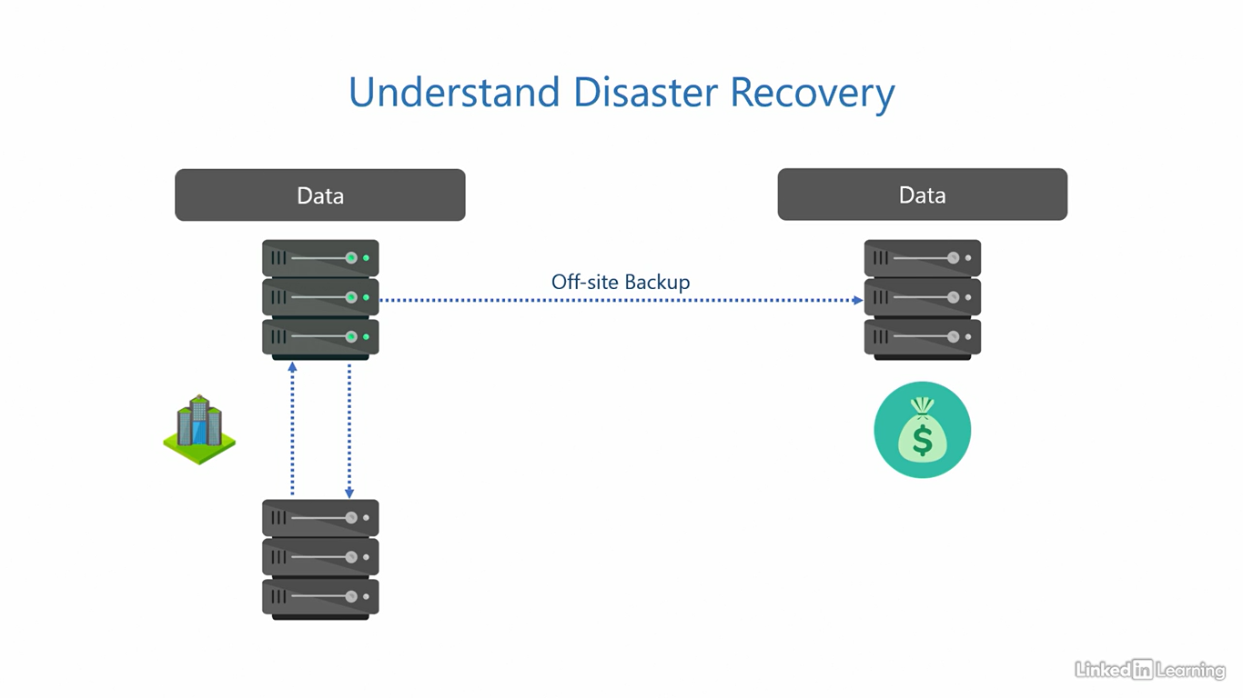

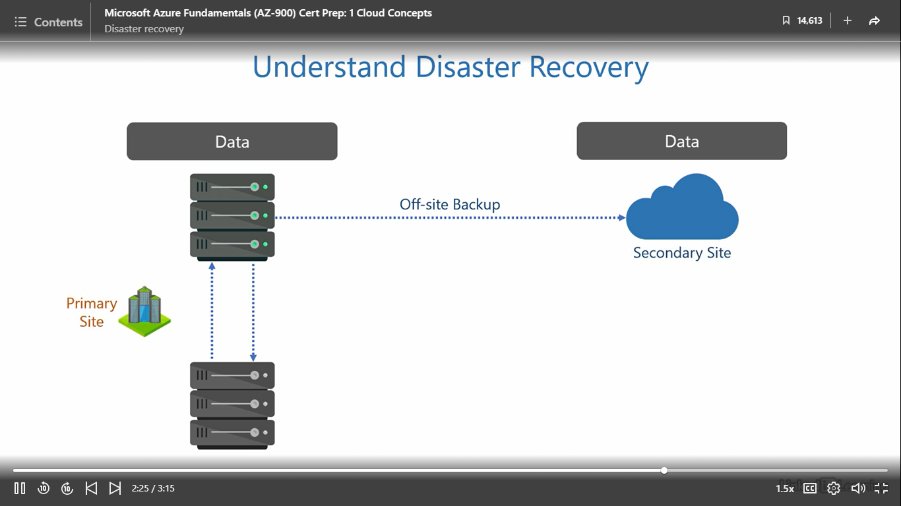

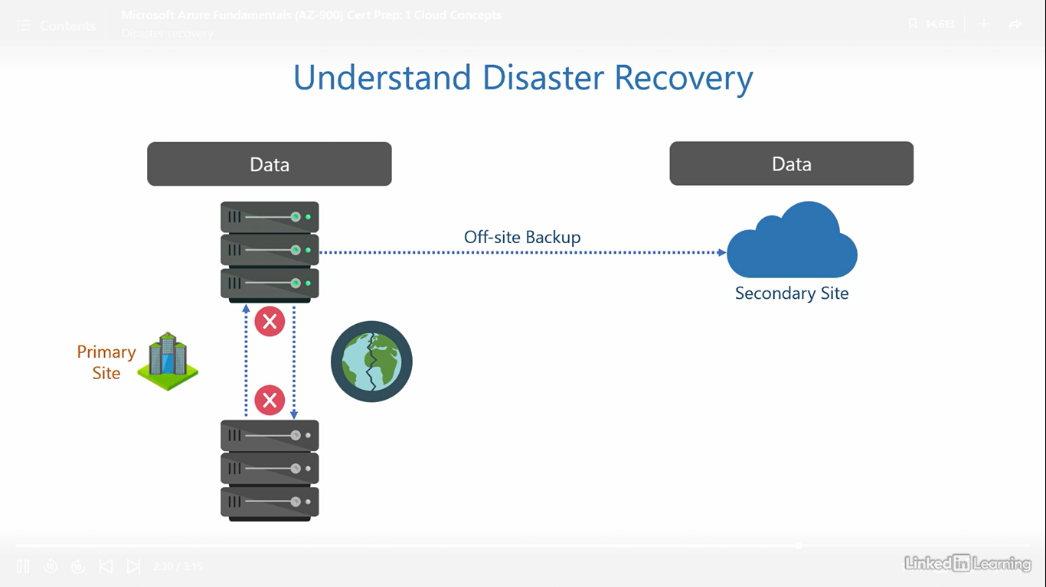

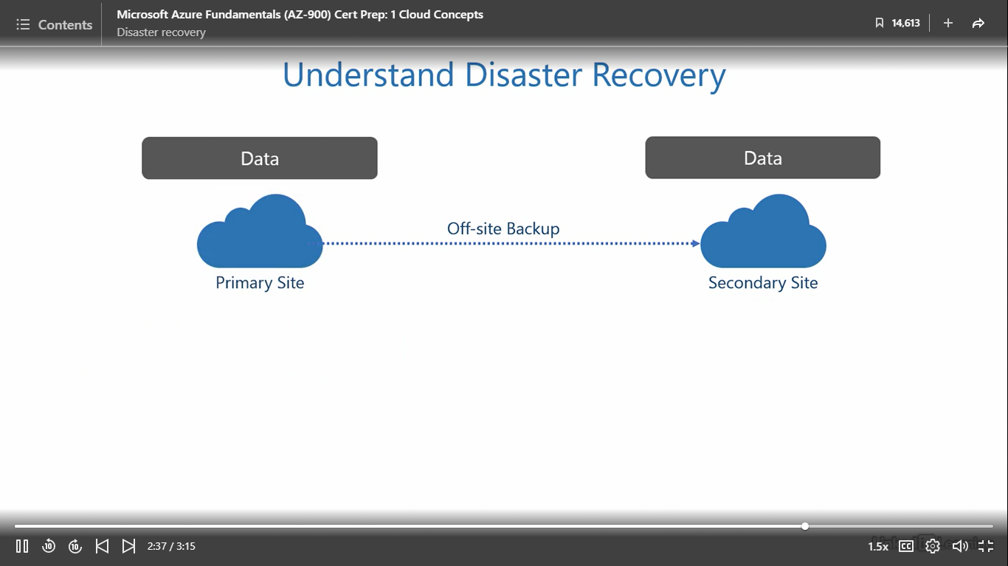

Understand security in the cloud

[Instructor] We know how important data is for an organization. It can contain trade secrets, design of a proprietary product, business strategy, personal and financial details of users, or any other information that is crucial for the organization to succeed. Any part of this in the wrong hands can severely damage the organization's revenues and reputation. And that's why a cloud should be security centric. It takes years for organizations to earn the trust of their users and build a reputation, but just one night is enough to lose it all. We need to be constantly on the lookout for bad actors, every minute of every day. But the bad guys only need one chance to destroy everything. That's why security is a complex subject. In addition to being security centric, let's see what other security controls we expect in the cloud at the bare minimum. The data should be protected with industry standard encryption when it's at addressed and in transit. Doing this prevents bad actors from getting access to readable data when it's stored in the cloud or being moved from one point to another. Administrators should also have tools for identity and access management at their disposal. This helps protect user accounts, passwords, groups, and devices from bad actors. Leaked passwords and stolen devices are the most common weak links in any organization. Then, there should be multi-layered approach to security for end-to-end protection. Because security is not just about protecting one or two parts, it's about protecting the whole string of components. Ideally, there should be multiple barriers to entry, one at each stage, just like when you peel an onion, there is one layer after another, after another, and so on. Legitimate users should get through easily, but bad actors must be stopped from unauthorized access. I also believe in proactive prevention over passive cure. It's better to proactively monitor, detect, and mitigate threats before they can do any damage. Trying to fix a security breach after it happens is not very helpful because of the impact it has on an organization's reputation. We all know a loss of reputation is the hardest to recover from. Next, there should be a unified pane that gives deeper insights into the overall security posture of the organization. Because tracking numerous security alerts across multiple metrics, services, and tools can be chaotic. There's a possibility an administrator may miss a warning because of the sheer number of tools involved. Having one single management interface with consolidated reporting of all security events can be very useful. And finally, there should be logs for auditing and tracking. Keeping a record of who did what is necessary for accountability. Any activity attempted or performed by internal employees and external actors should be recorded and retained. Because when people know any mischief they make with bad intent can be traced back to them, they usually refrain from doing it. These mechanisms keep everybody honest.

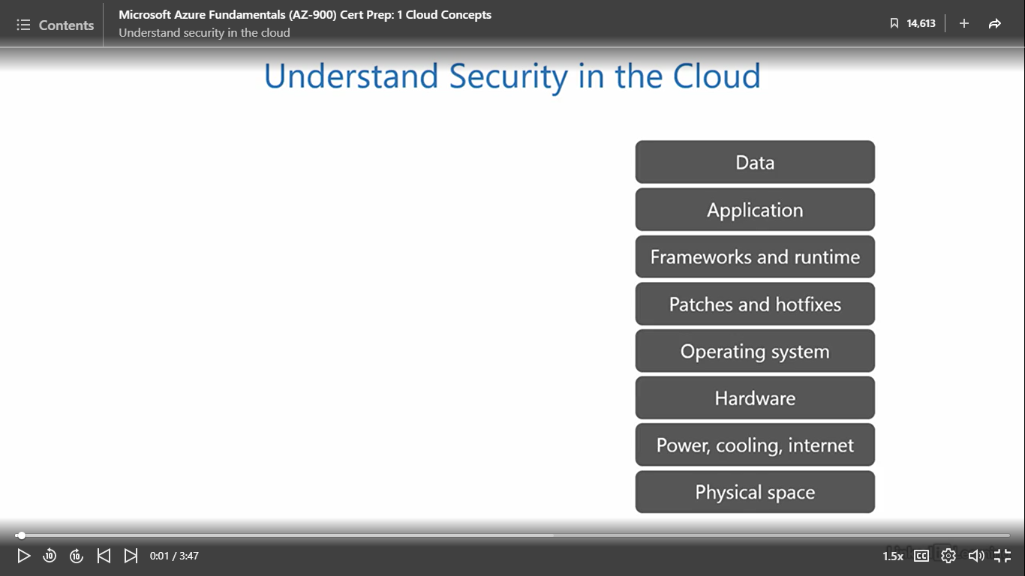

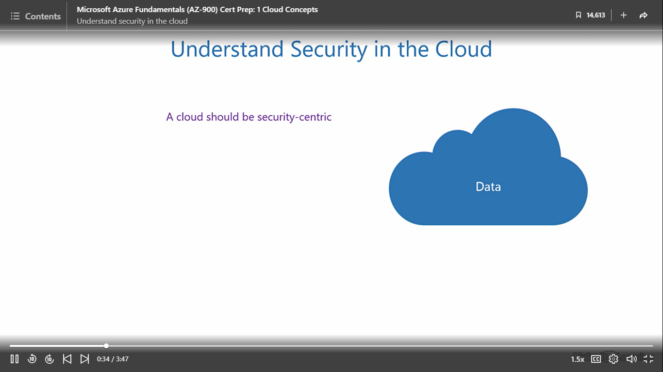

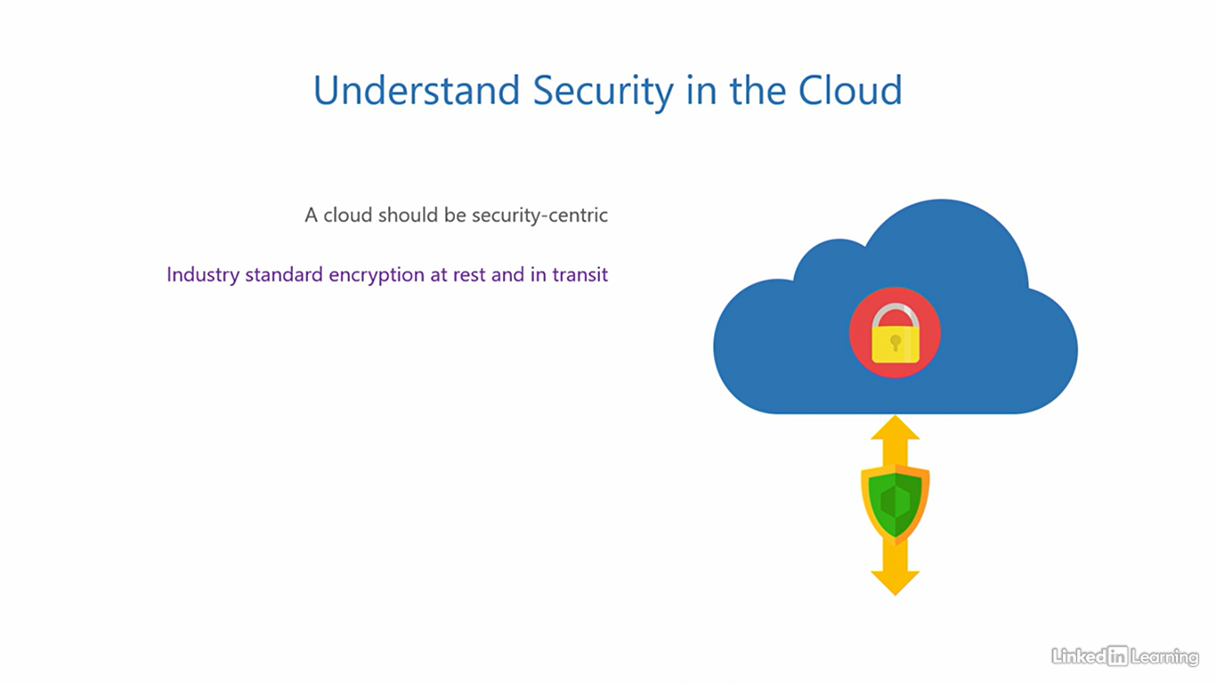

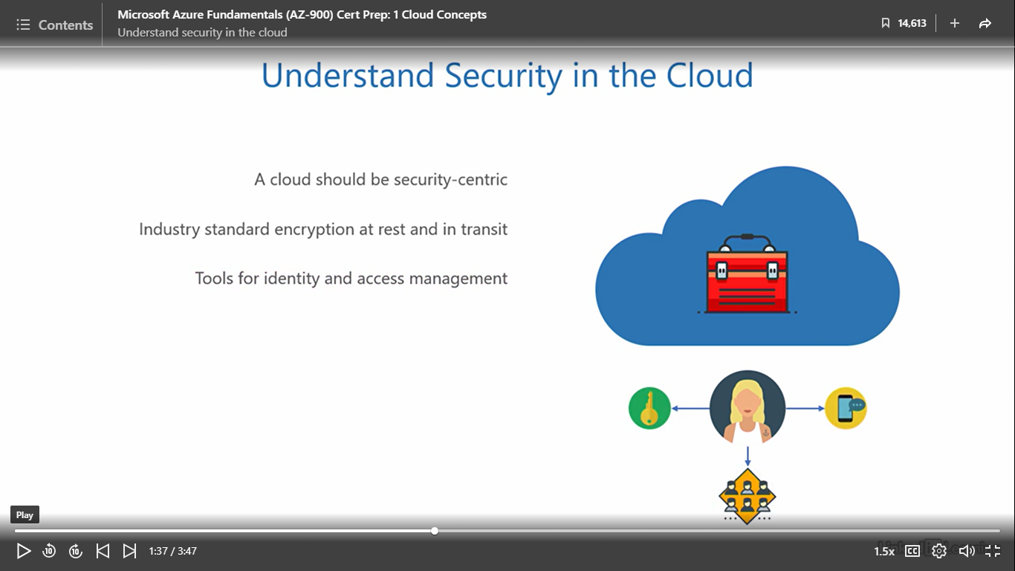

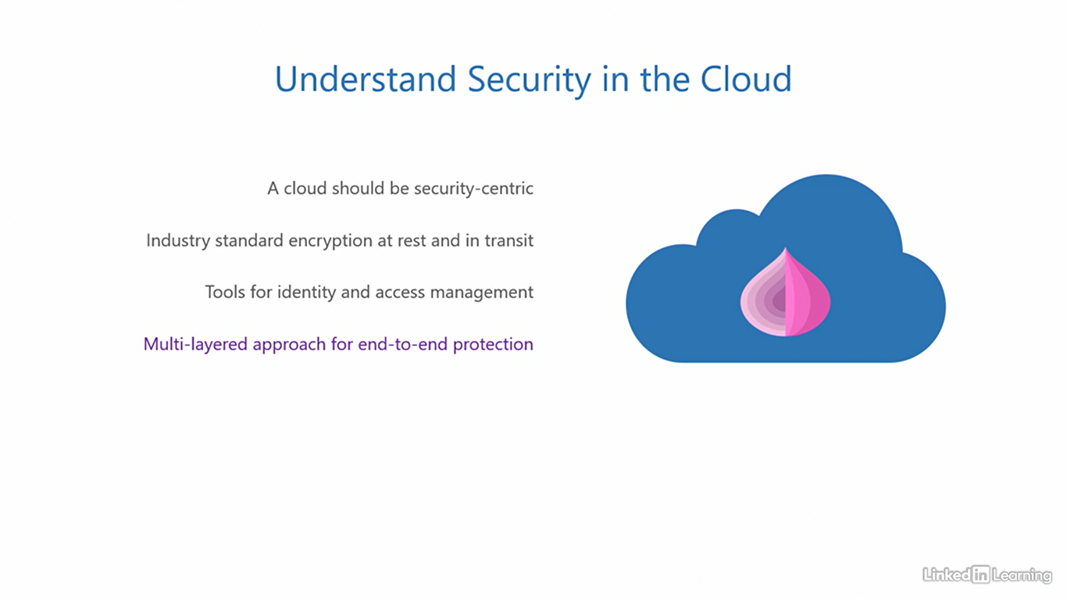

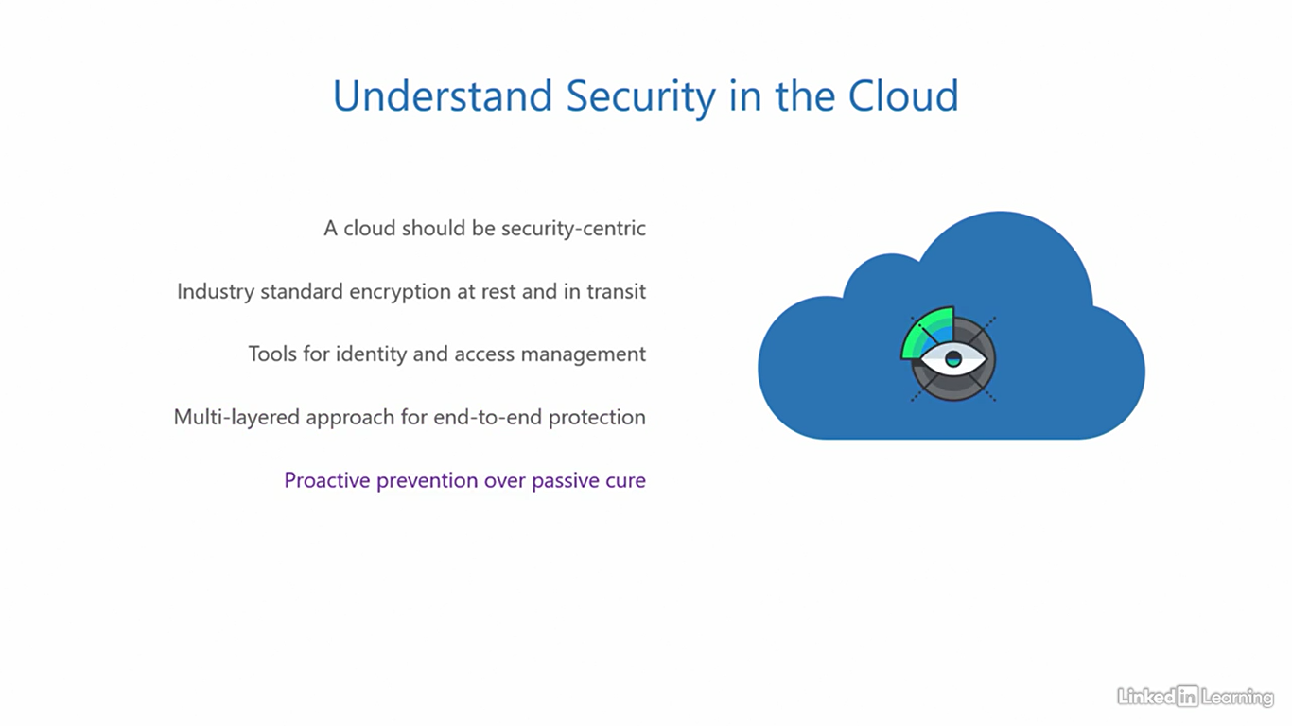

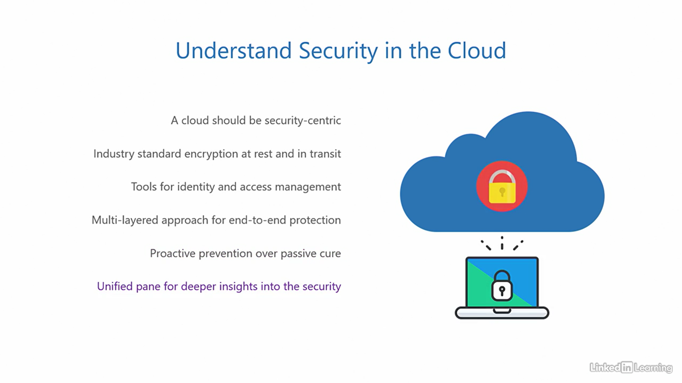

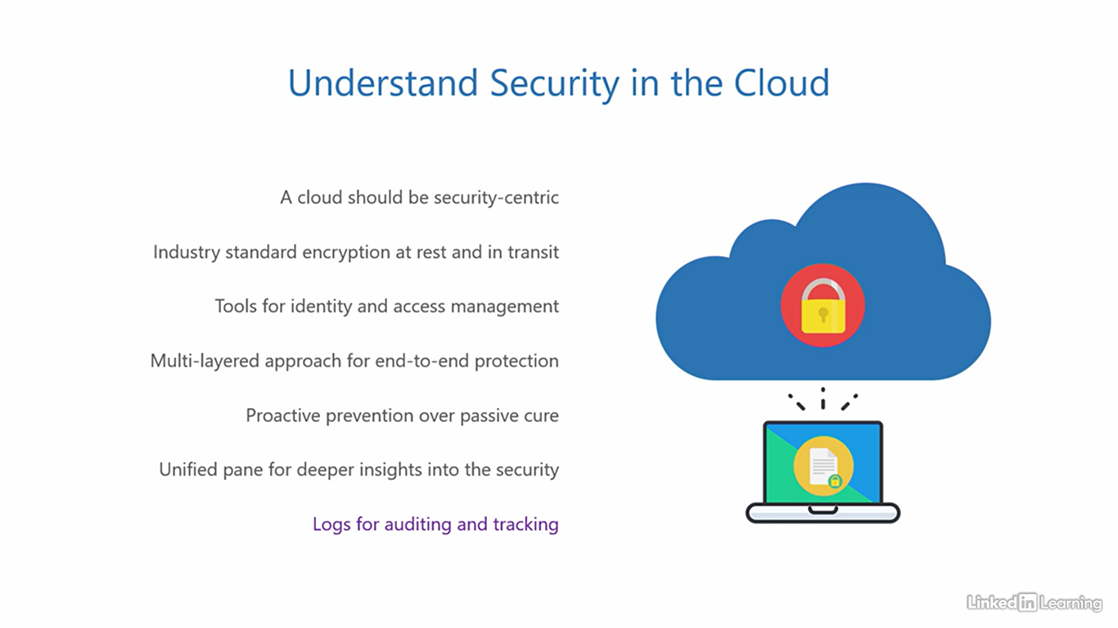

Understand management and governance

[Instructor] In the last video, you saw what we expect a cloud to be capable of from a security point of view. Here, I'll outline the expectations from a management and governance standpoint. First of all, when it comes to management, we appreciate comfort. A cloud should be intuitive to manage. It shouldn't be like walking through a maze or solving a jigsaw puzzle. The interface should be clean, understandable, and easy to navigate. Then, the cloud should support applications that leverage common industry standards and offer adherence to regulatory compliance requirements. Industry standards give developers the freedom to choose any popular language and platform to build their applications. And regulatory compliance ensures the application runs within the confines of company policies and regulations. Next, the cloud should offer a myriad of services, tools, and utilities to configure and deploy. An organization should never be limited by the range of services in the cloud. The cloud should be able to provide any and all resources to an organization for turning their idea into a real functional application. A cloud that restricts you is no good. Then, the cloud should also allow you to monitor the health of its services and the application, provide performance reports at regular intervals, trigger alerts when the application performance falls below a fixed threshold, and recommend best practices to optimize and fine-tune the resources in the cloud. Next, the cloud should be transparent about its pricing. It should help estimate costs an organization will pay for services and applications. There should be no hidden costs added with the intention of unethical profits. In case the organization struggles with a problem that they cannot figure out, the cloud should be able to extend support for both business and technical queries. This can be done through a fleet of trained customer support engineers who are experts in the cloud. And finally, it's beneficial if the cloud can integrate with existing solutions and third-party products that an organization already uses and is familiar with. This helps an organization to smoothly transition to the cloud without having to build and pay for new solutions. Smaller effort and lower costs lead to better outcomes for cloud adoption. As we progress through the learning path, you'll discover where Microsoft Azure stands with respect to security, management, and governance criteria we just discussed.

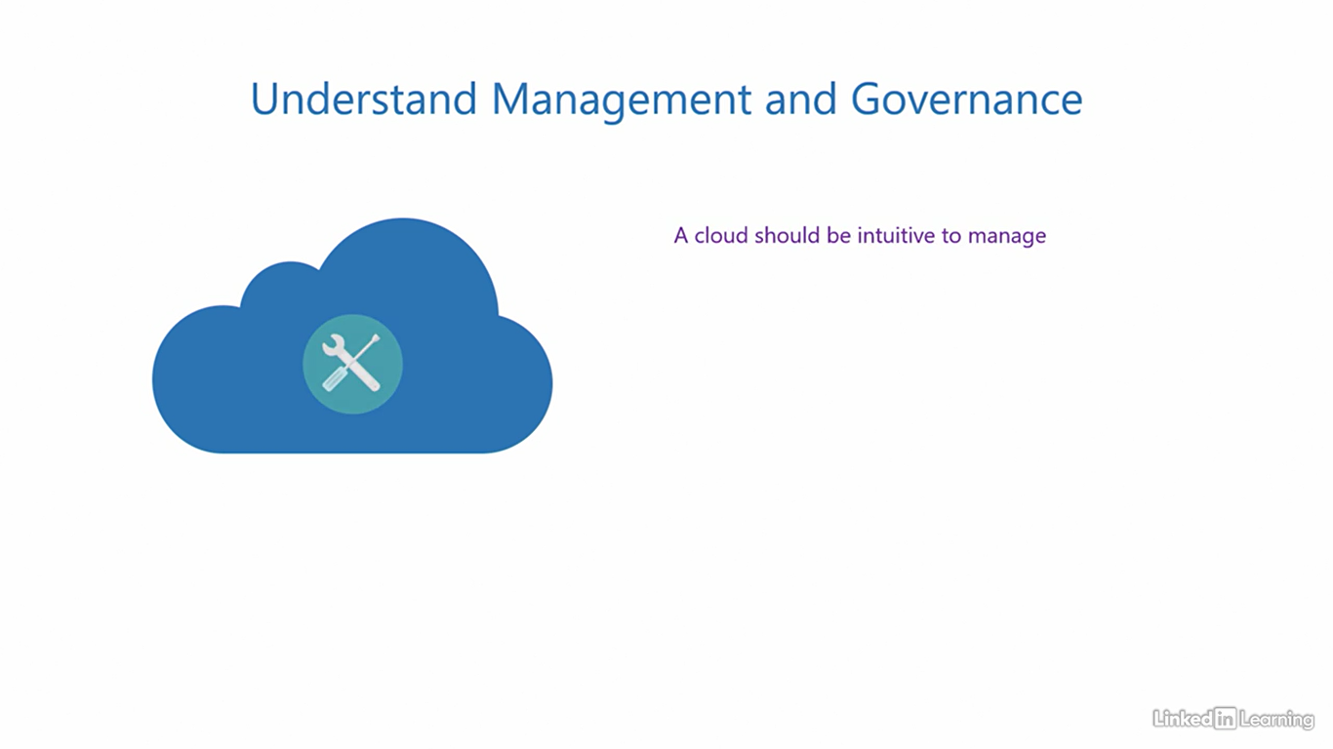

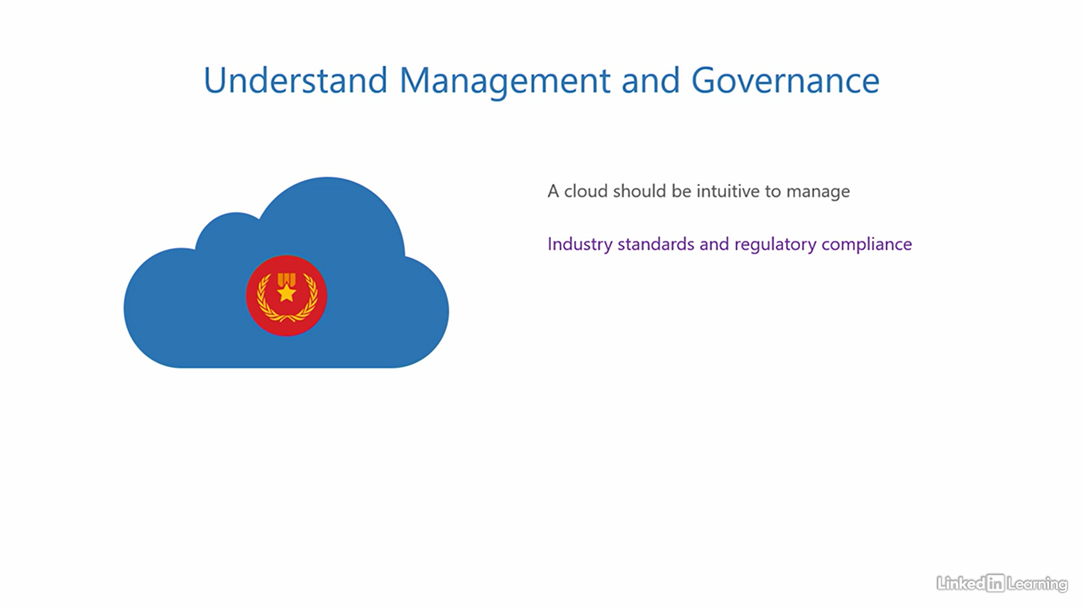

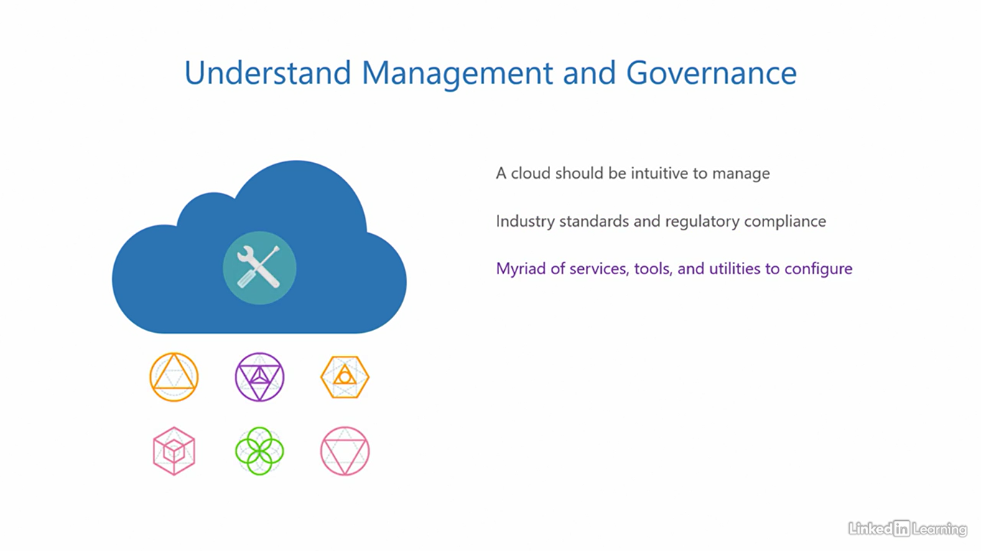

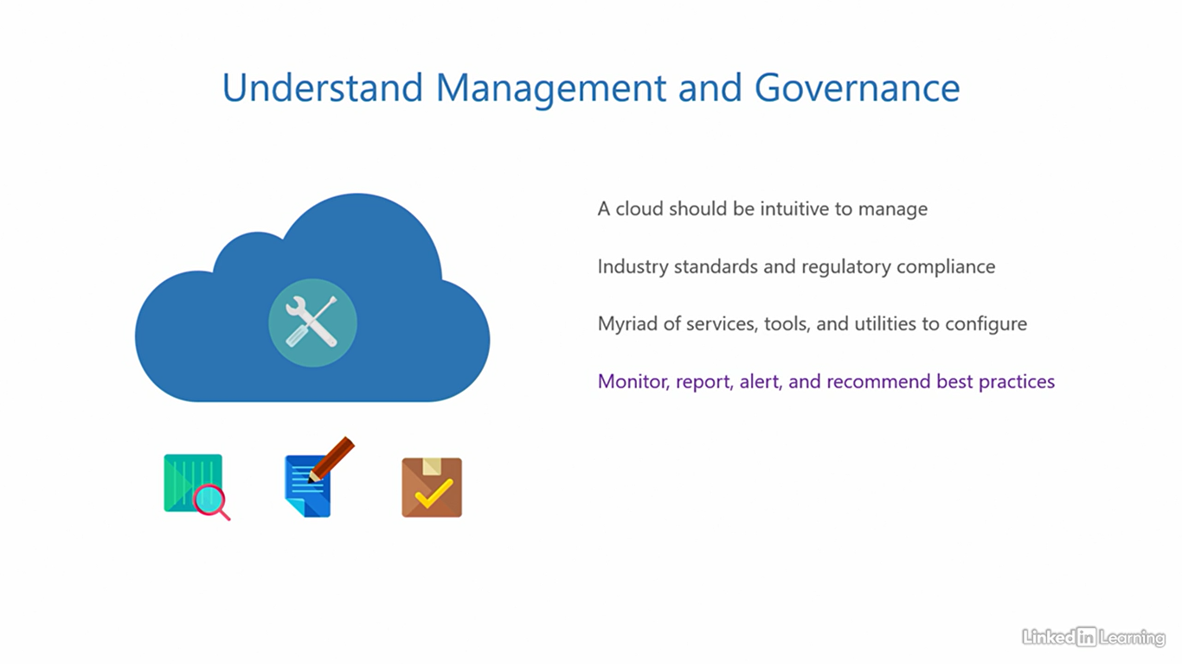

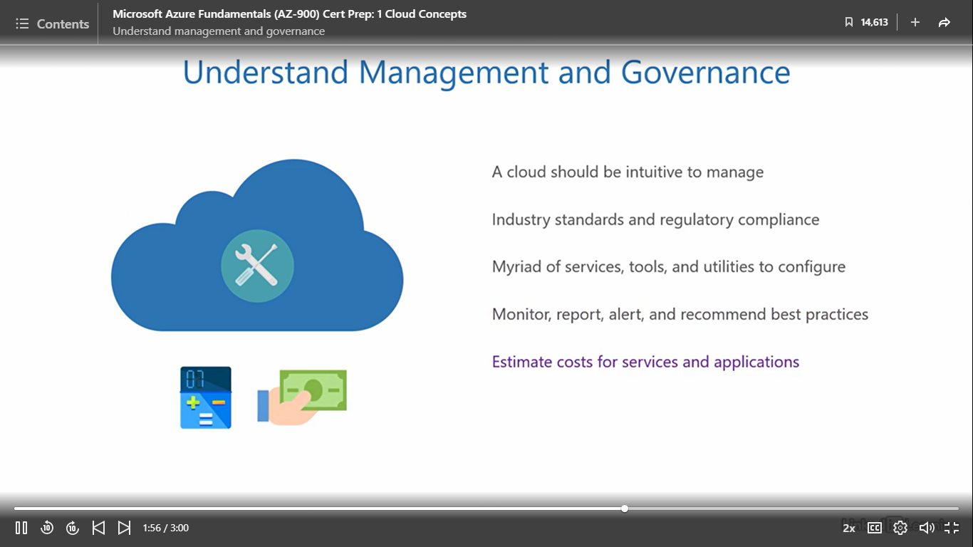

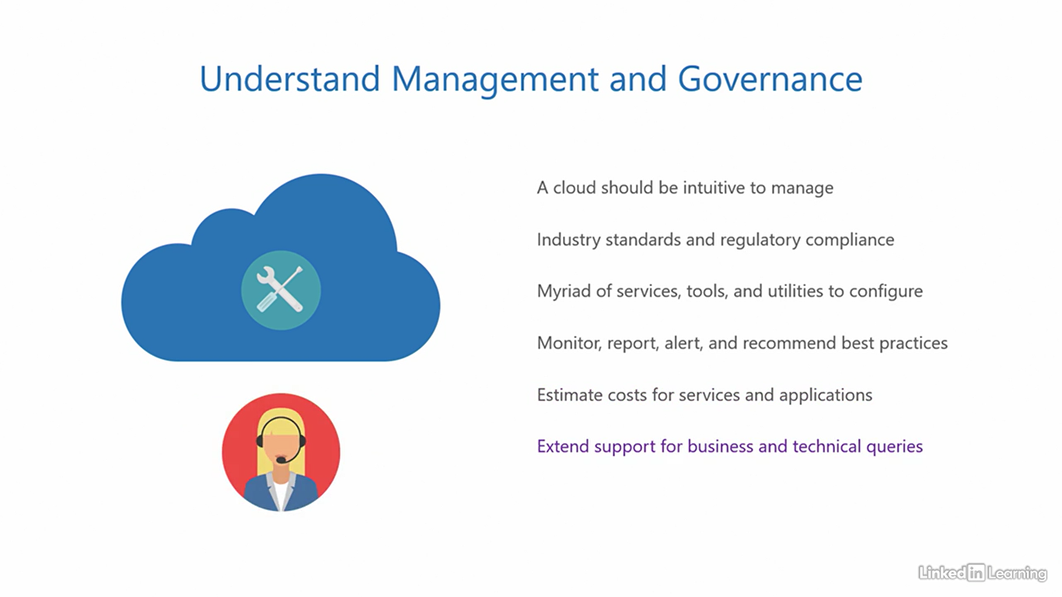

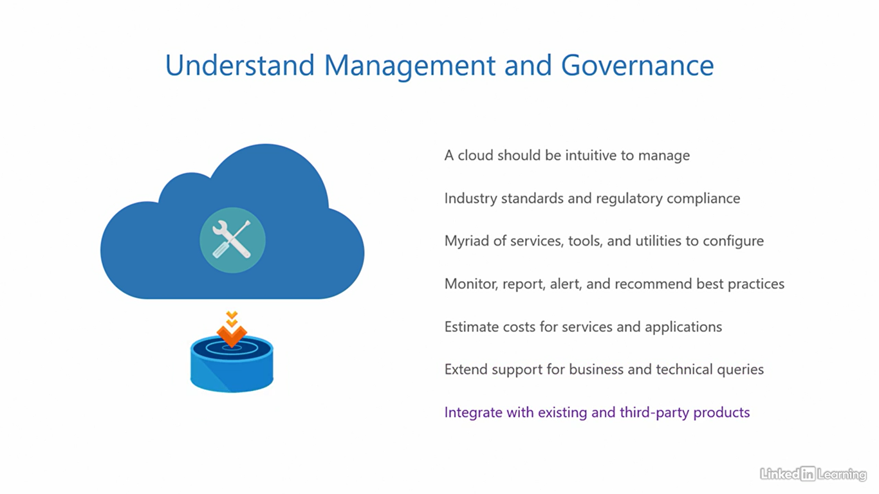

Course summary

[Instructor] Welcome to the last chapter of this course, the conclusion. Here, we'll wrap up the course by reviewing the important bits that are essential for the AZ-900 exam. So let's go back into a quick flashback. In this course, we covered the first section of the AZ-900 exam, describe cloud concepts. In the first chapter, I mentioned how every IT enabled organization has an application that is critical for its business. This application needs to be up and accessible for users around the world around the clock. For that, you need to traditionally build an IT stack and constantly maintain it. To make things easier, you can use cloud computing where a cloud service provider offers parts of the IT stack as a service to customer organizations. Then we learned about the three cloud service models; when an organization consumes virtual hardware resources and its underlying components from the cloud service provider, it's called infrastructure as a service. When it consumes the application dependencies and the underlying components, it's called platform as a service, and when it directly consumes the application ready made from the cloud service provider, it's called software as a service. After that, I showed you the shared responsibility model that outlines how the responsibility of parts of the IT stack is distributed between the customer and the cloud service provider, depending on the cloud service type. And lastly, I emphasized that the data is always under the control of the customer. I also illustrated the four key characteristics of the cloud; resource pooling, elasticity, pay per use, and automation. In the second chapter, I explained the types of cloud computing, a public cloud, which is open for anyone to access, then a private cloud that organizations can deploy for dedicated use to comply with company policy and data security. The third one was a combination of these two, a hybrid cloud. You also learned about a fourth special type of cloud called a sovereign cloud that is reserved for national governments and not open for general public use. In the third chapter, you learned about the benefits of cloud computing. We saw how an infrastructure pool provides and adjusts resources for an application based on demand enabling elasticity, and therefore the infrastructure becomes an elastic infrastructure. Next, you saw if an application can scale vertically or horizontally based on user demand, it enables scalability and therefore, the application becomes a scalable application. Then we saw how maintenance and failures can be handled without disrupting the application and keeping the downtime minimum through high availability. And finally, we saw how instantaneous faults in a system can be handled by the operating system without affecting the application through fault tolerance. And that was an express recap of everything we learned so far in this course.

